INTEGRATION TEST DOCUMENT |  |  | Application/System Name |  | PawCruz
Test Cycle No. | 5 |  | User/Access Type |  | Pet Owner
Date Tested | 10/08/2026 |  | Type of System |  | Mobile Application (IOS)
Pre-conditions | Open the mobile app
Verification Steps | Functions are working with no errors
Modules | Action Descriptions | Expected Results |  | Actual Results |  | Remarks
Login Page | Open the mobile application | Display the login page |  | 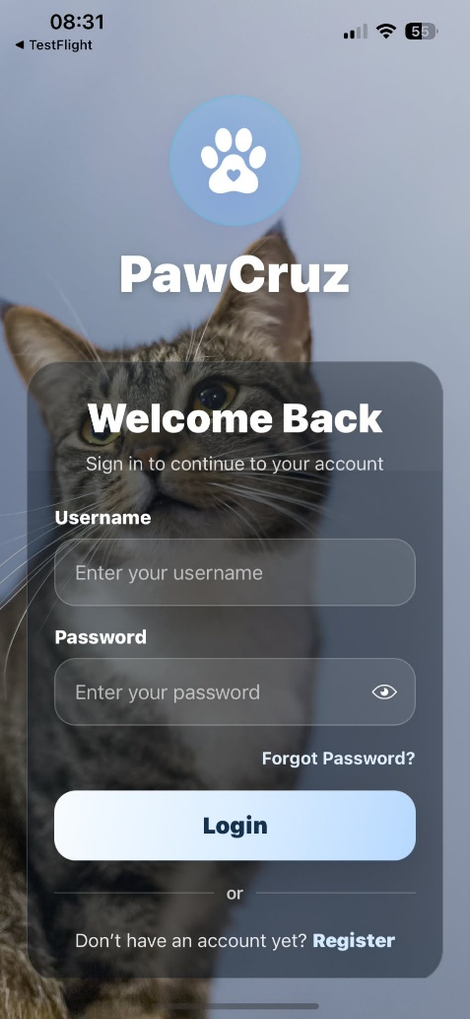 |  | PASSED
Login Page/Forgot Password | Tap the "Forgot Password?" button | Displays the Forgot Password page |  | 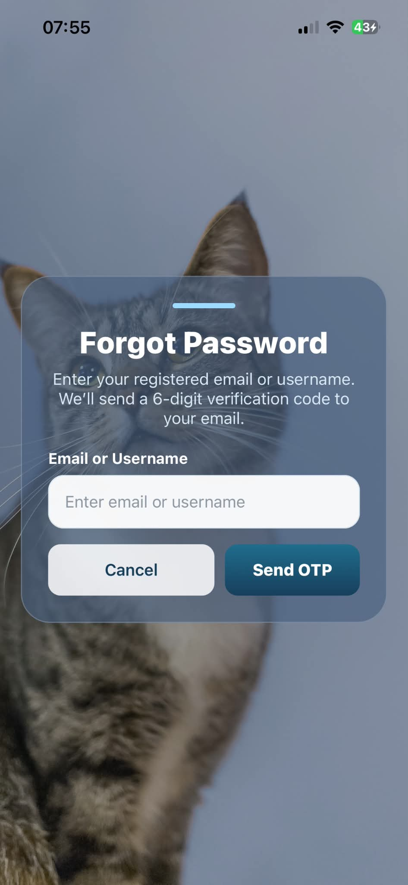 |  | PASSED
Forgot Password/OTP Page | Enter email address and tap the "Send OTP" button | Displays the OTP Verification page |  | 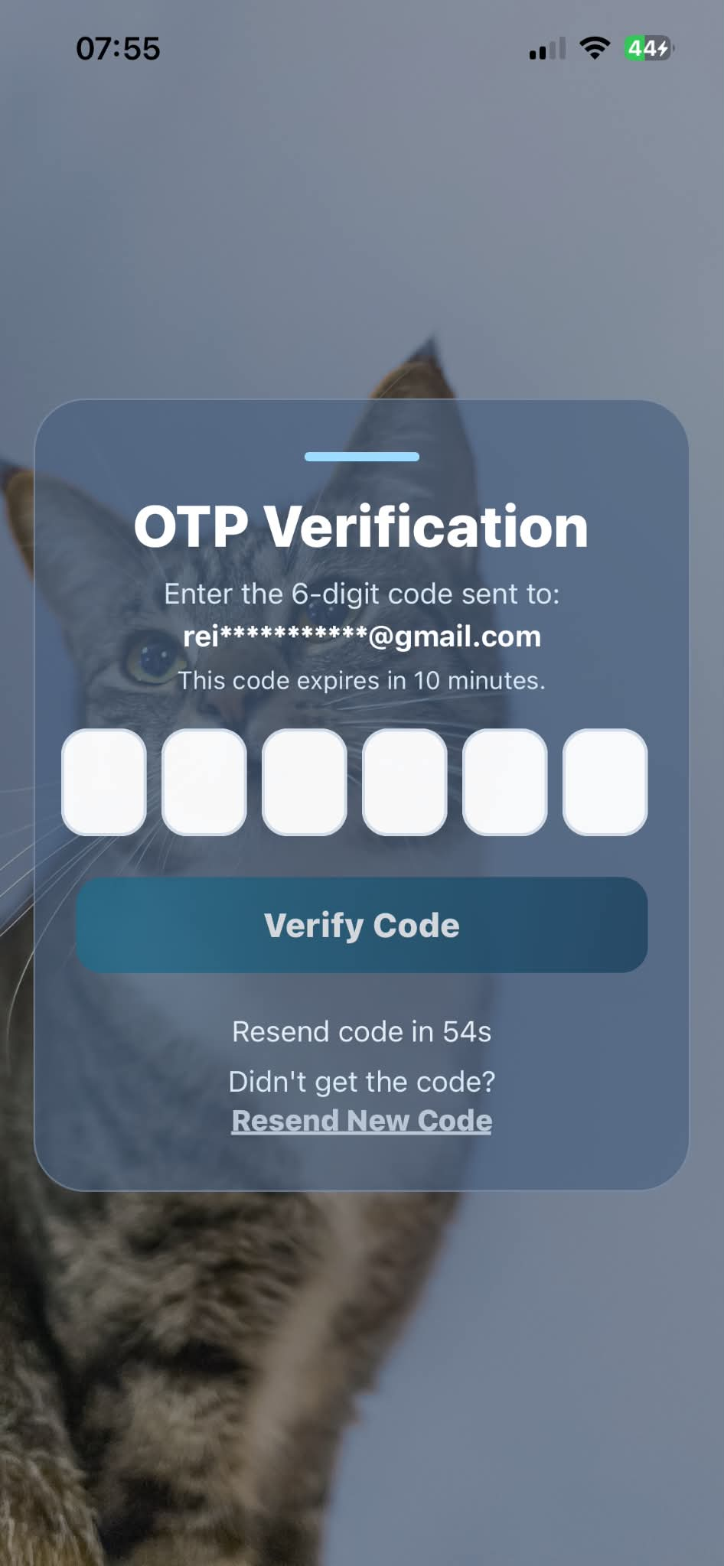 |  | PASSED
OTP Page | Tap "Resend OTP" button | Resends OTP to email address |  | 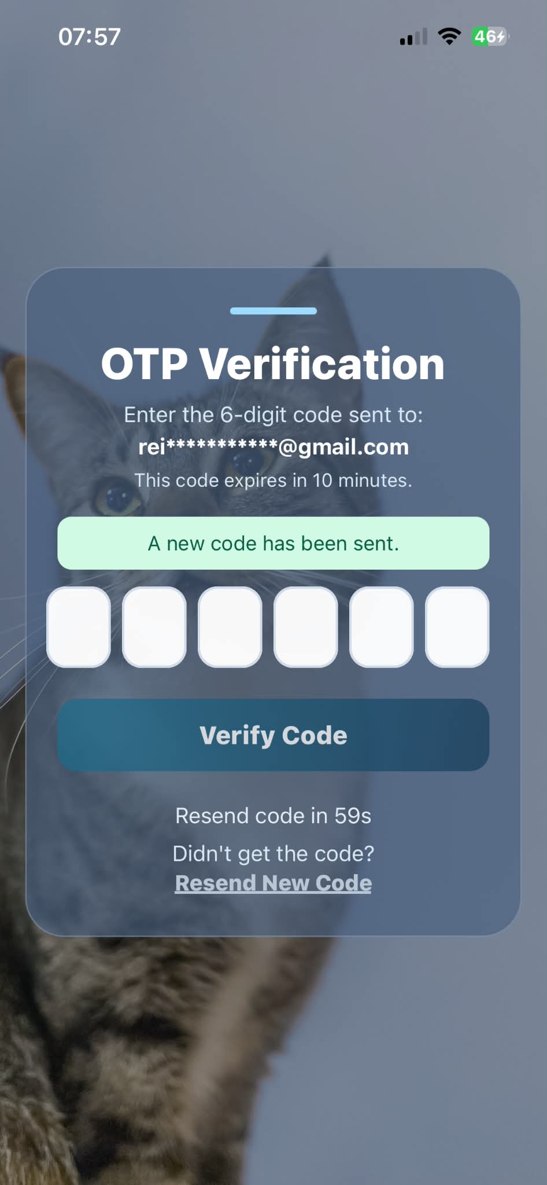 |  | PASSED
Forgot Password Page | Tap "Verify OTP" button after entering code | Displays Set a New Password page |  | 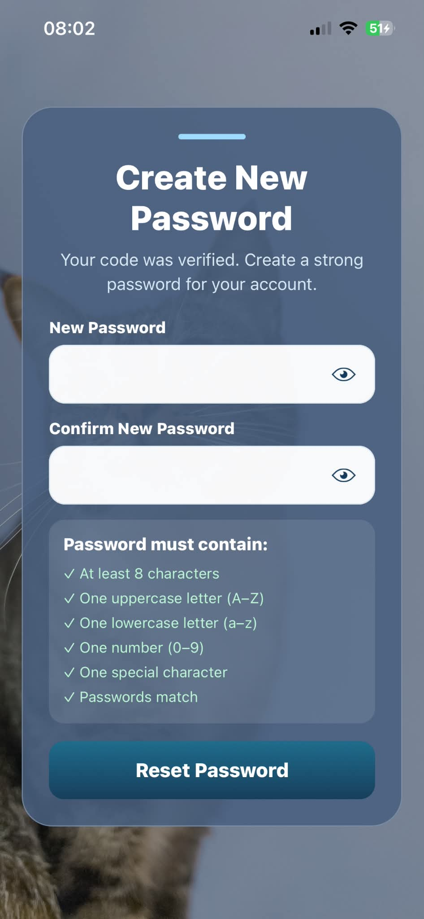 |  | PASSED
Forgot Password Page/ Login Page | Tap "Update Password" button | Displays Login Page if criteria for password are met |  | 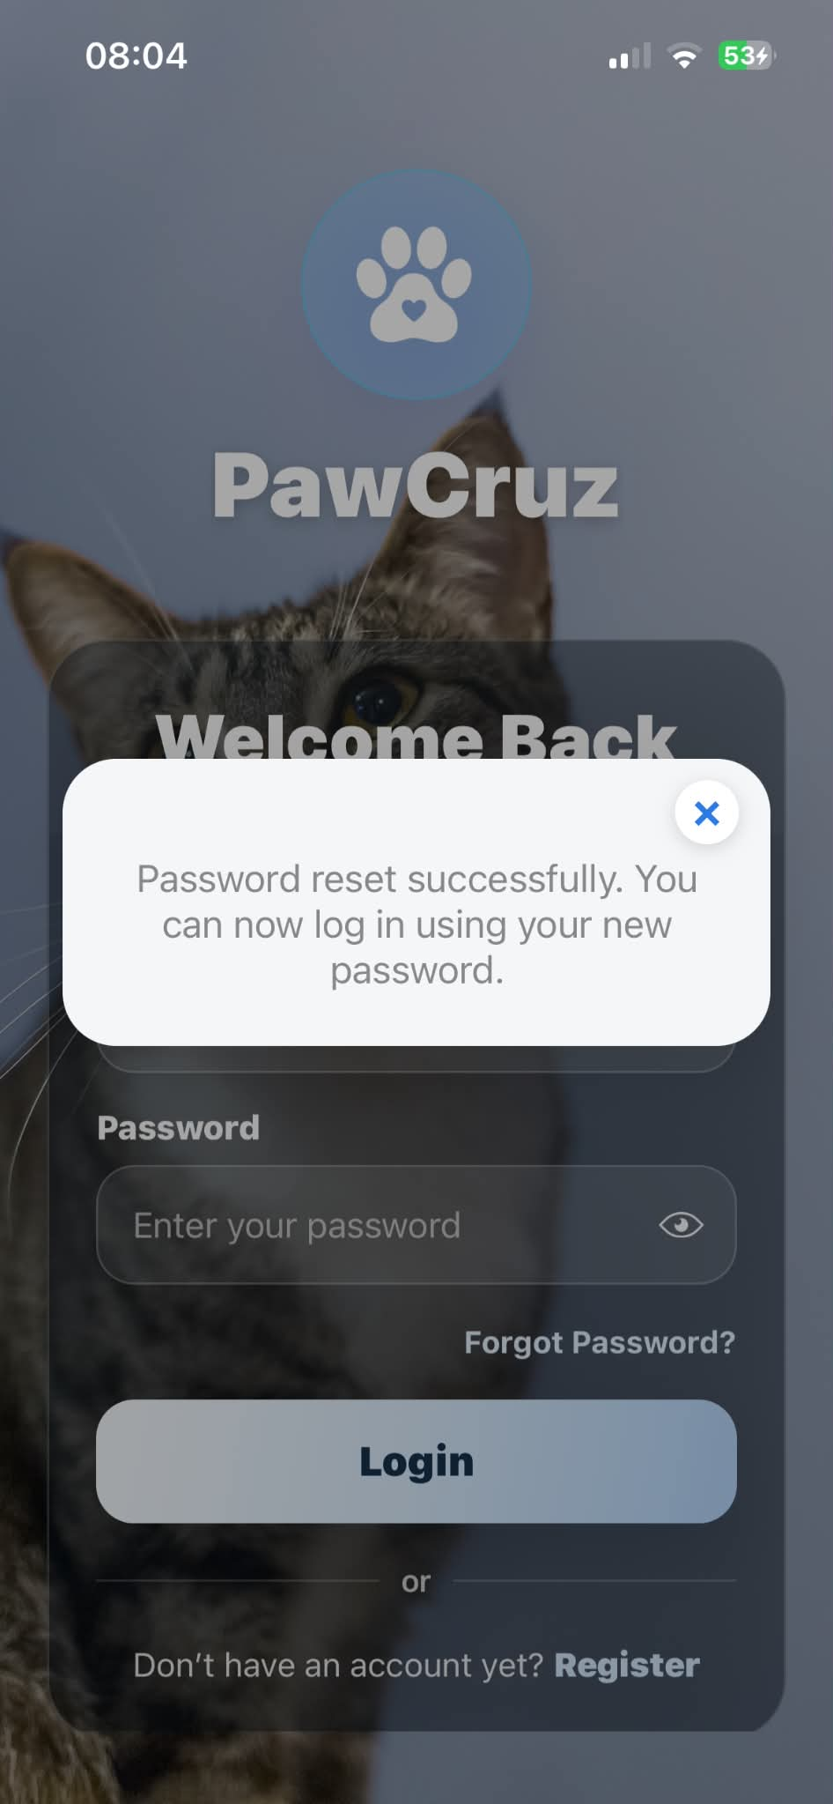 |  | PASSED
Login Page/Register Page | Tap "Register" / "Don't have an account yet?" link | Displays Pet Owner Registration form |  | 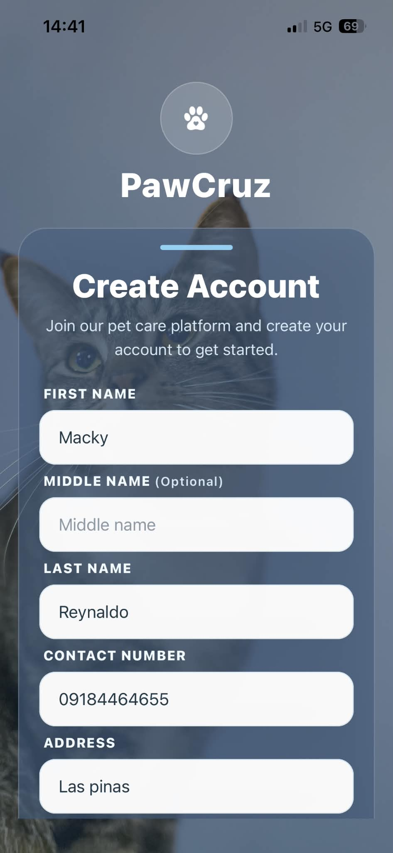 |  | PASSED
Register Page/Login Page | Tap the "Login" link on the Create Account form | Redirects back to the Login page |  | 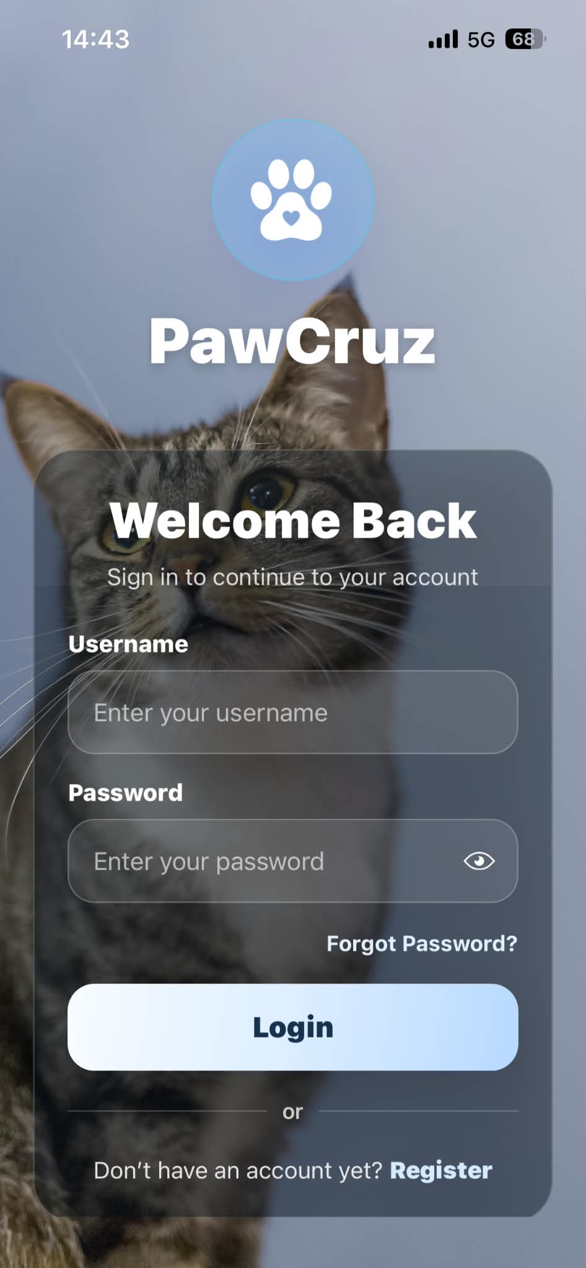 |  | PASSED
Register Page/OTP Page | Tap the "Create Account" button on Registration form | Asks for verification code to verify account |  | 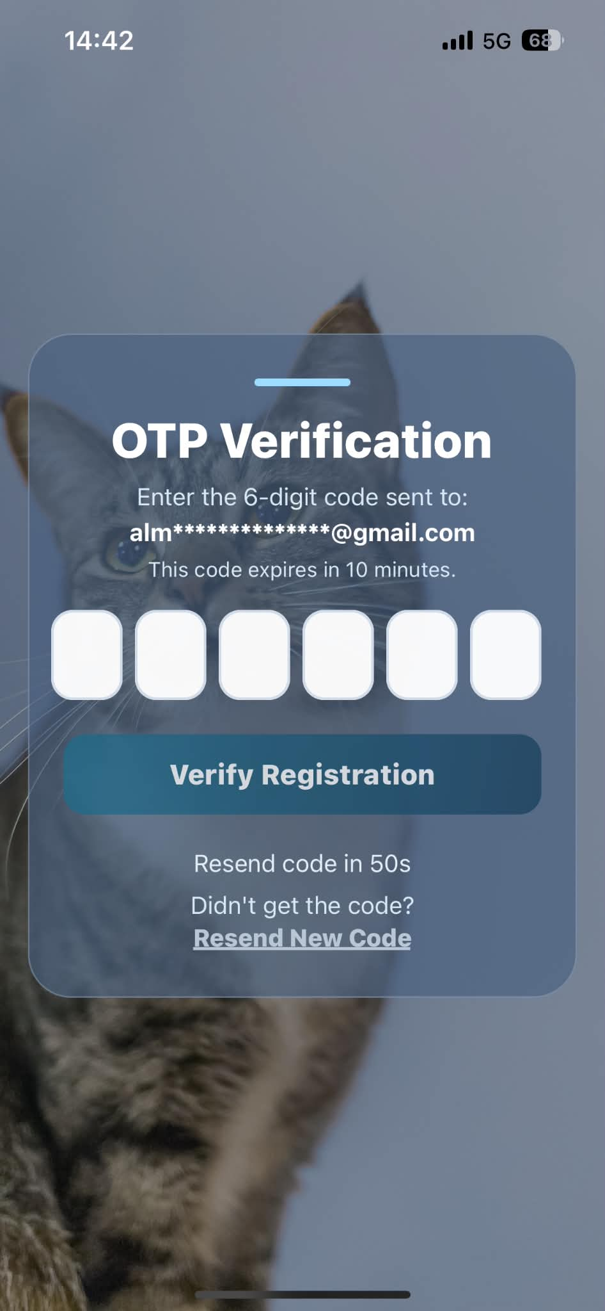 |  | PASSED
OTP Page/Login Page | Verify account via gmail code | Displays the Login Page again after successful registration |  | 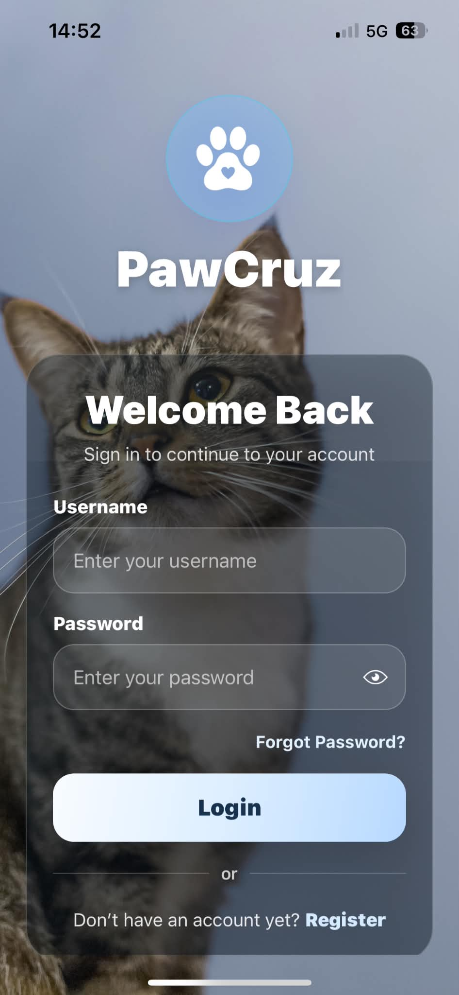 |  | PASSED
Dashboard | Swipe the screen down to refresh | Refreshes and displays the updated pet owner dashboard |  | 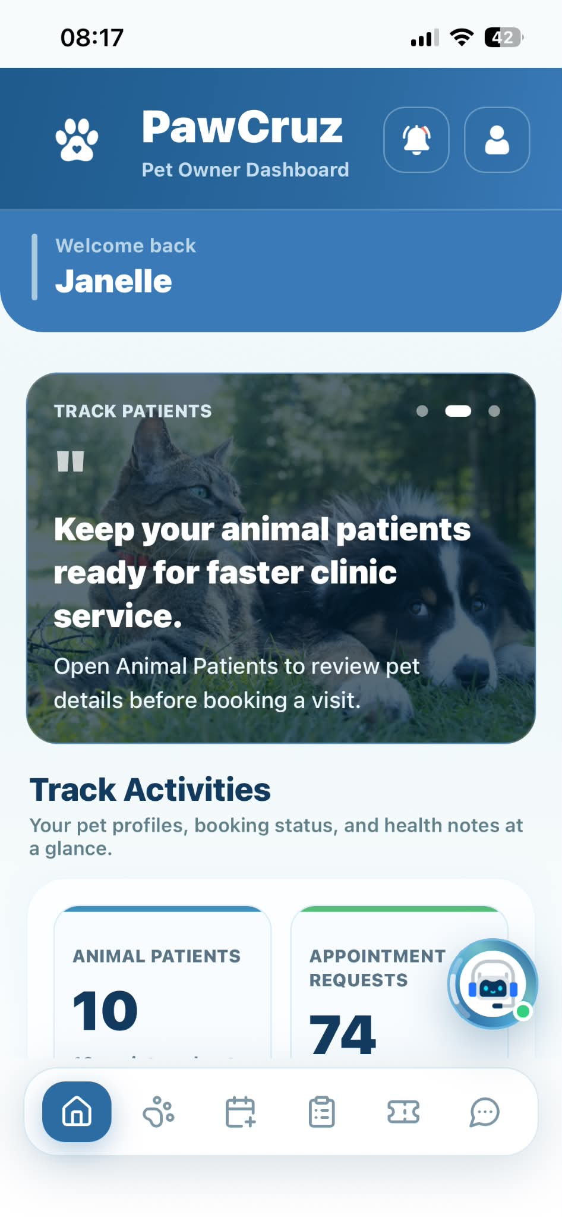 |  | PASSED
Dashboard | Tap the "Notification Bell" icon on header bar | Displays the Notifications page |  | 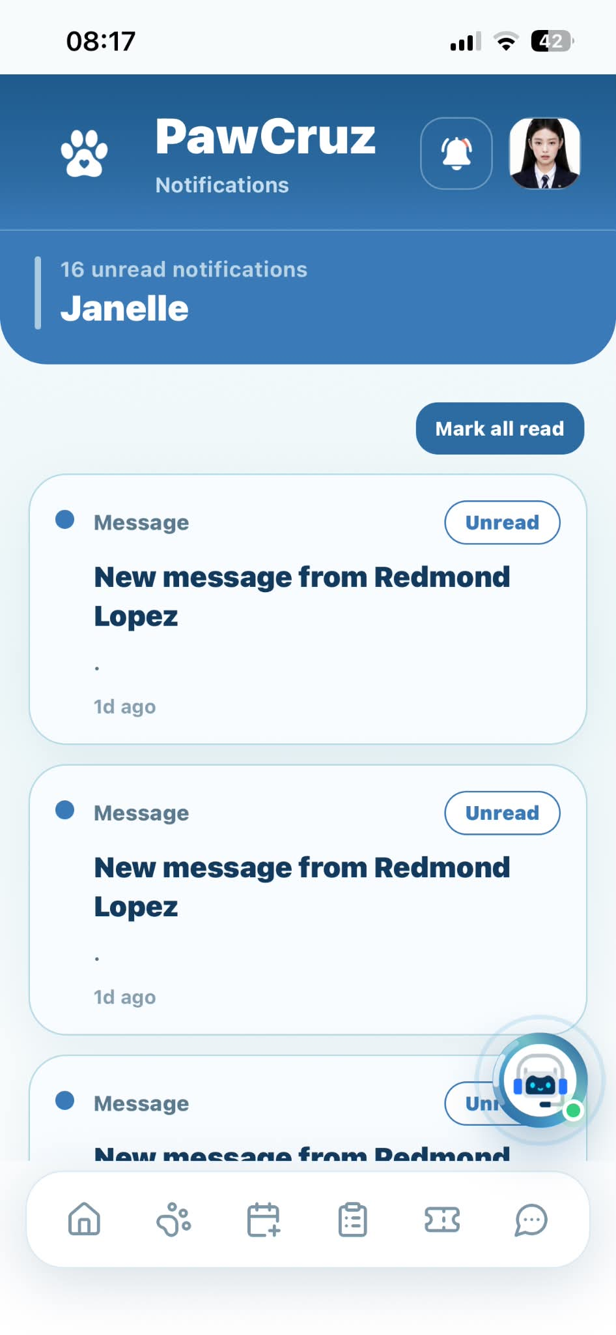 |  | PASSED
Dashboard | Tap the "Profile picture” on header bar | Displays the Pet Owner Profile options |  | 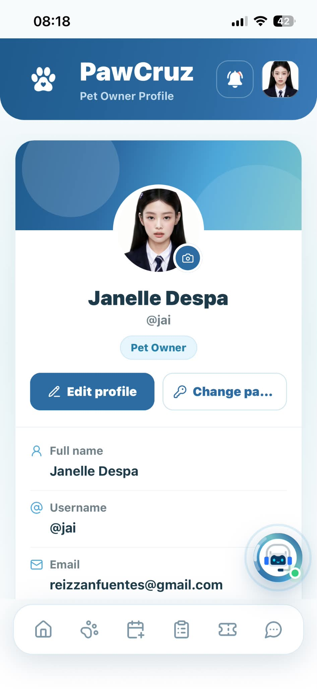 |  | PASSED
Dashboard/Services | Tap "Book Appointment" tile under Services | Displays the Book Appointment screen |  | 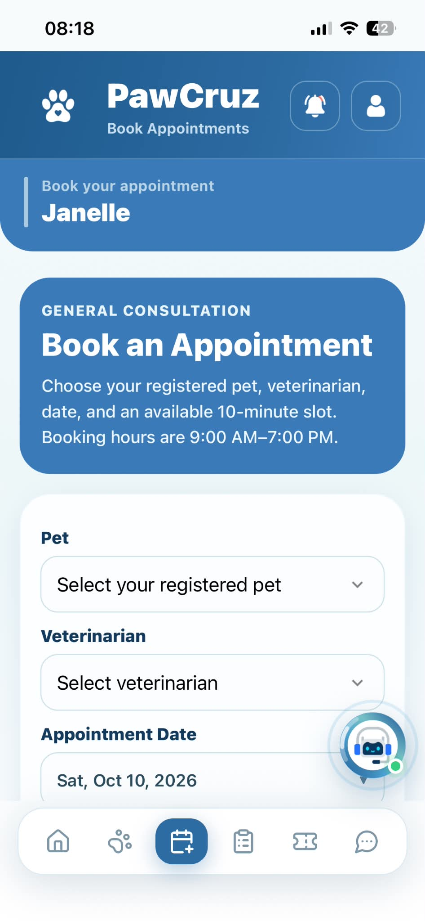 |  | PASSED
Dashboard/Services | Tap "Animal Patients" tile under Services | Displays the Animal Patients screen |  | 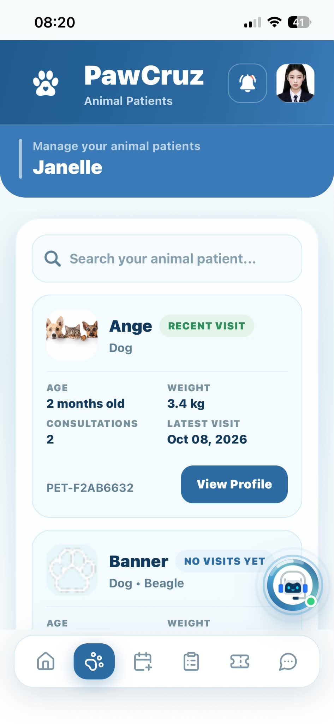 |  | PASSED
Dashboard/Services | Tap "Messages" tile under Services | Displays the Messages screen |  | 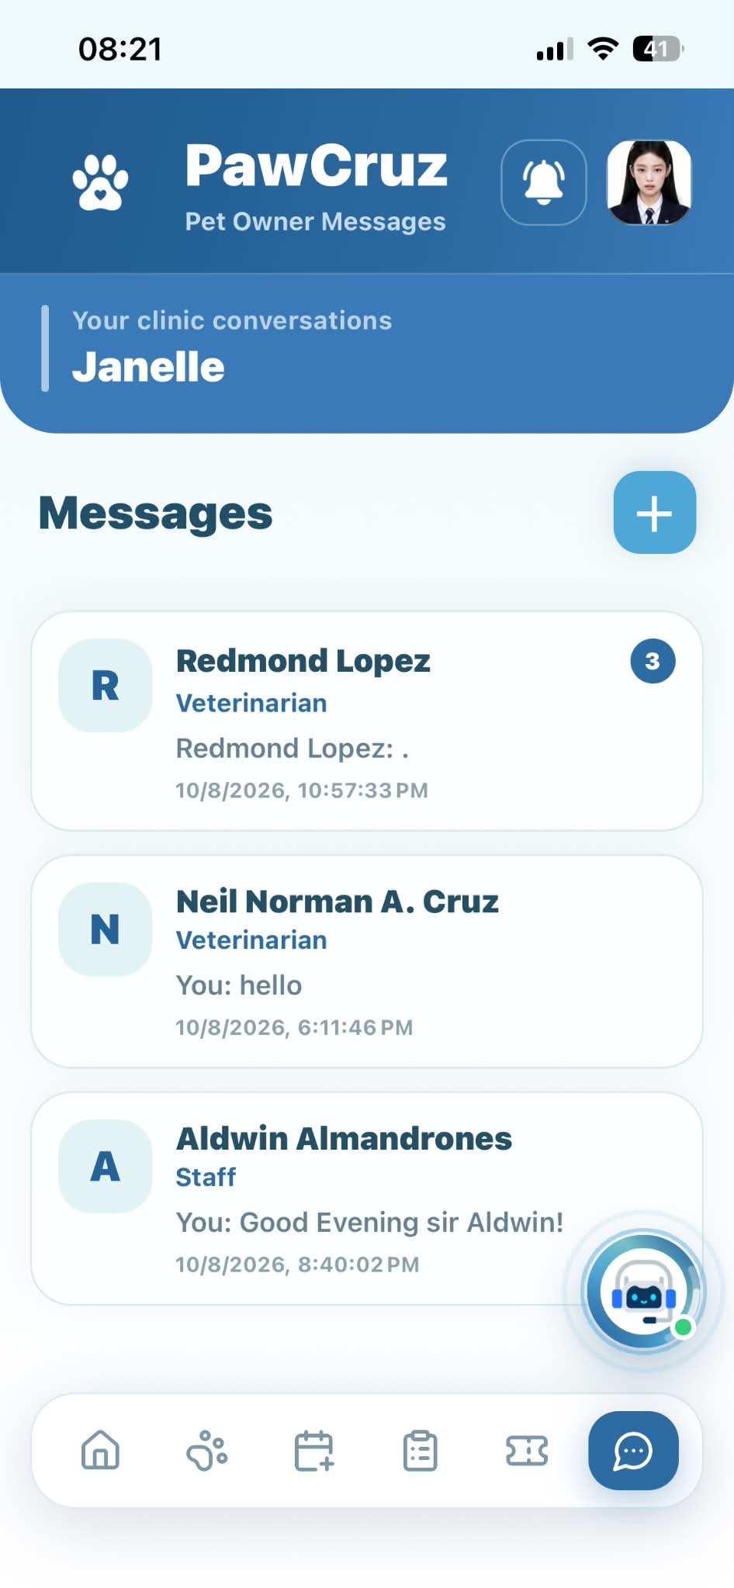 |  | PASSED
Dashboard/Services | Tap "Queue" tile under Services | Displays the Queue Summary screen |  | 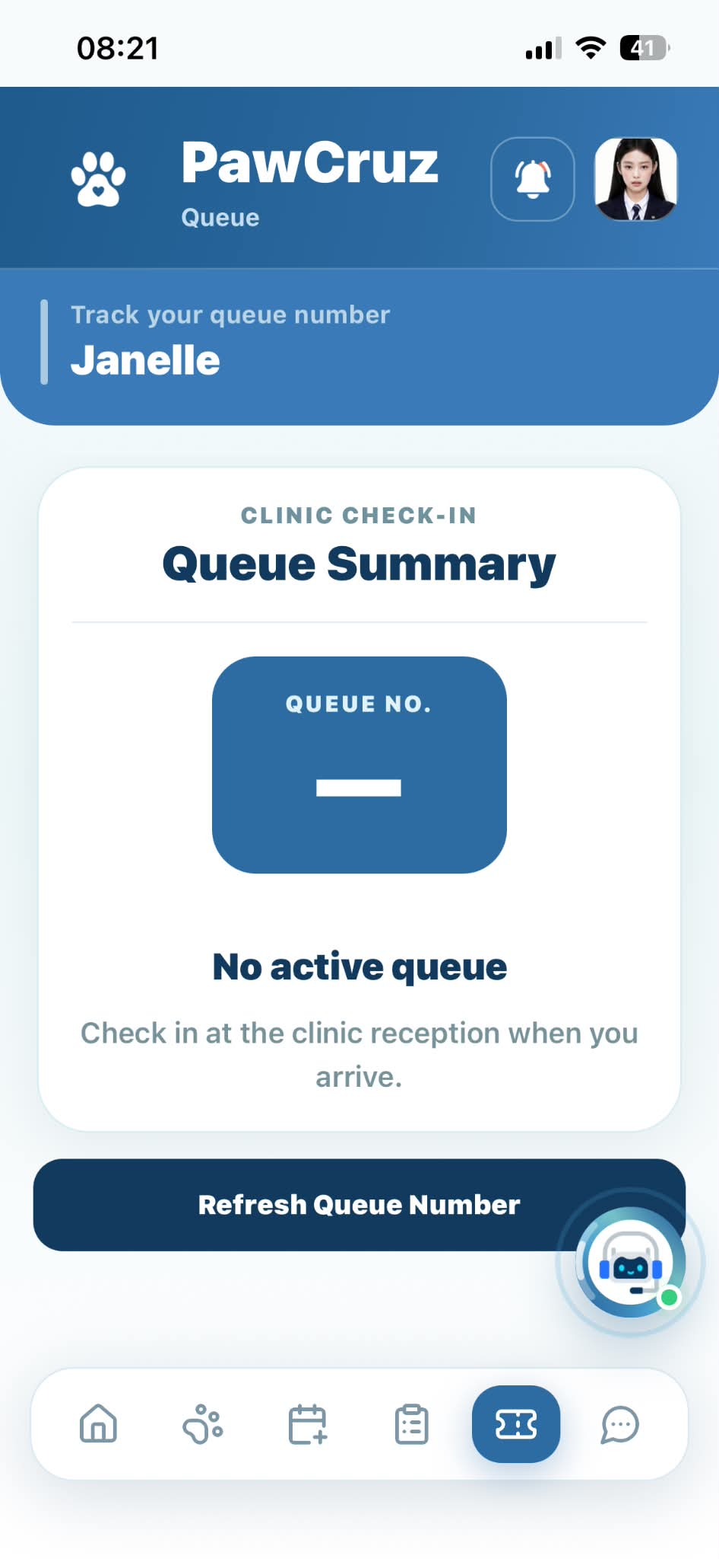 |  | PASSED
Bottom Navigation Bar | Tap "Home" icon tab | Navigates to Pet Owner Dashboard |  | 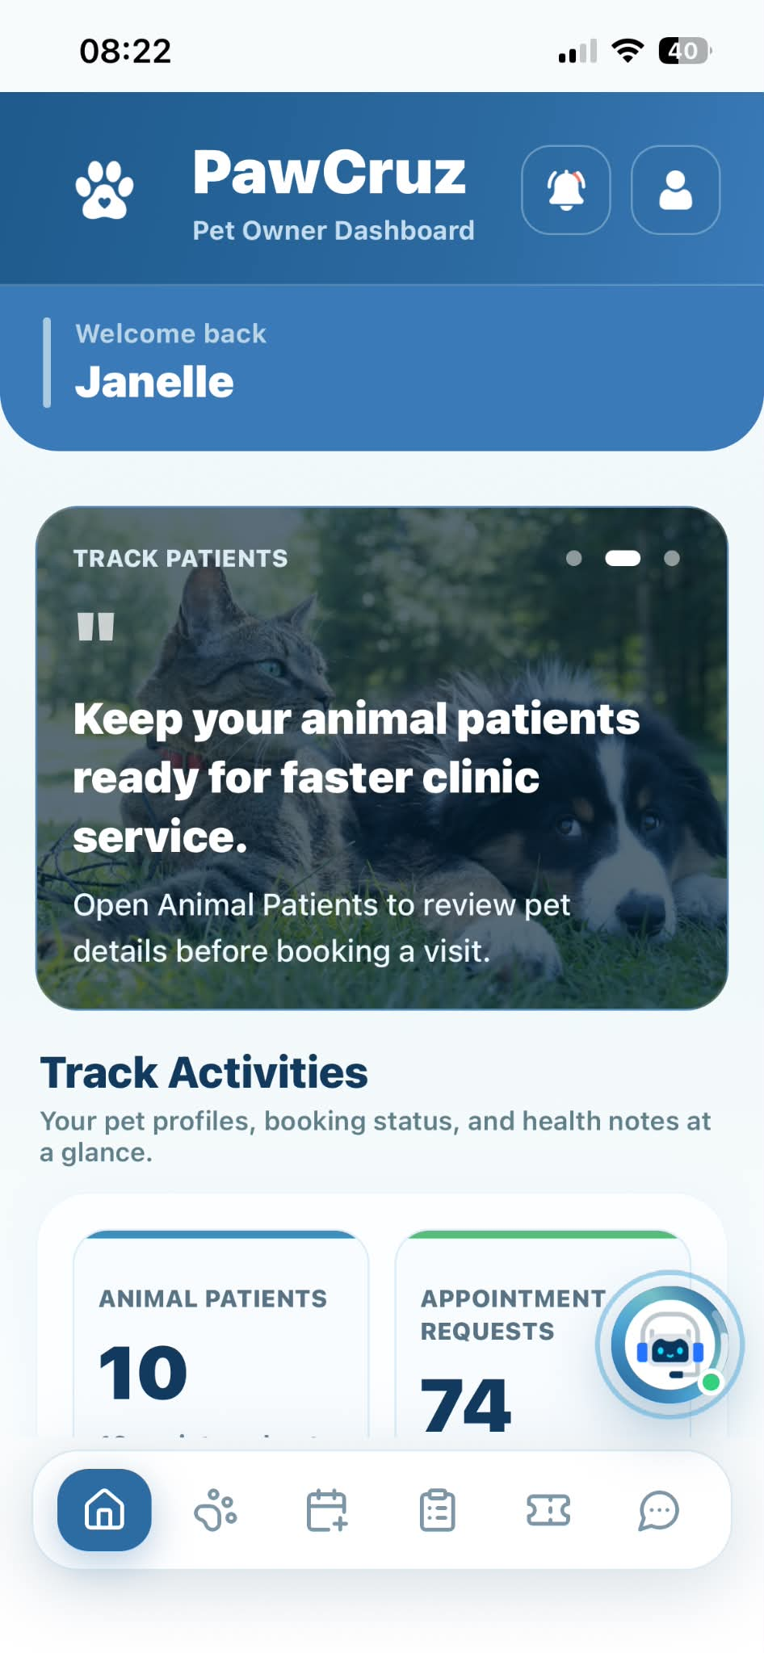 |  | PASSED
Bottom Navigation Bar | Tap "Animal Patients" icon tab | Navigates to Animal Patients screen |  |  |  | PASSED
Bottom Navigation Bar | Tap "Book Appointment" icon tab | Navigates to Book Appointment screen |  | 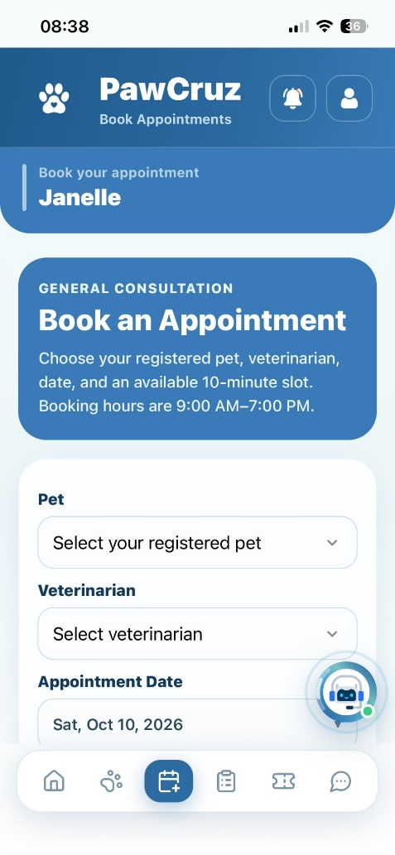 |  | PASSED
Bottom Navigation Bar | Tap "Appointments" icon tab | Navigates to Appointments screen |  | 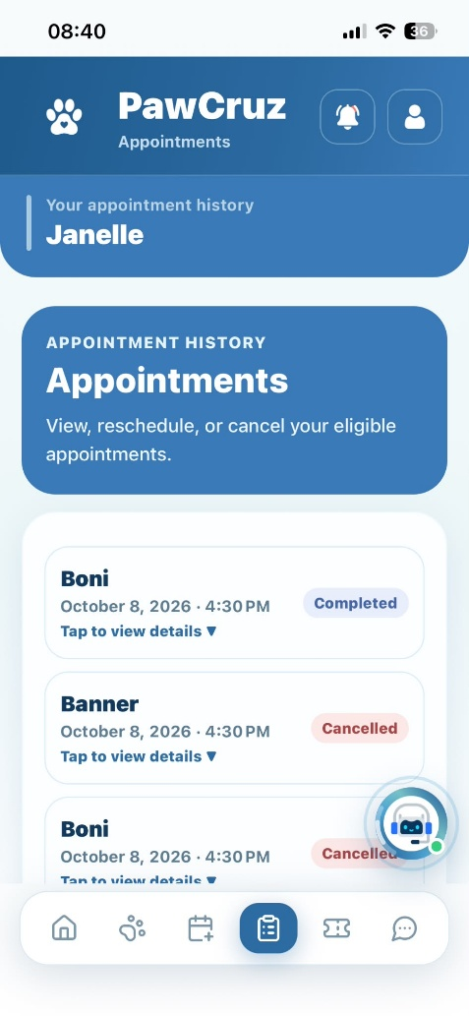 |  | PASSED
Bottom Navigation Bar | Tap "Queue" icon tab | Navigates to Queue Summary screen |  | 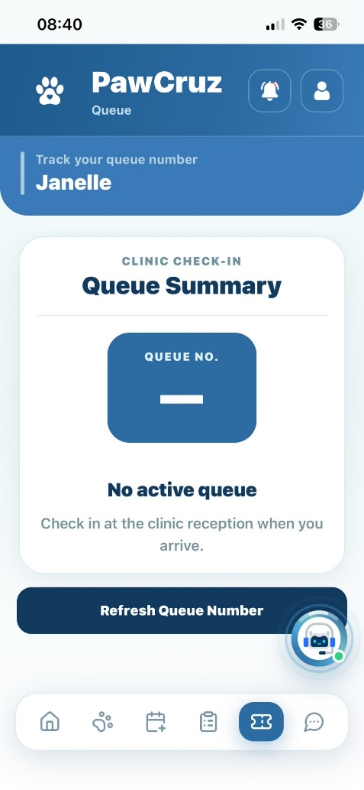 |  | PASSED
Bottom Navigation Bar | Tap "Messages" icon tab | Navigates to Messages screen |  | 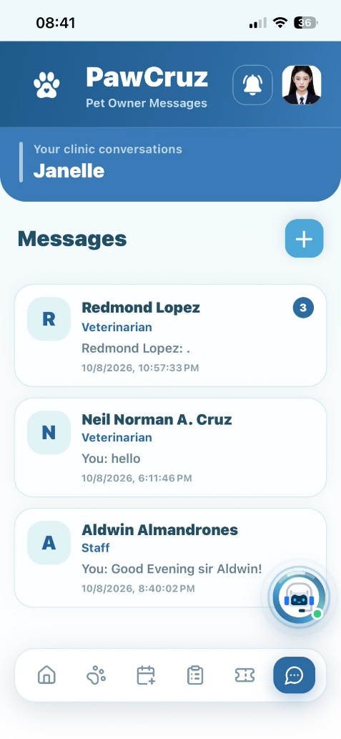 |  | PASSED
Bottom Navigation Bar | Tap "PetCare Assistant" floating button | Displays PetCare Assistant AI chat page |  | 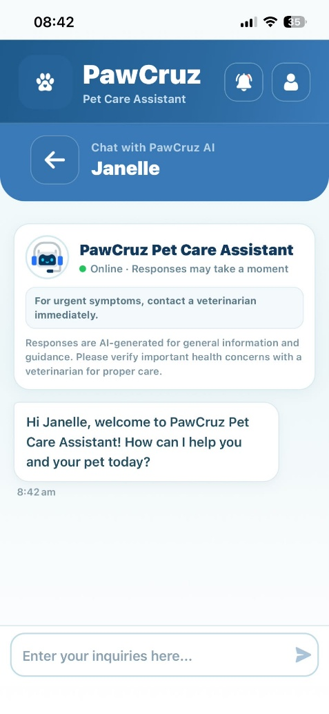 |  | PASSED
Notifications | Tap the "Mark all read" (check icon) | Marks all unread notifications as read and updates badge count |  | 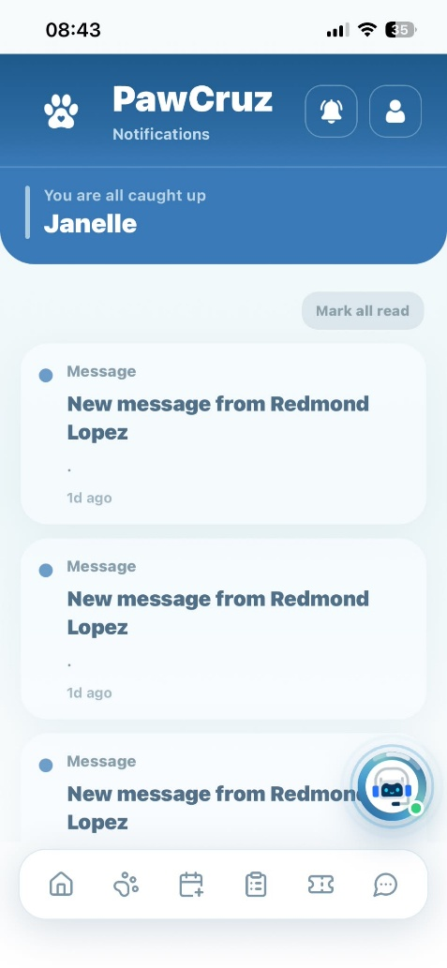 |  | PASSED
Pet Owner Profile | Tap "Edit profile" button | Expands and displays editable personal information fields |  | 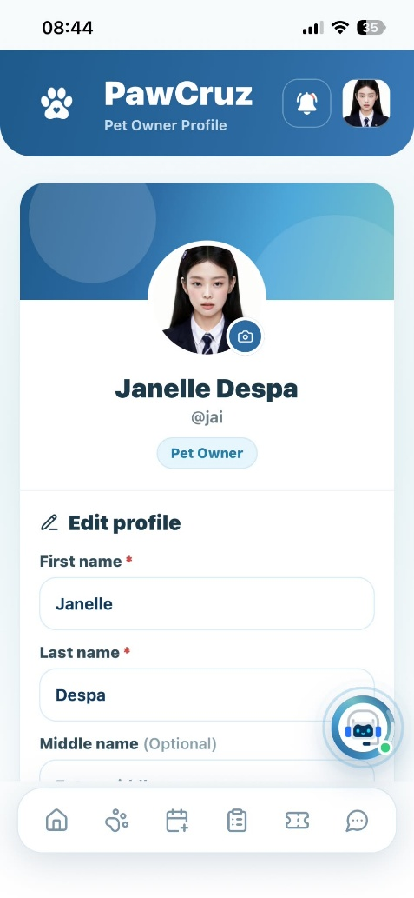 |  | PASSED
Pet Owner Profile | Update personal details and tap "Save changes" button | Saves and updates Pet Owner personal information |  | 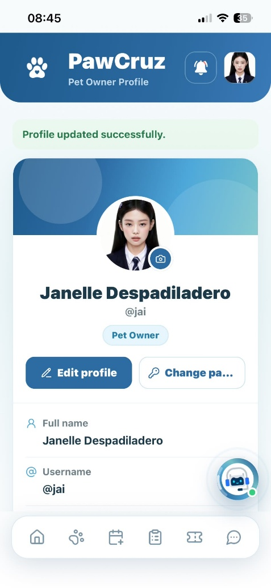 |  | PASSED
Pet Owner Profile | Tap the camera icon on profile picture | Opens file selection window to select profile picture |  | 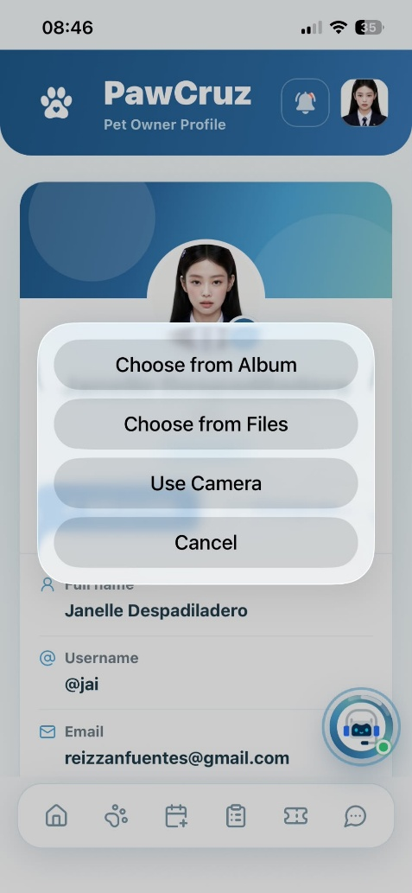 |  | PASSED
Pet Owner Profile | Tap “Change password” button | Displays password update fields with criteria validation |  | 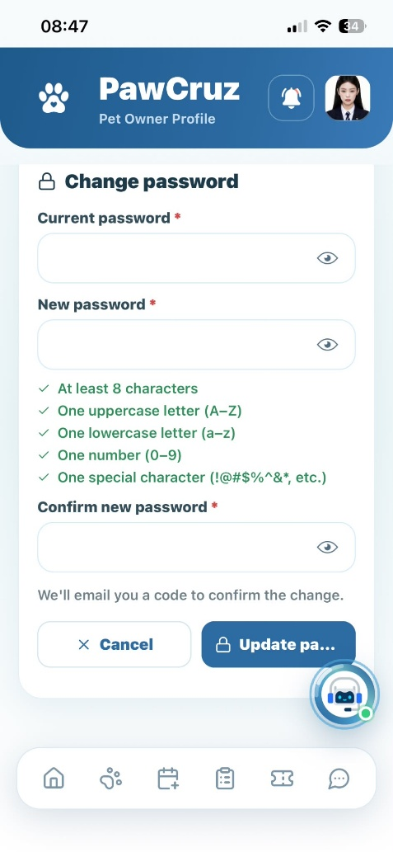 |  | PASSED
Pet Owner Profile | Tap "Show/Hide Password" toggle icon | Displays or hides entered new password text |  | 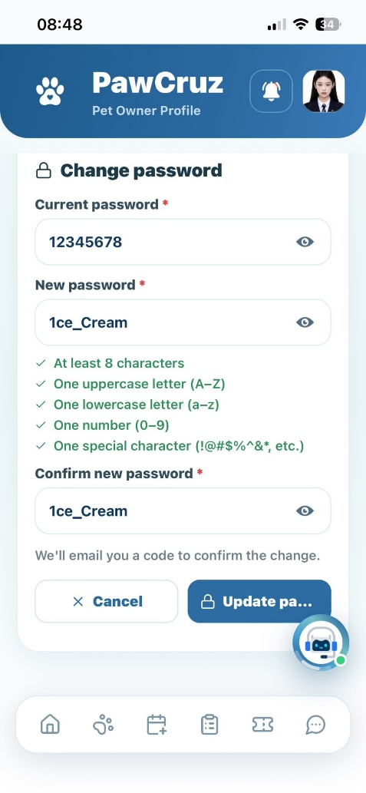 |  | PASSED
Pet Owner Profile | Update password and tap "Update password" button | Sends OTP to pet owner email to verify password change |  | 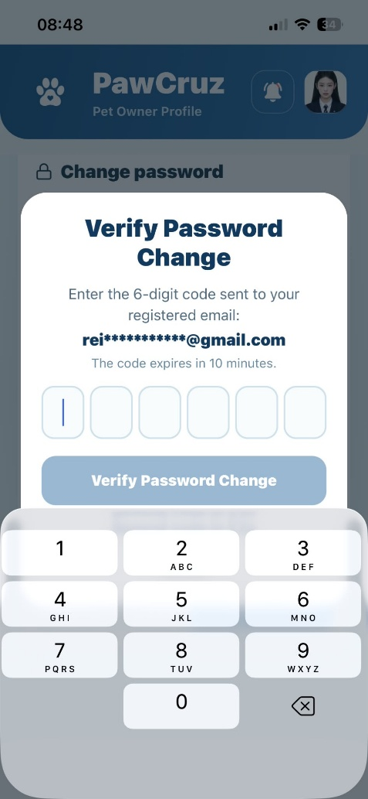 |  | PASSED
Pet Owner Profile | Tap "Cancel" button on verification modal | Cancels action and returns to profile view |  | 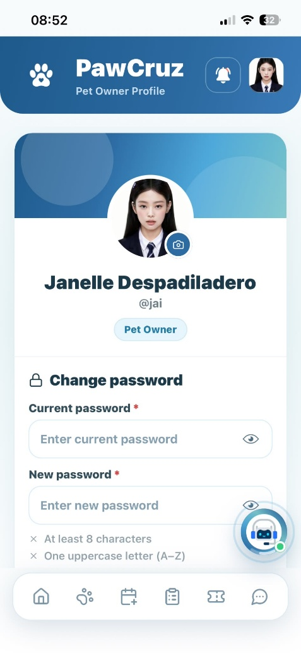 |  | PASSED
Pet Owner Profile | Tap "Verify Code" button after entering code | Updates password and returns to profile view |  | 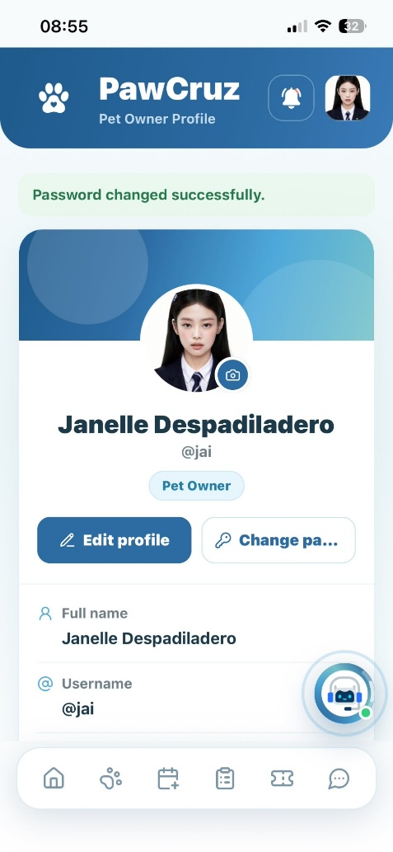 |  | PASSED
Pet Owner Profile | Tap "Logout" button | Displays logout confirmation modal with "Cancel" and "Logout" |  | 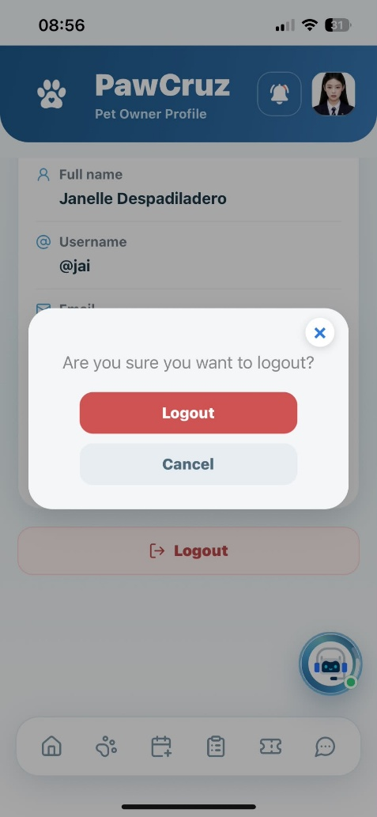 |  | PASSED
Logout | Tap "Cancel" button in confirmation dialog | Closes dialog and keeps user logged in |  | 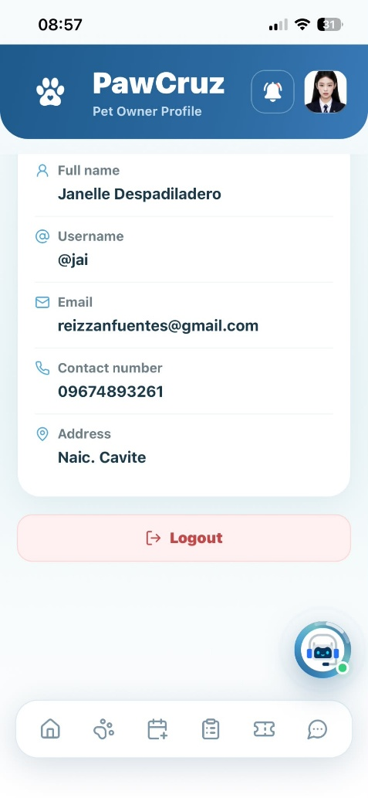 |  | PASSED
Logout | Tap "Logout" button in confirmation dialog | Logs out user and redirects to Login page |  | 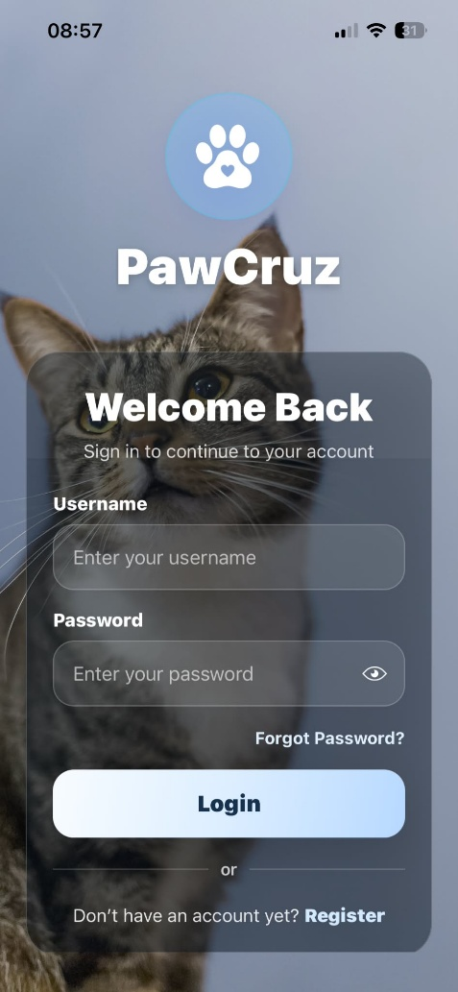 |  | PASSED
Animal Patients | Tap "+ Add Pet Profile" / "Register Pet" button | Opens Register Animal Patient form |  | 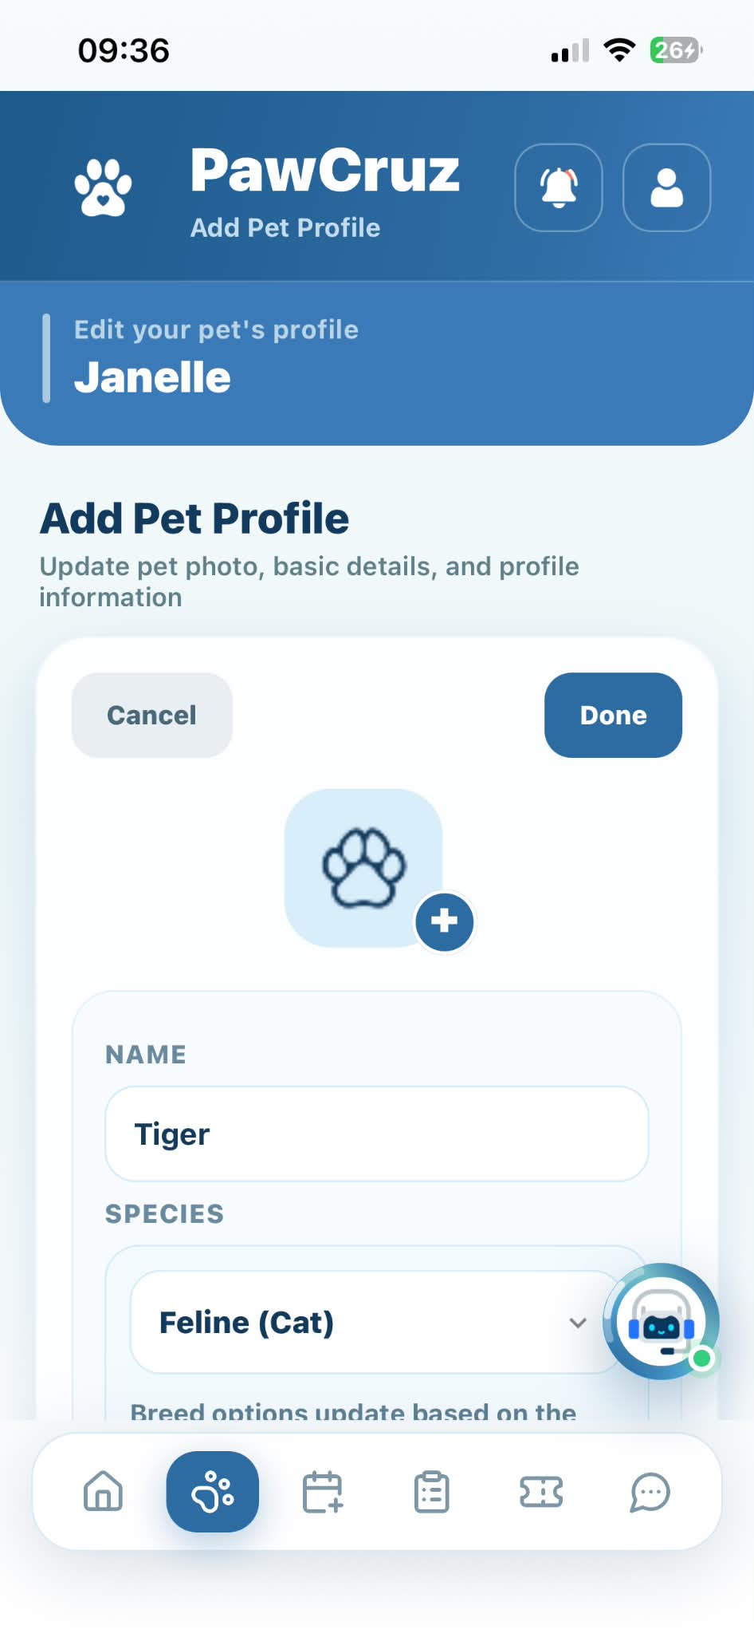 |  | PASSED
Animal Patients | Enter required pet info and tap "Register Pet" button | Registers pet and displays newly added pet in patient list |  | 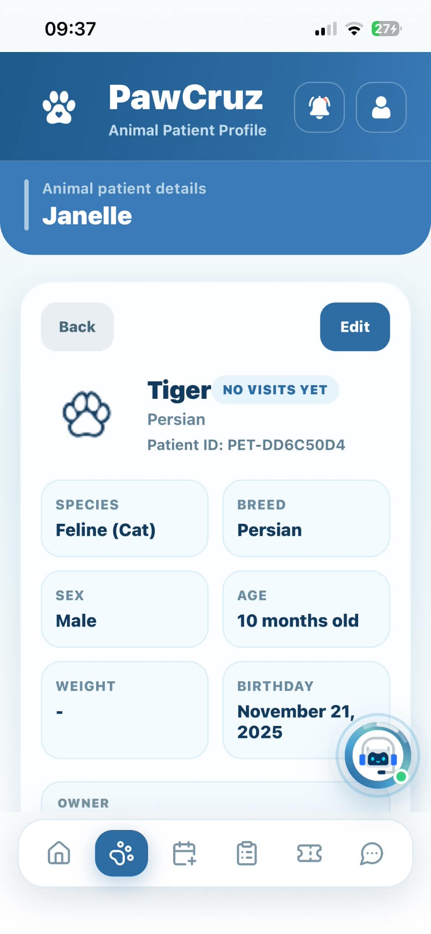 |  | PASSED
Animal Patients | Tap "View Profile" button on pet card | Displays pet profile details with Medical History and AI Health tab |  | 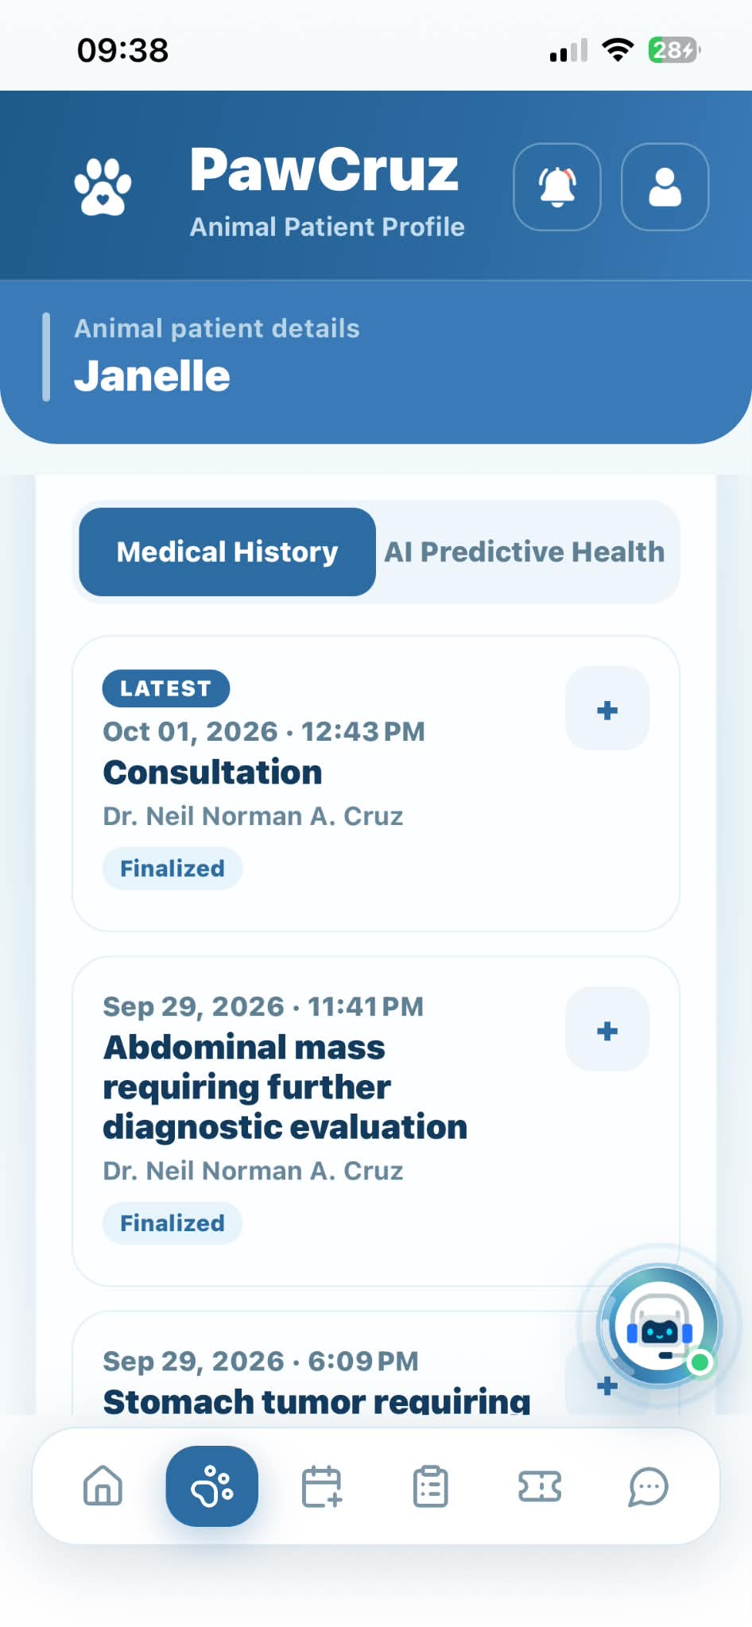 |  | PASSED
Animal Patients | Tap "Medical History" tab on pet profile | Displays pet's clinical records, billing, and prescriptions |  | 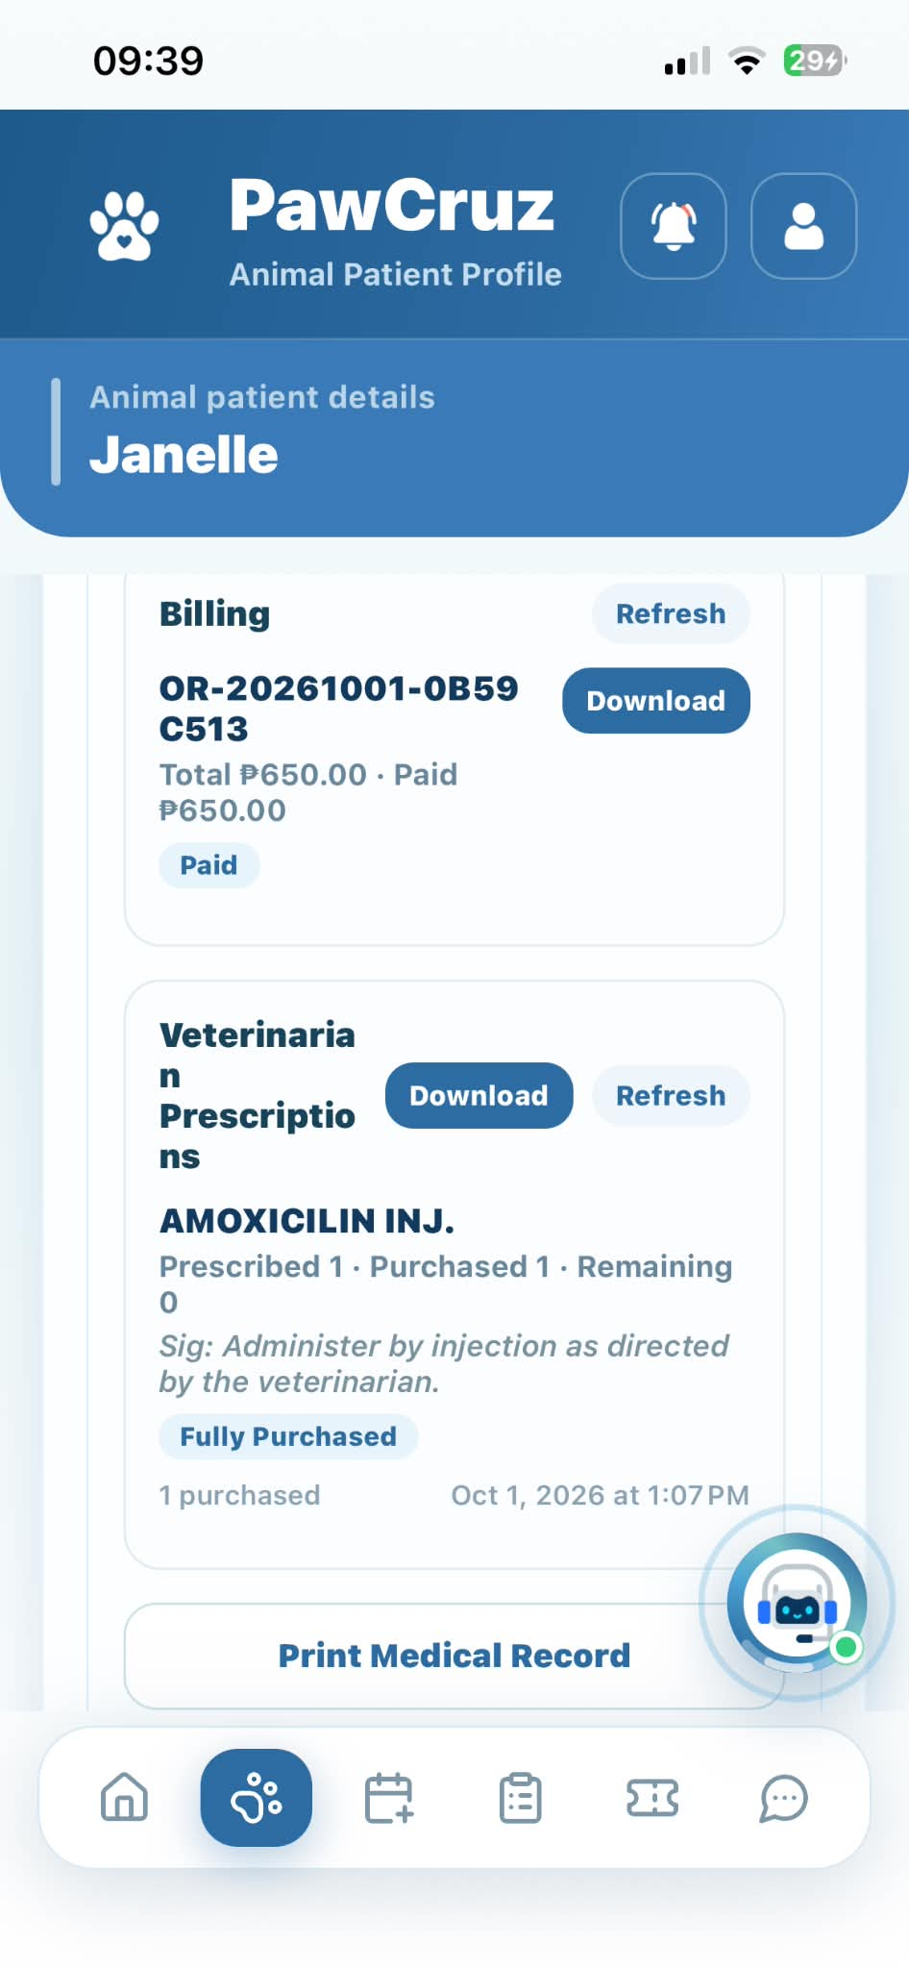 |  | PASSED
Animal Patients | Tap "AI Predictive Health" tab on pet profile | Displays summary of AI-generated health findings |  | 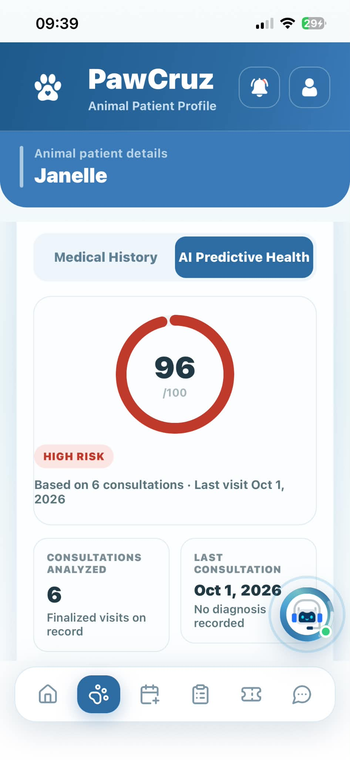 |  | PASSED
Animal Patients | Tap "Download" button in Billing section | Previews file to confirm download |  | 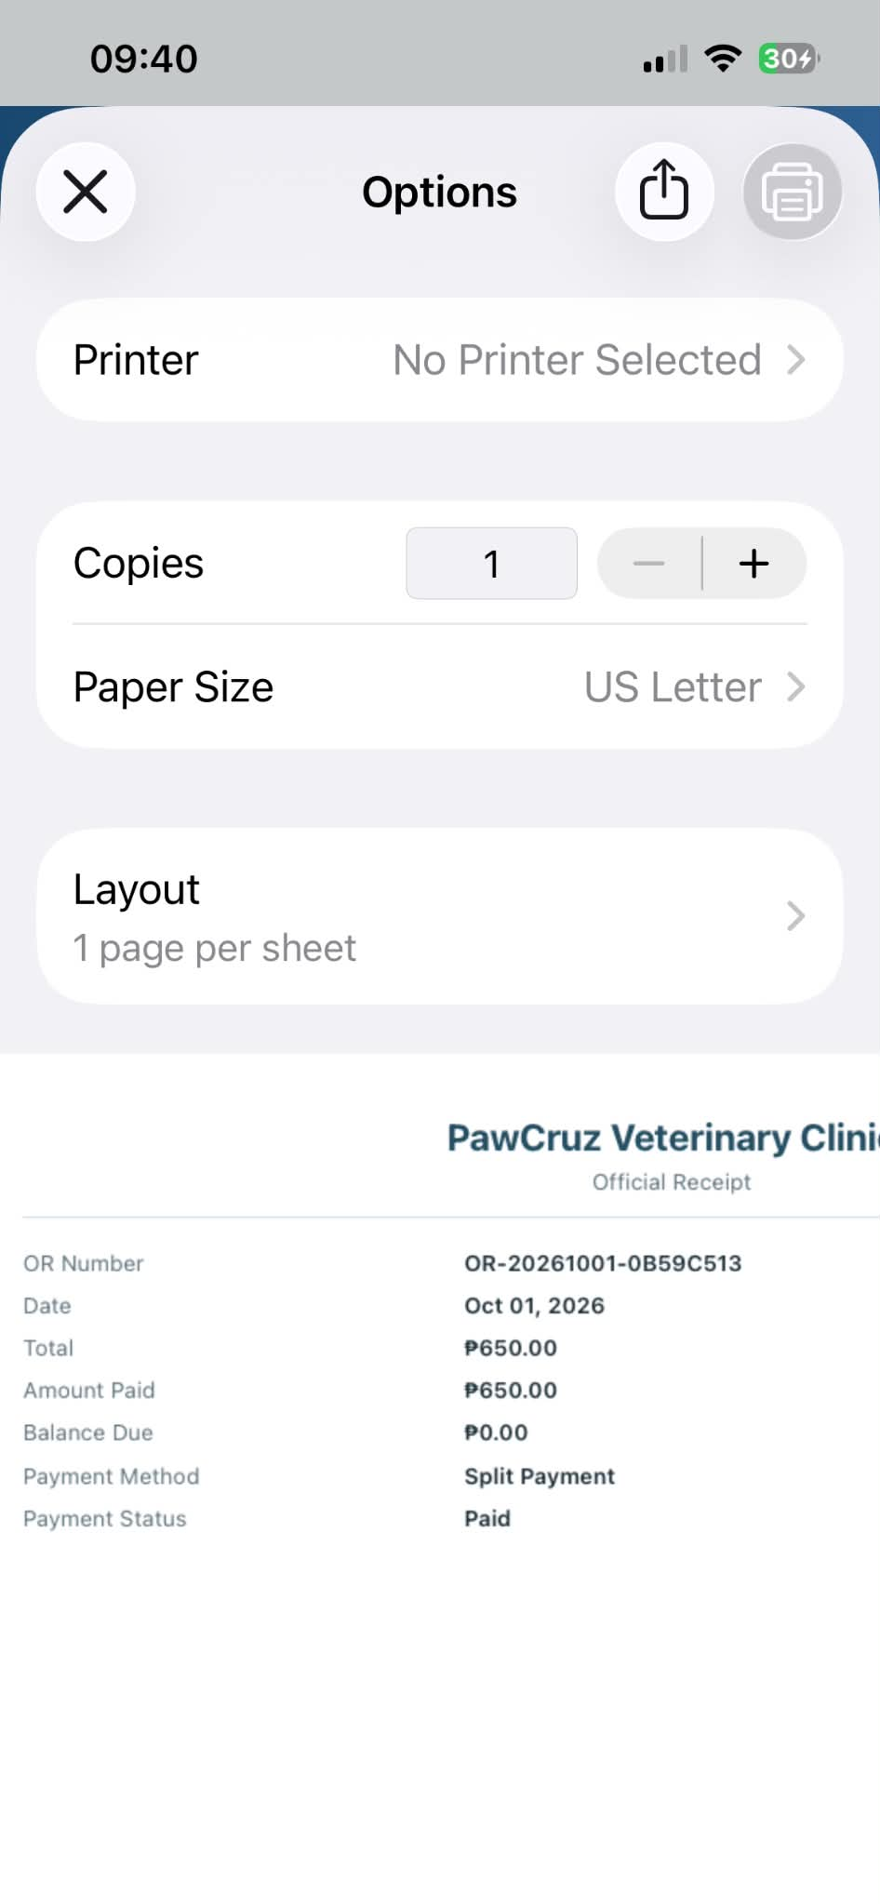 |  | PASSED
Animal Patients | Tap "Download" button on previewed billing file | Downloads file to device as PDF |  | 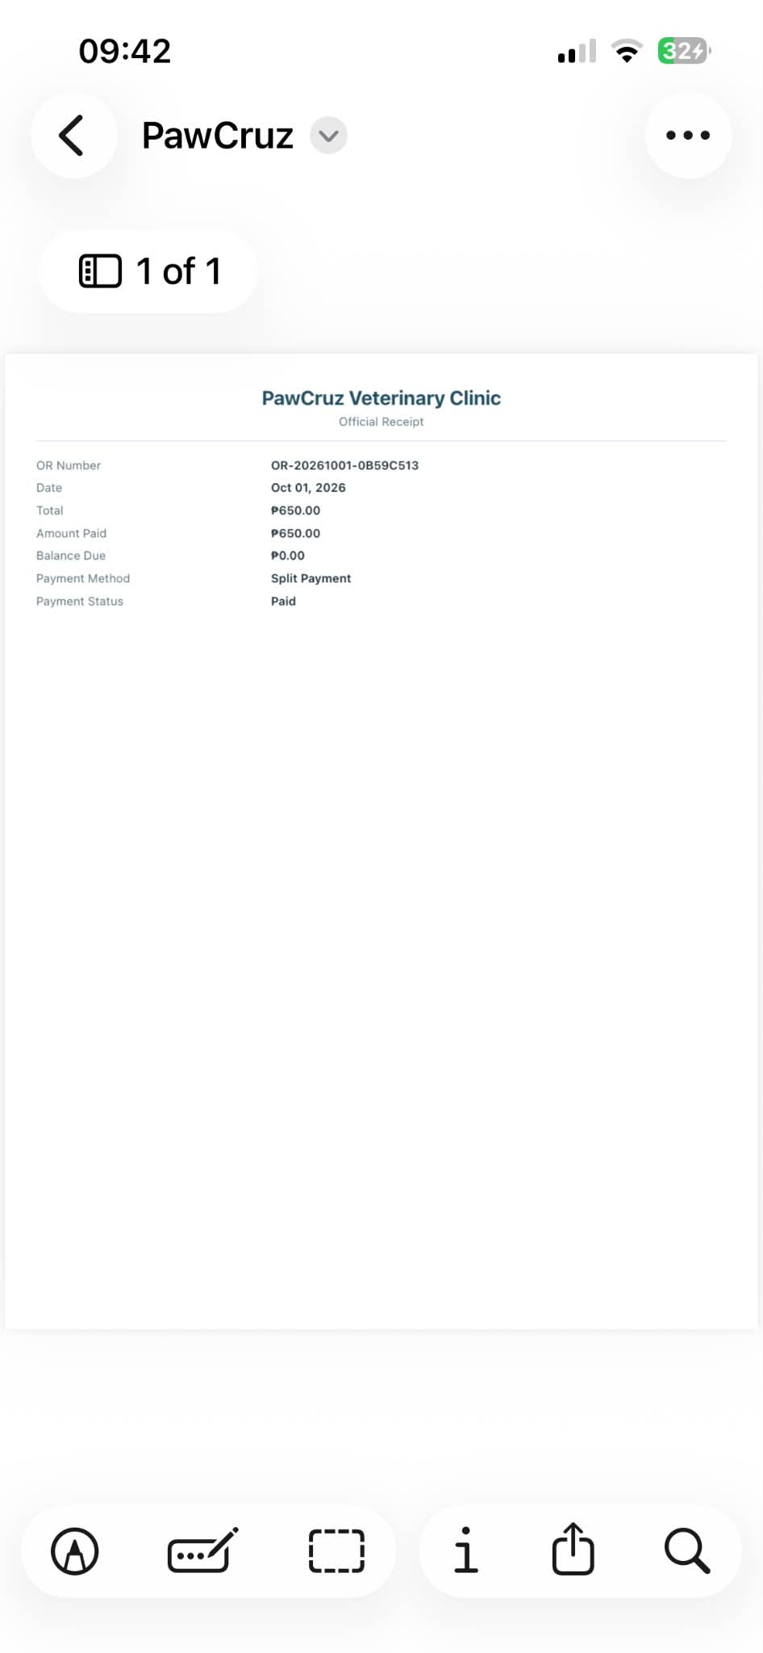 |  | PASSED
Animal Patients | Tap "View" button under prescription record | Previews file prior to printing |  | 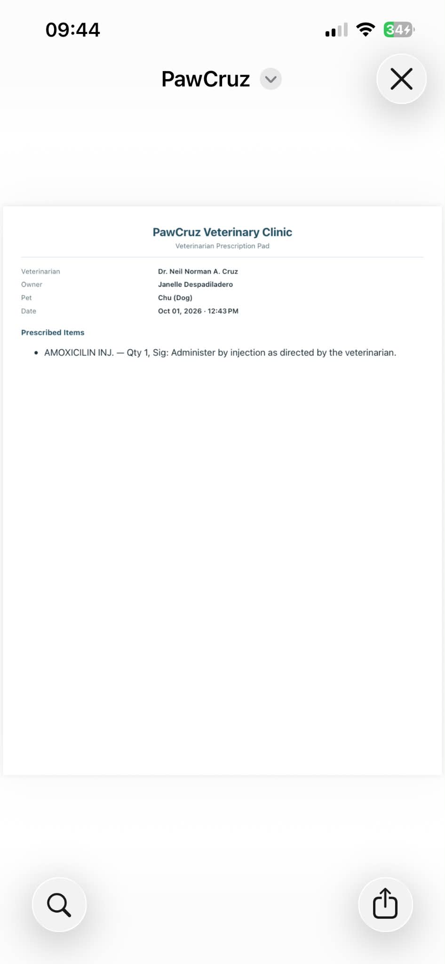 |  | PASSED
Animal Patients | Tap "Print" button on previewed prescription | Redirects to system print menu |  | 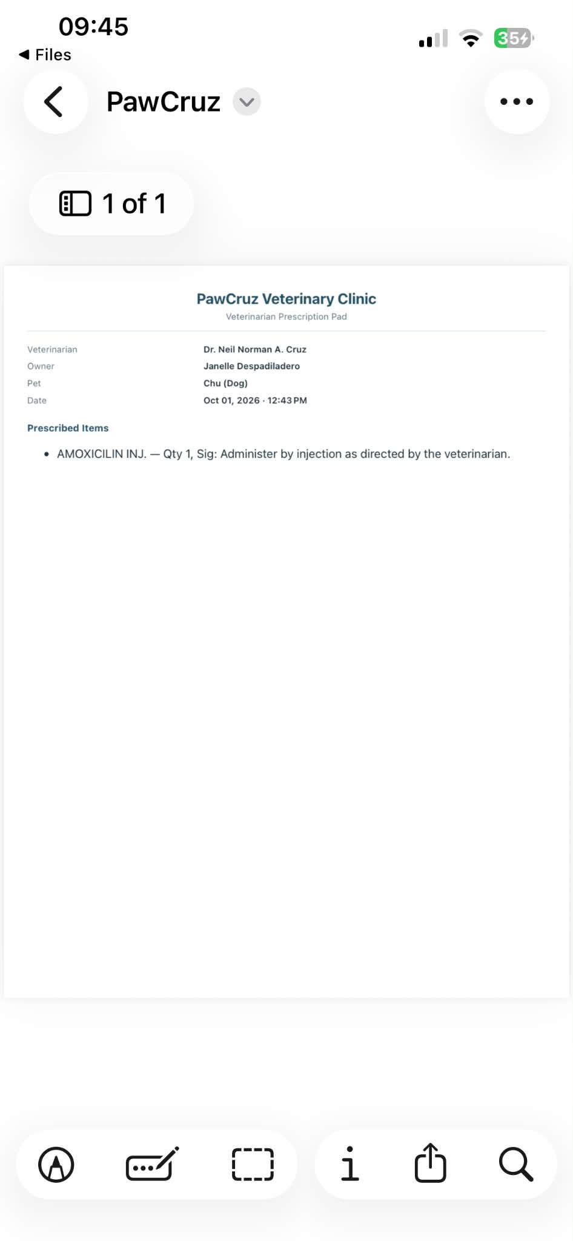 |  | PASSED
Animal Patients | Tap "Print Medical Record" button | Previews full medical record file prior to printing |  | 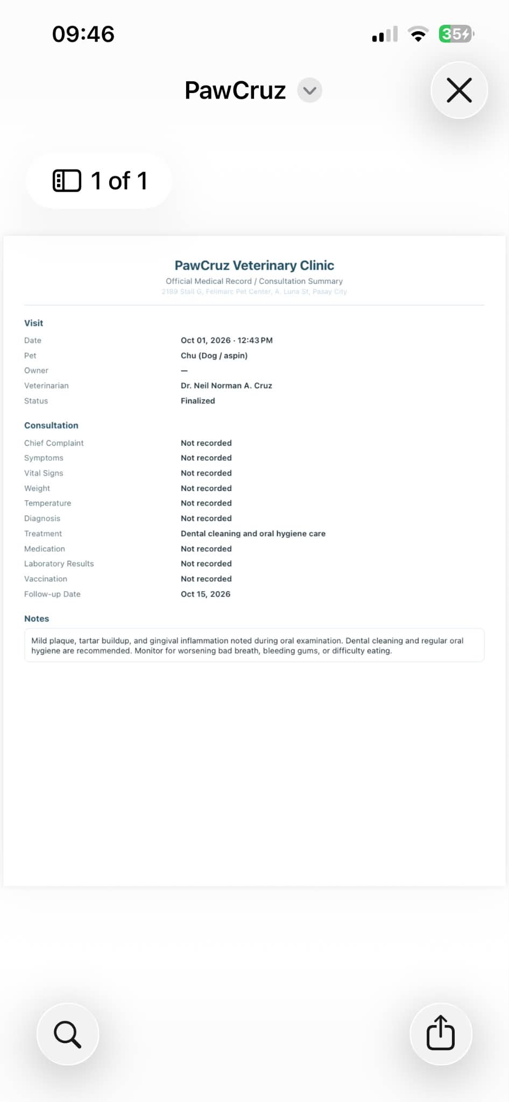 |  | PASSED
Animal Patients | Tap "Print" button on previewed Medical Record | Redirects to system print menu |  | 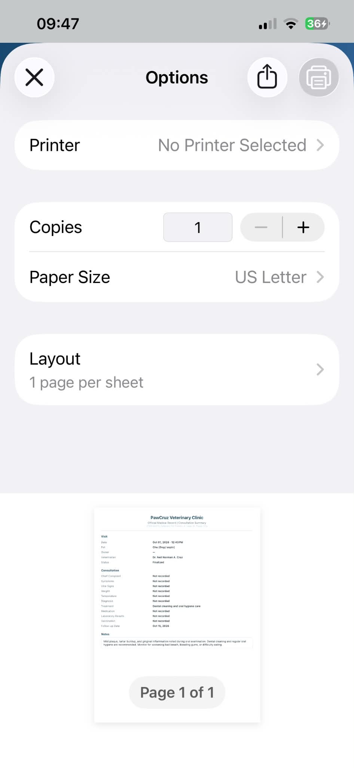 |  | PASSED
Animal Patients | Tap "Edit" icon/button on pet profile | Displays Edit Pet Record form |  | 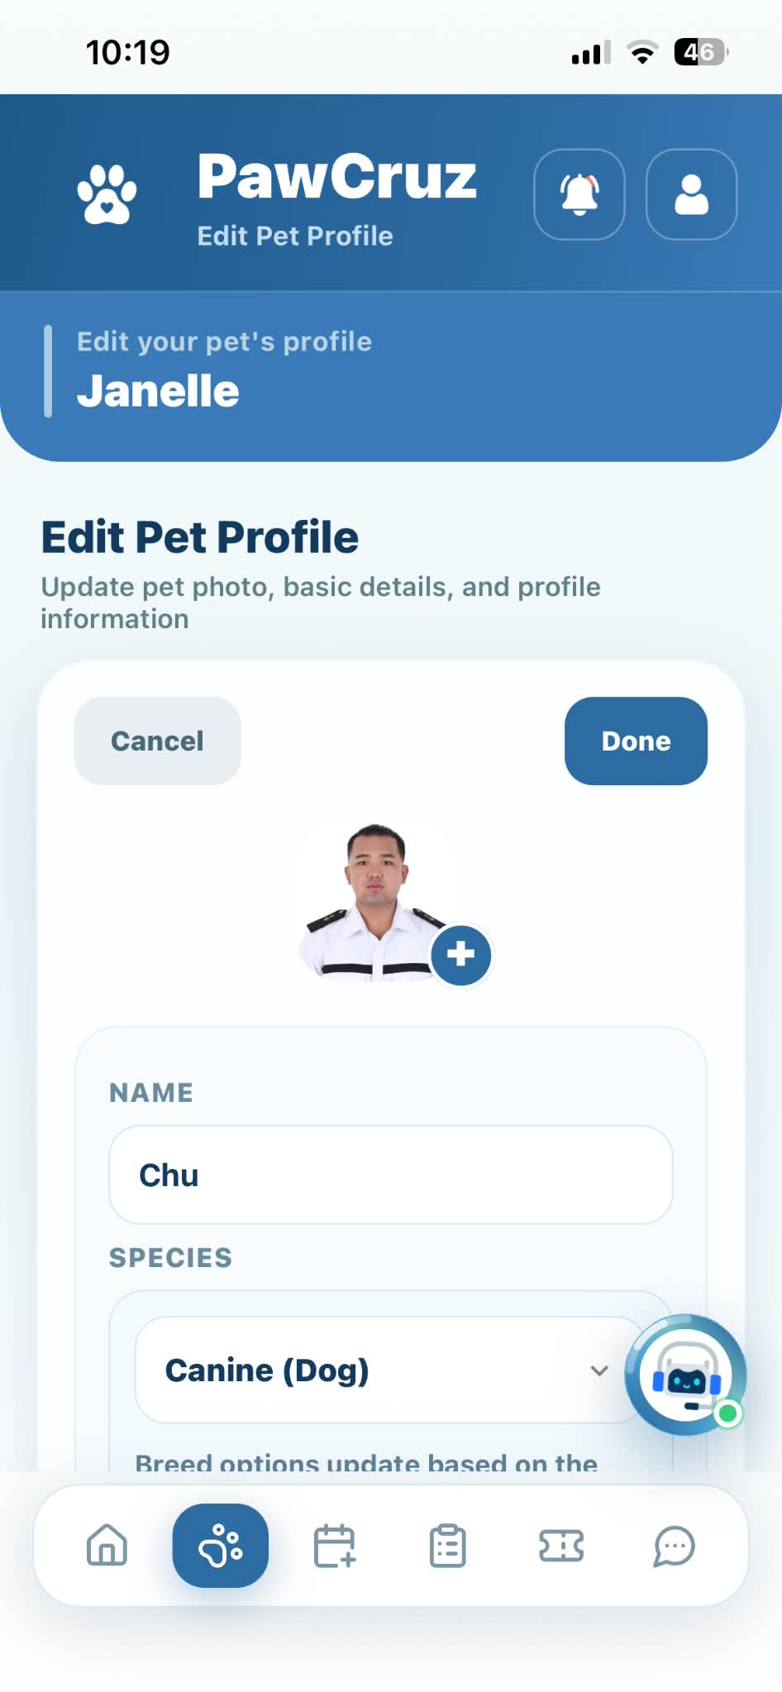 |  | PASSED
Animal Patients | Update info and tap "Update Pet" button | Saves changes and updates selected pet record |  | 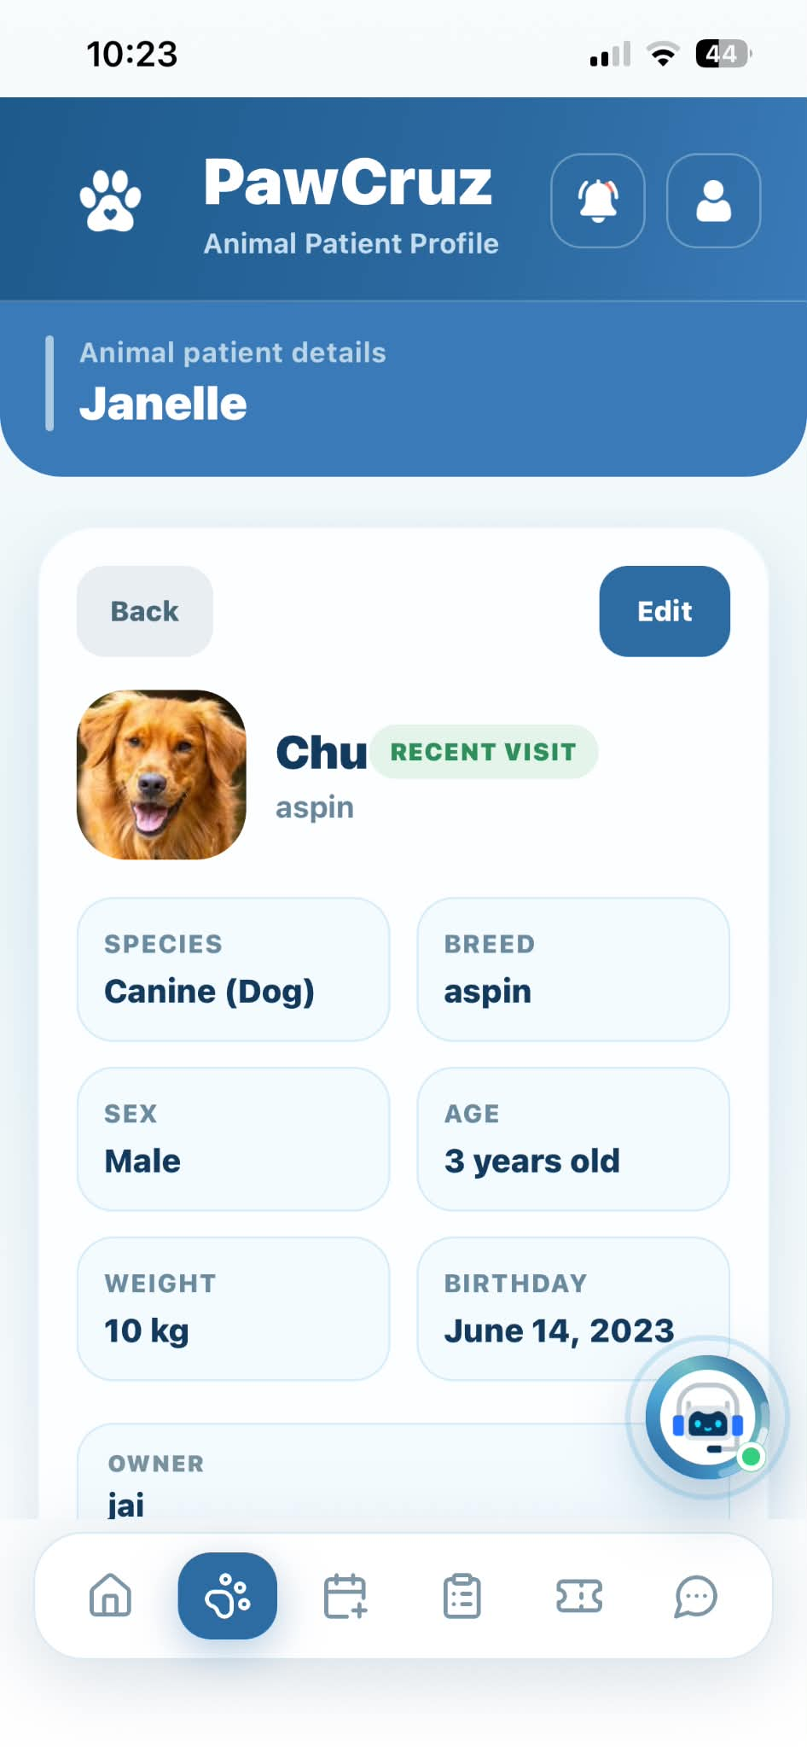 |  | PASSED
Animal Patients | Tap camera icon on pet photo | Opens file picker to select pet photo |  | 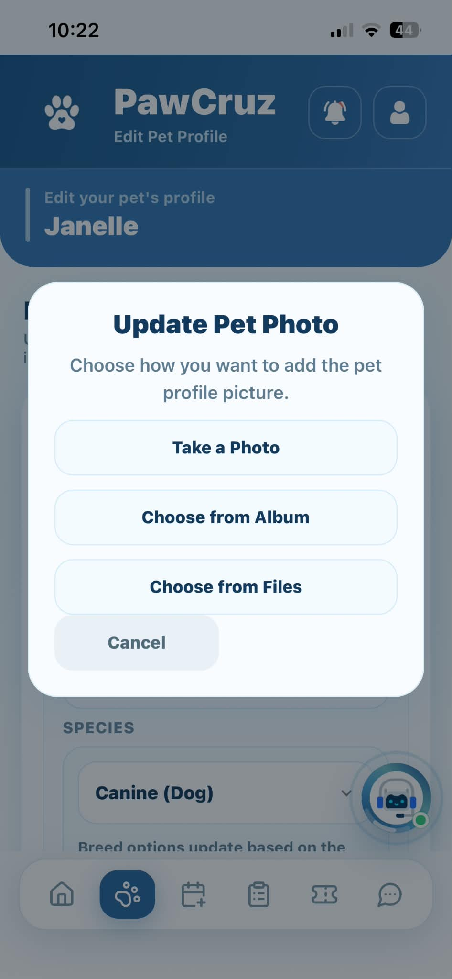 |  | PASSED
Animal Patients | Tap "No" / "Cancel" on archive modal | Cancels action and returns to pet list |  | 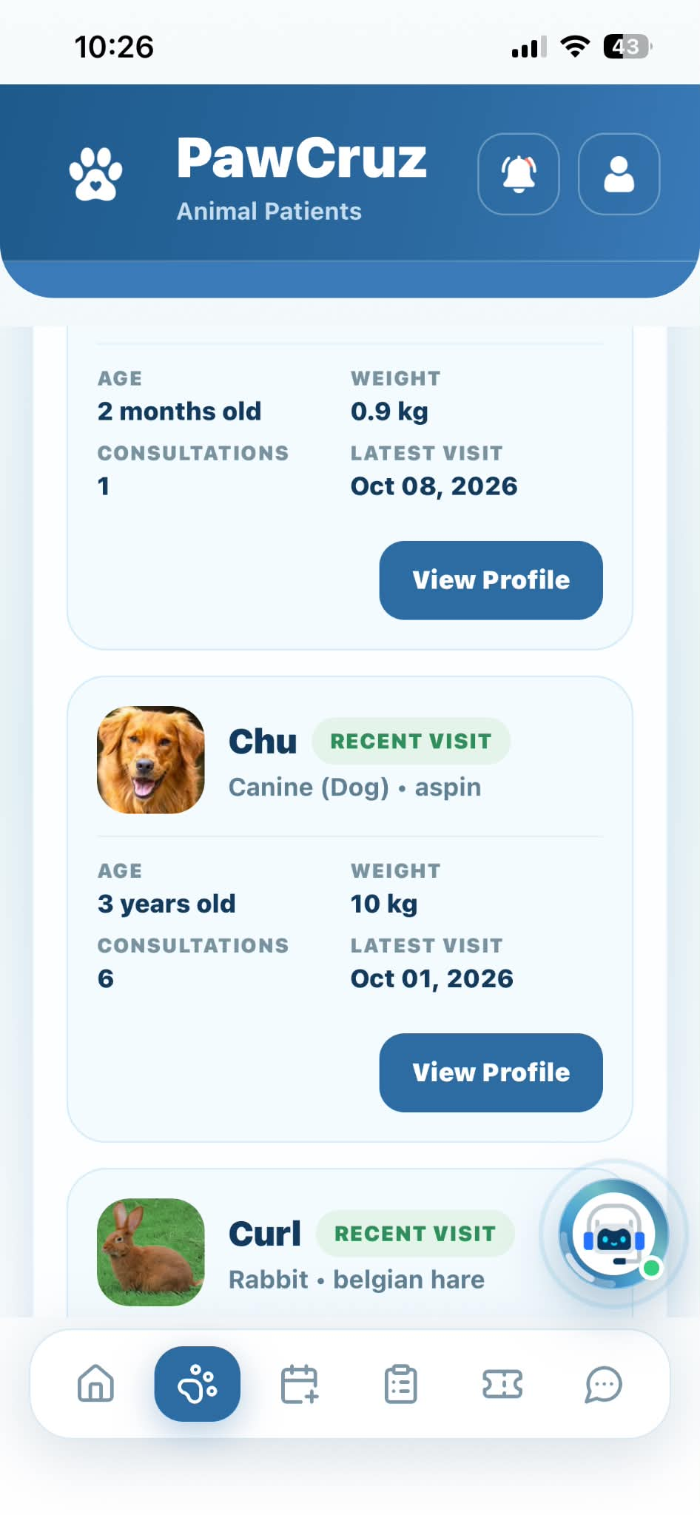 |  | PASSED
Animal Patients | Tap "Yes, Archive" on archive modal | Archives pet and removes record from active list |  | 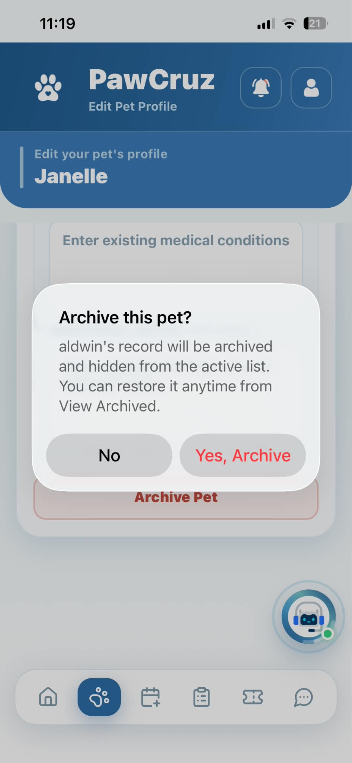 |  | PASSED
Animal Patients | Tap "View Archive" button | Displays list of archived pets |  | 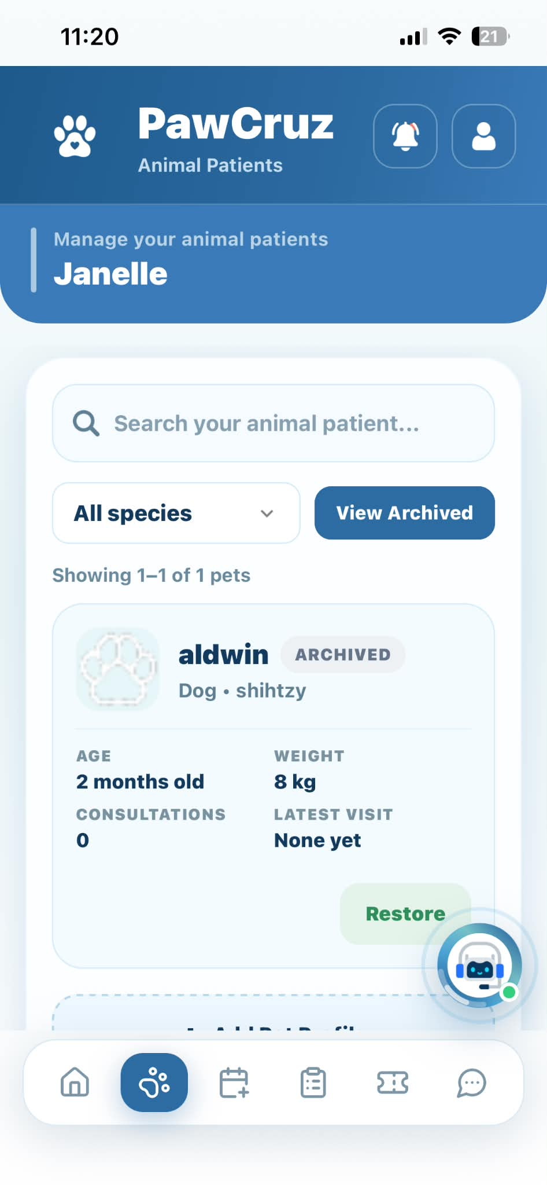 |  | PASSED
Animal Patients | Tap "Restore" icon on archived pet | Restores pet back to active Animal Patients list |  | 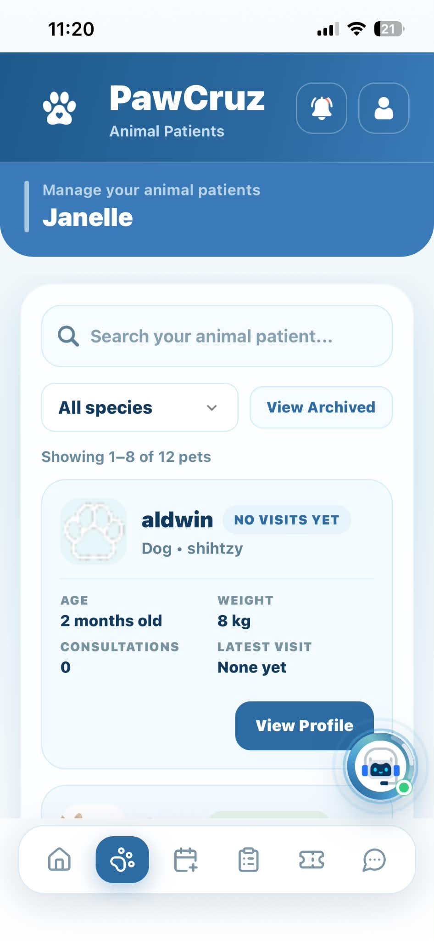 |  | PASSED
Animal Patients | Tap "All species" dropdown | Filters and displays species options |  | 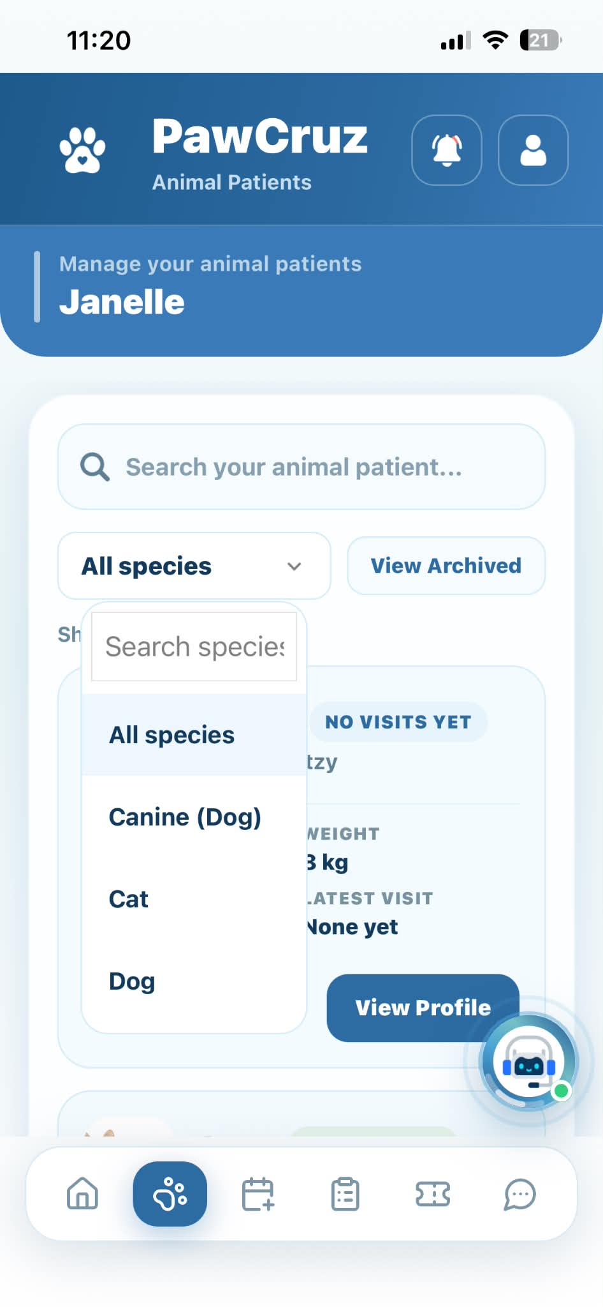 |  | PASSED
Book Appointment | Tap "Pet" dropdown and select pet | Displays registered pets and sets chosen pet for booking |  | 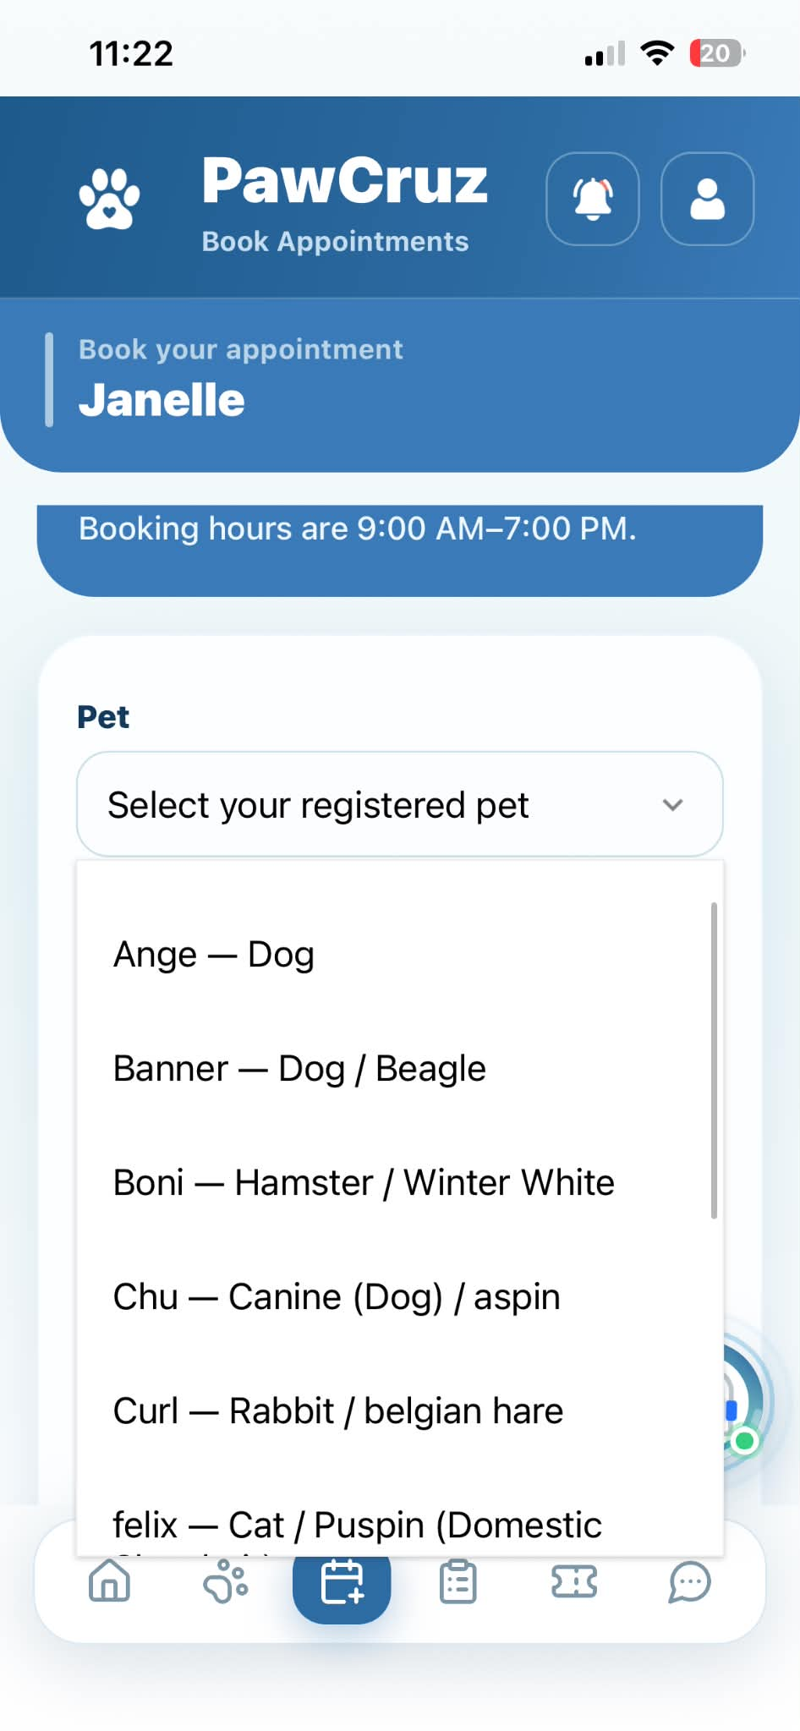 |  | PASSED
Book Appointment | Tap "Add Pet" button | Displays Pet Registration form |  | 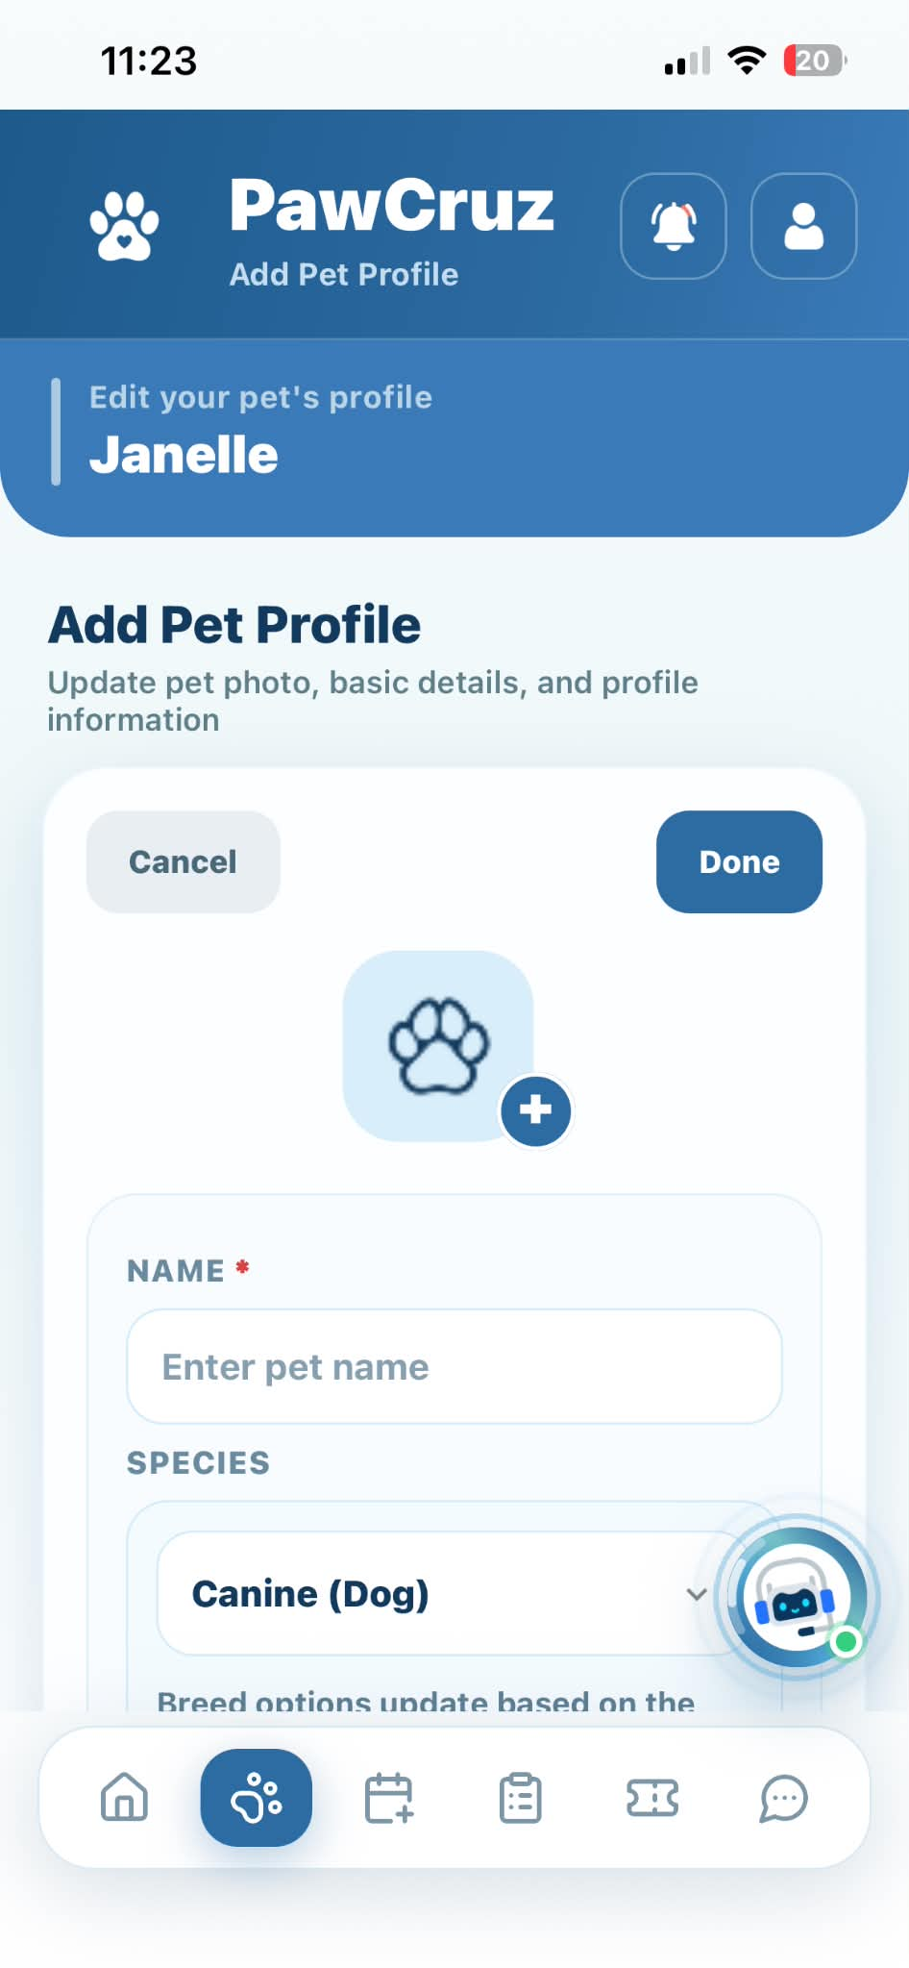 |  | PASSED
Book Appointment | Tap "Register Pet" under form | Registers new pet and auto-selects it for booking |  | 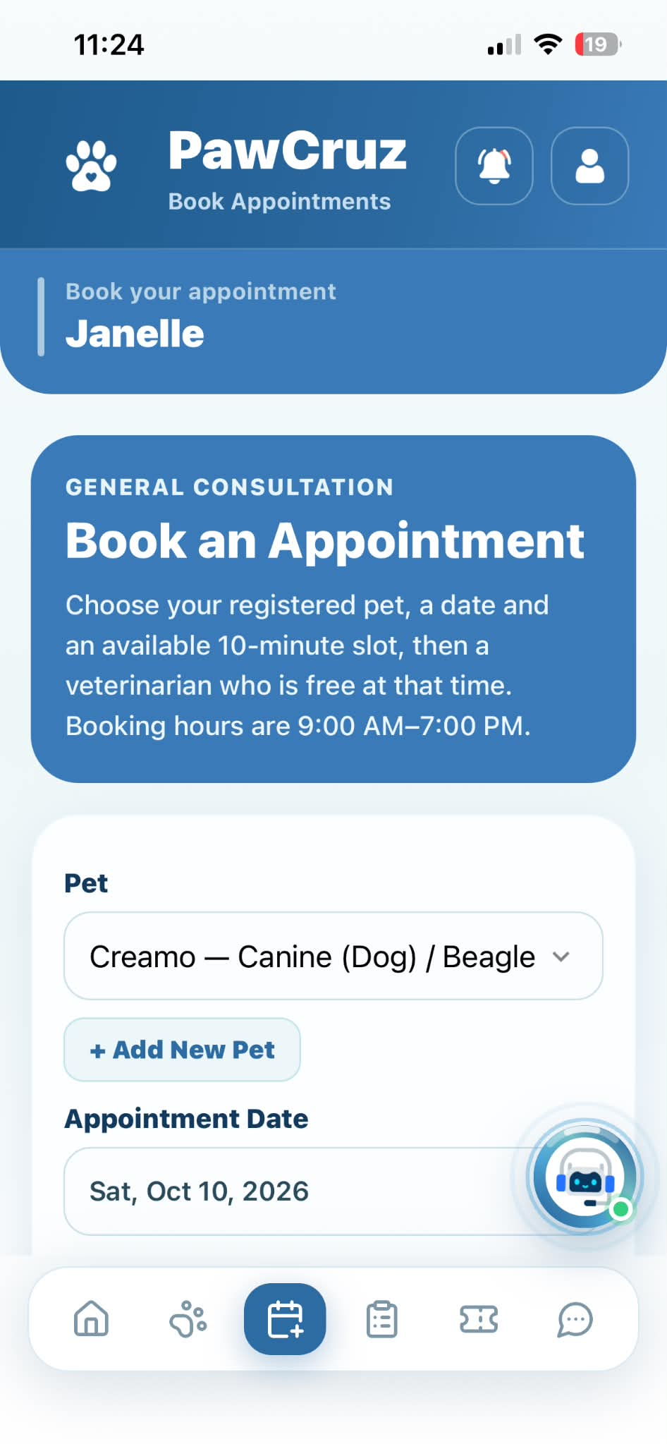 |  | PASSED
Book Appointment | Tap "Appointment Date" field and pick date | Displays selected date in field |  | 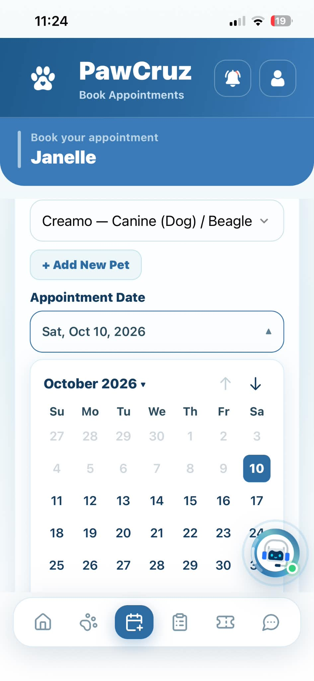 |  | PASSED
Book Appointment | Tap "Select Time" field and pick time slot | Displays selected time slot in field |  | 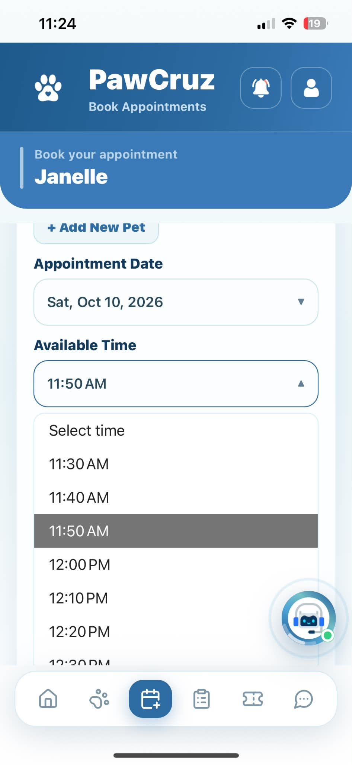 |  | PASSED
Book Appointment | Tap "Select Veterinarian" dropdown | Displays available veterinarians for selected time |  | 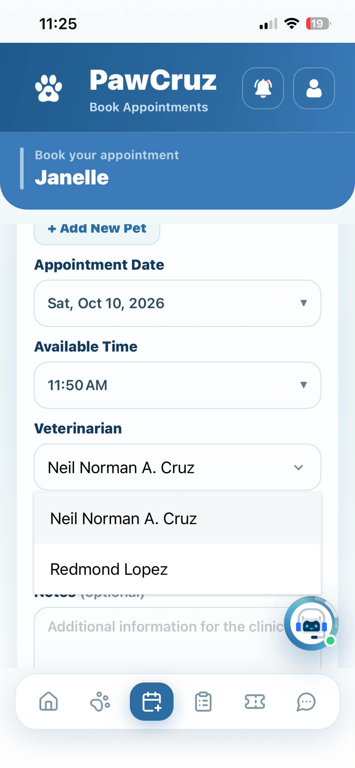 |  | PASSED
Book Appointment | Tap "Book Appointment" button | Creates appointment and displays confirmation toast |  | 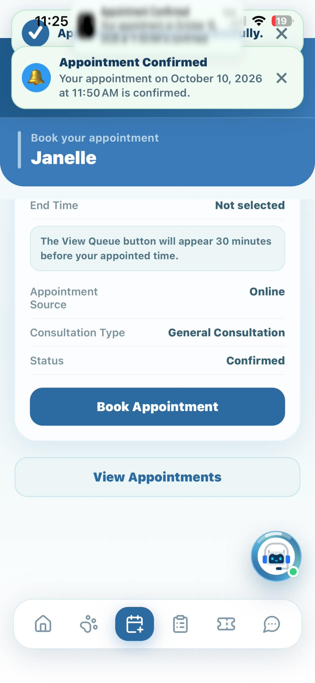 |  | PASSED
Appointments | Tap "Cancel" button on eligible appointment | Displays confirmation modal to keep or cancel appointment |  | 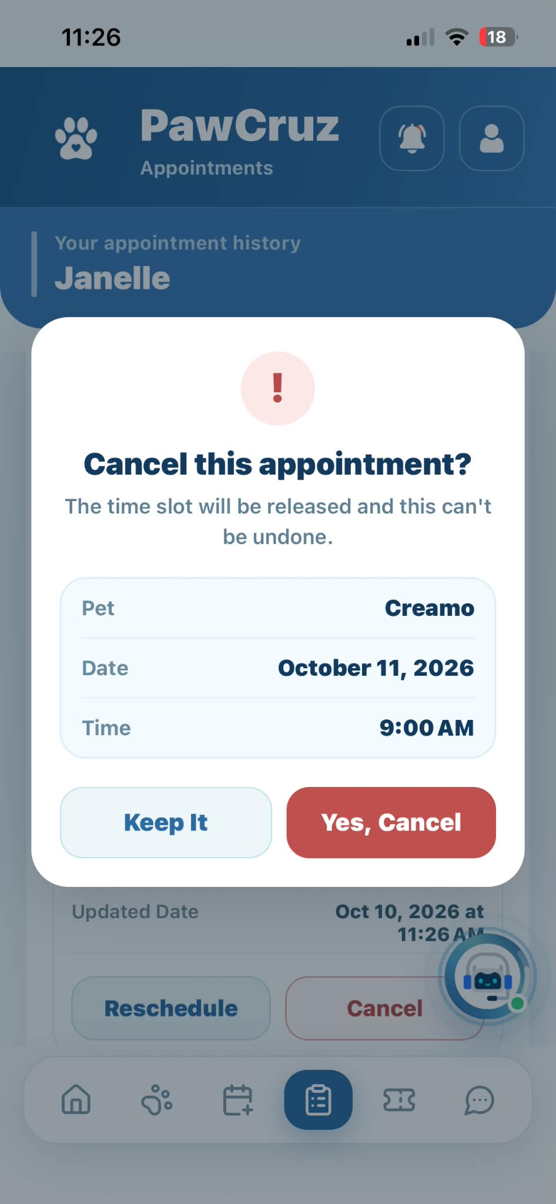 |  | PASSED
Appointments | Tap "Keep Appointment" in confirmation dialog | Closes dialog and maintains appointment status |  |  |  | PASSED
Appointments | Tap "Yes, Cancel Appointment" in confirmation dialog | Cancels appointment and updates status list |  | 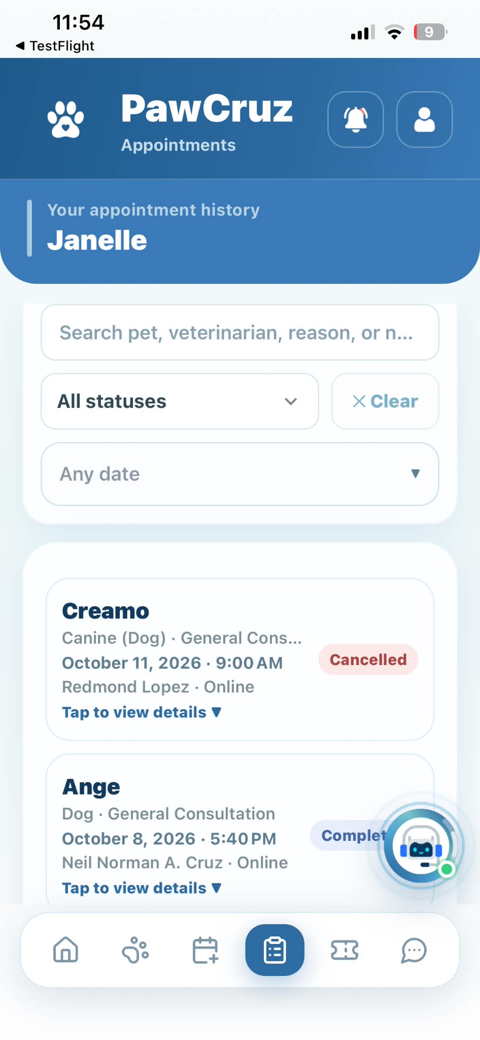 |  | PASSED
Appointments | Scroll / Tap "Next" button at bottom of list | Displays next paginated appointment history list |  | 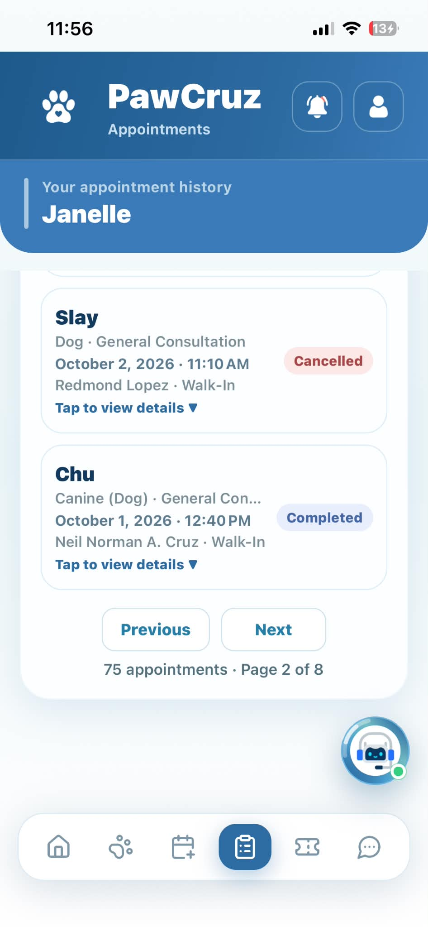 |  | PASSED
Appointments | Scroll / Tap "Previous" button at bottom of list | Displays previous paginated appointment history list |  | 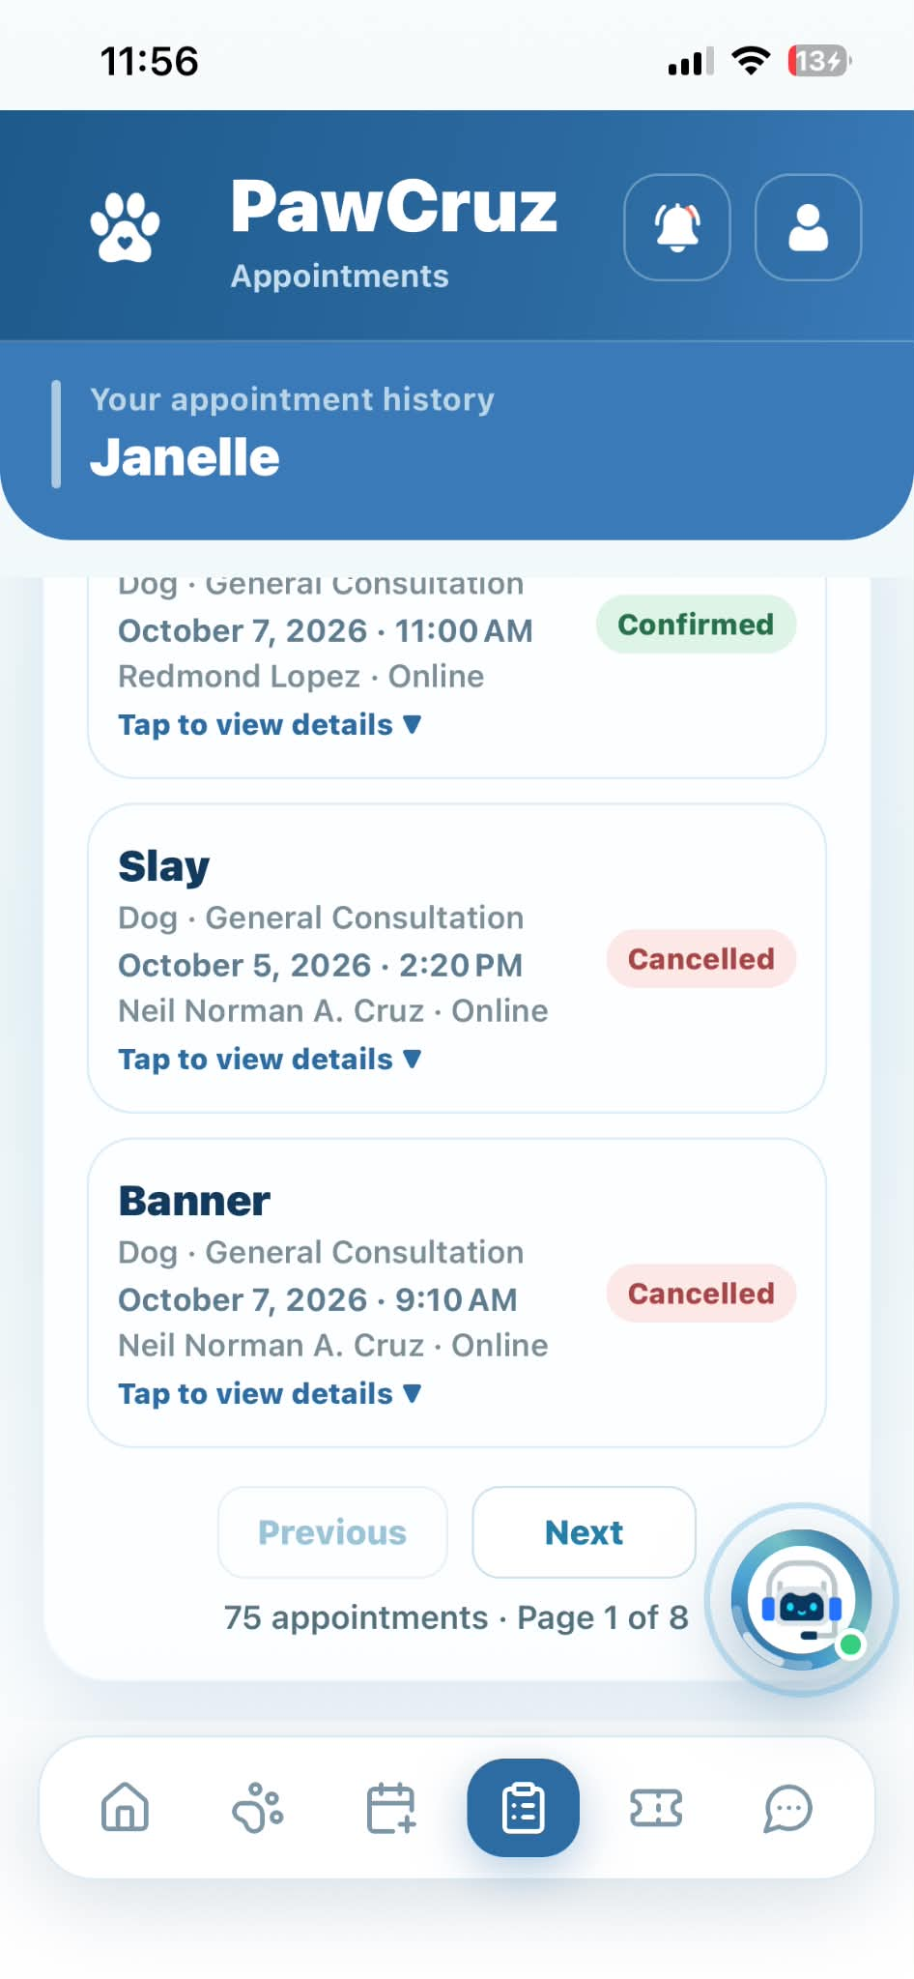 |  | PASSED
Queue | Tap "Refresh Queue Number" button | Refreshes and updates queue status |  | 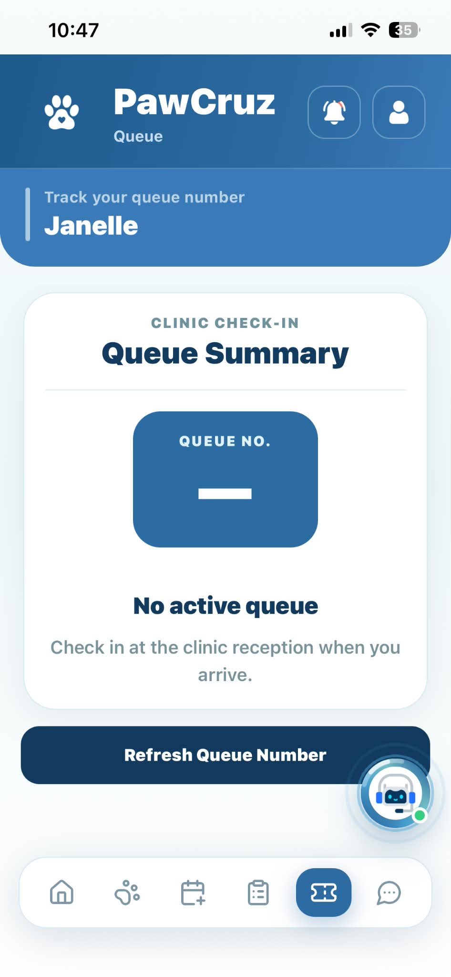 |  | PASSED
Messages | Tap "+" / "Add sign" button | Opens New Conversation dialog |  | 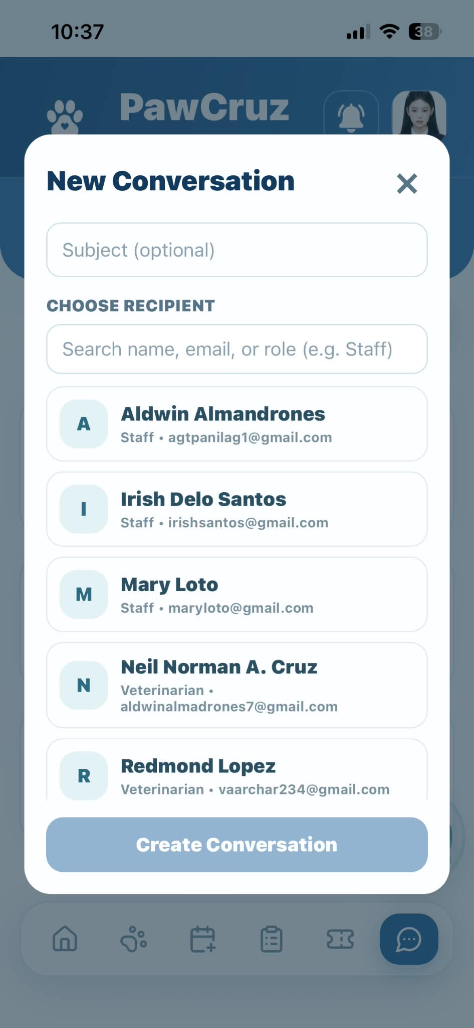 |  | PASSED
Messages | Tap "x" / close button on modal | Closes conversation dialog |  | 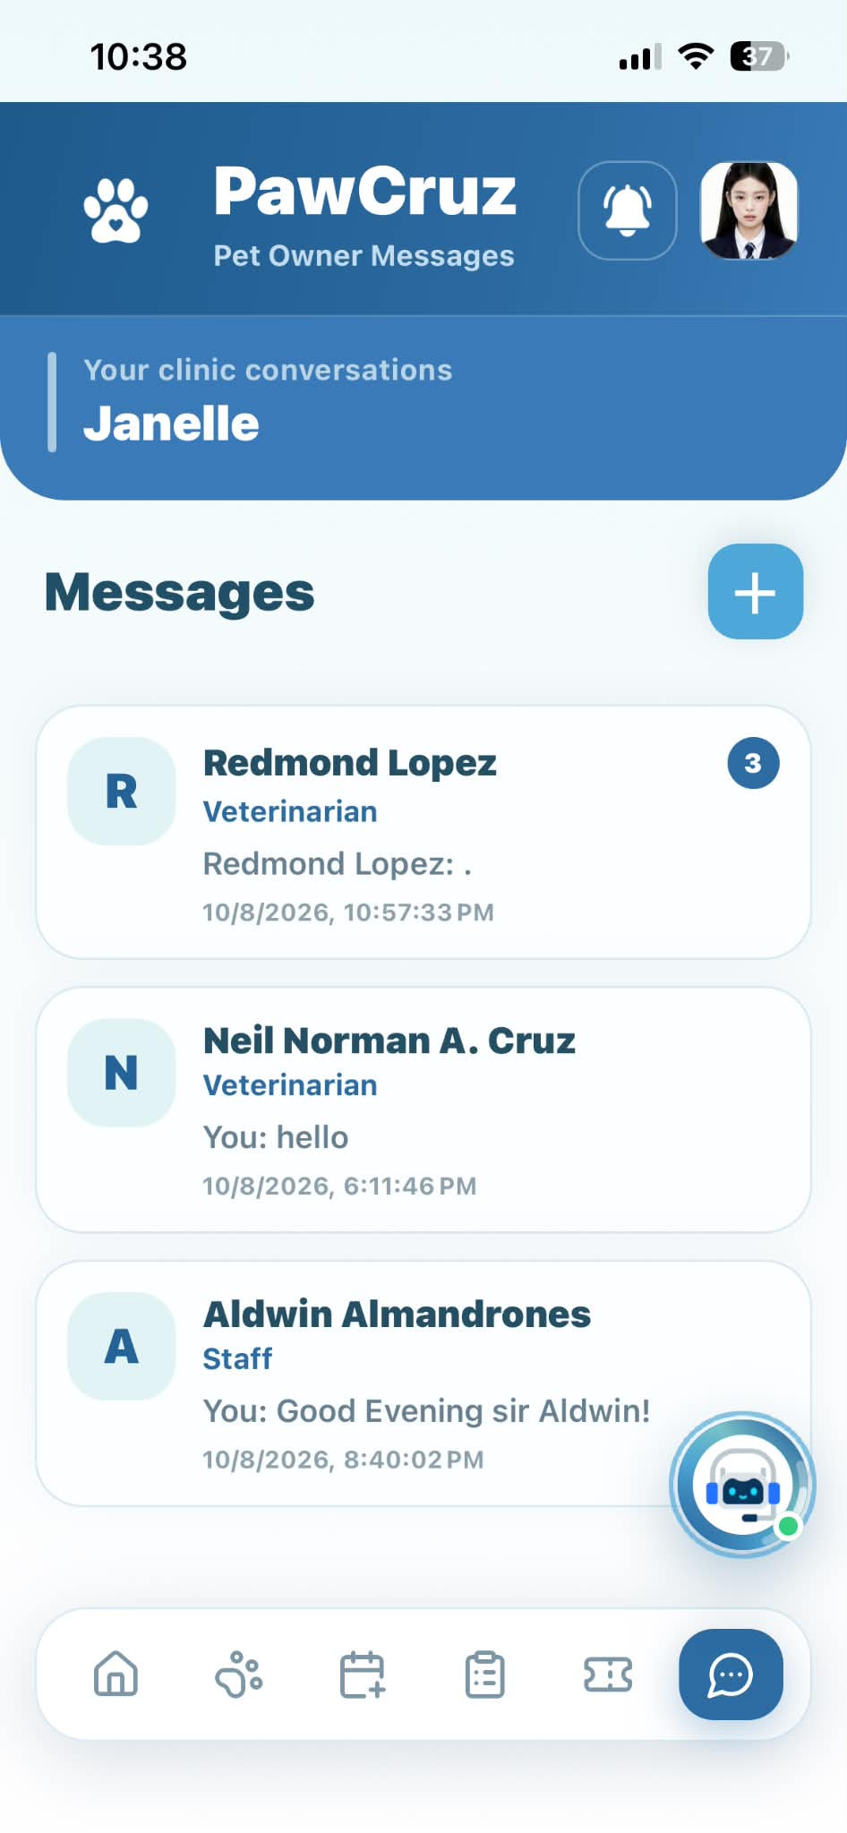 |  | PASSED
Messages | Select recipient and tap "Create Conversation" | Opens direct messaging thread with selected user |  | 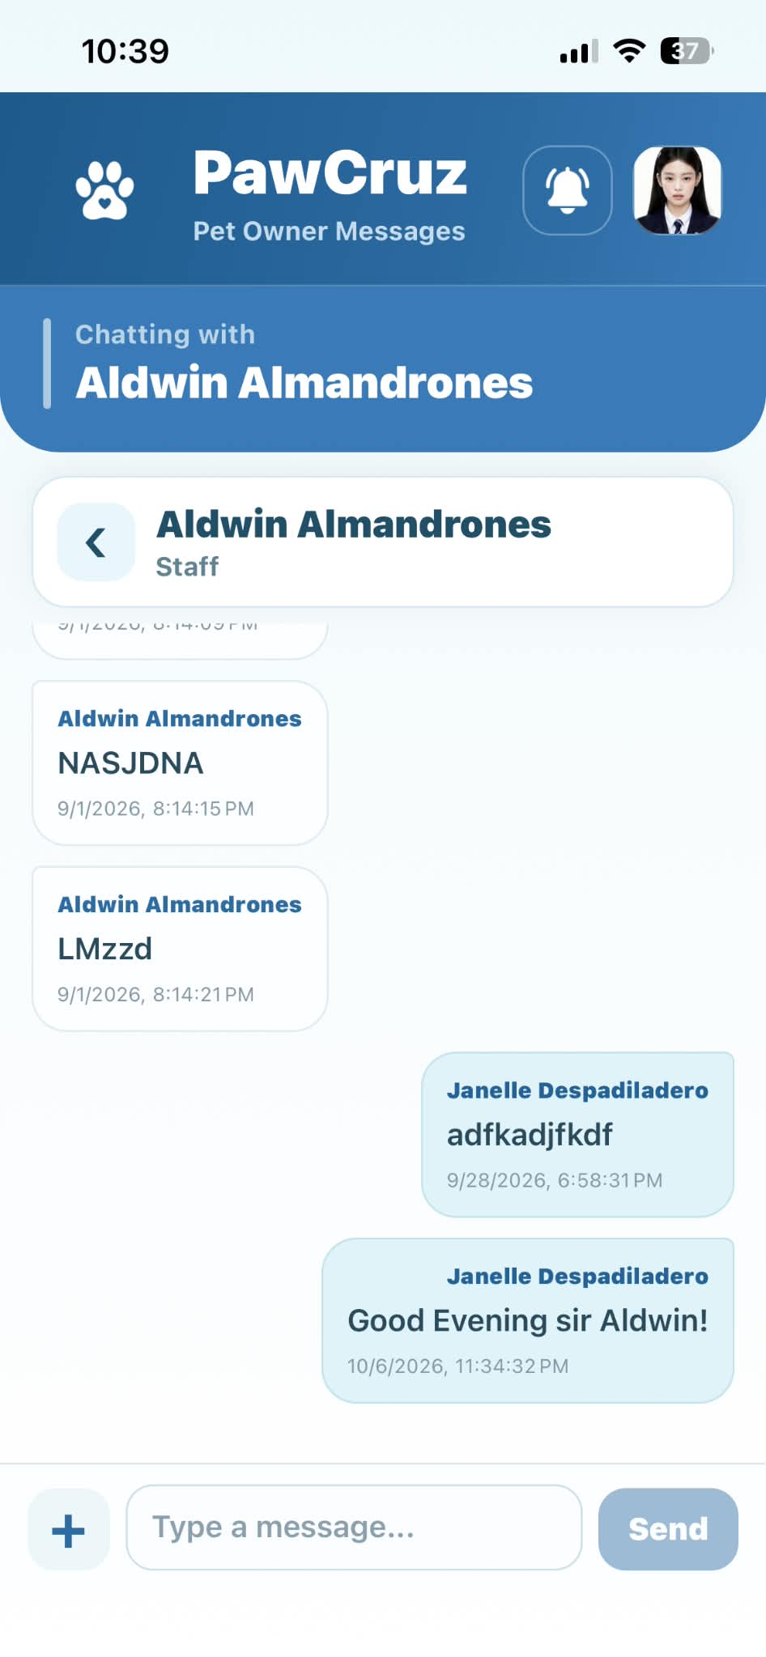 |  | PASSED
Messages | Tap "attachment paperclip" icon | Opens file selection option to attach image/file |  | 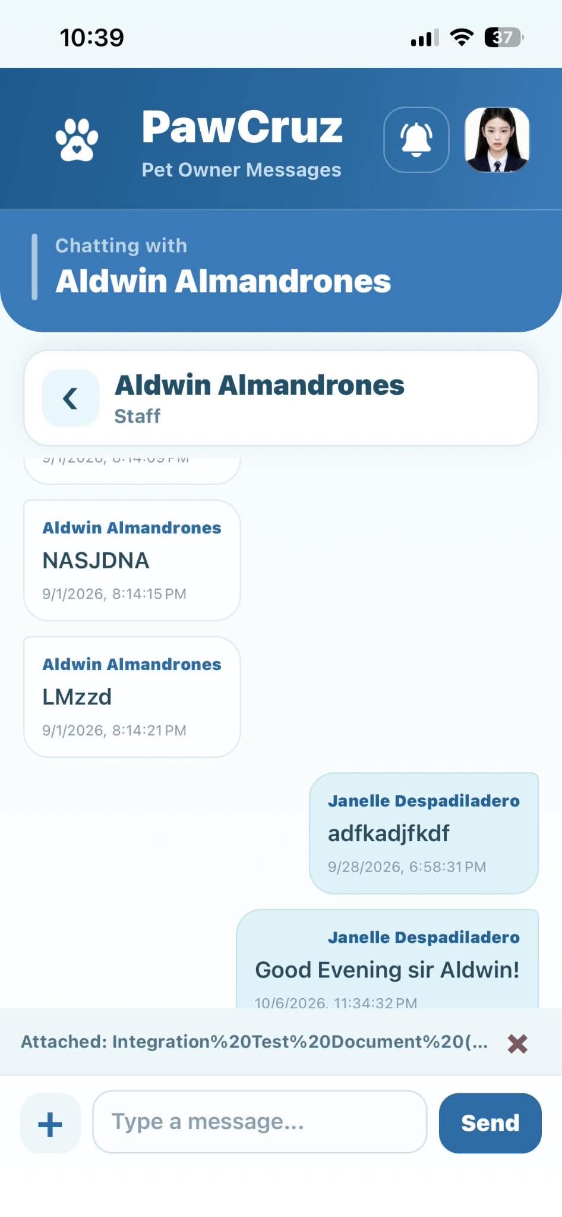 |  | PASSED
Messages | Enter message and tap "Send" icon | Sends message and displays it in chat conversation |  | 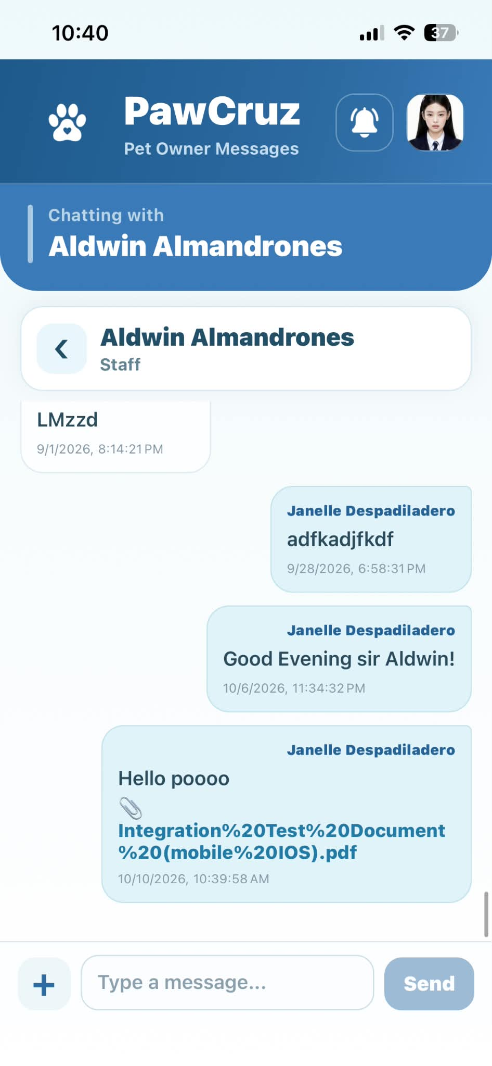 |  | PASSED
PetCare Assistant | Tap "Question About" dropdown and select pet | Selects specific pet context for AI inquiry |  | 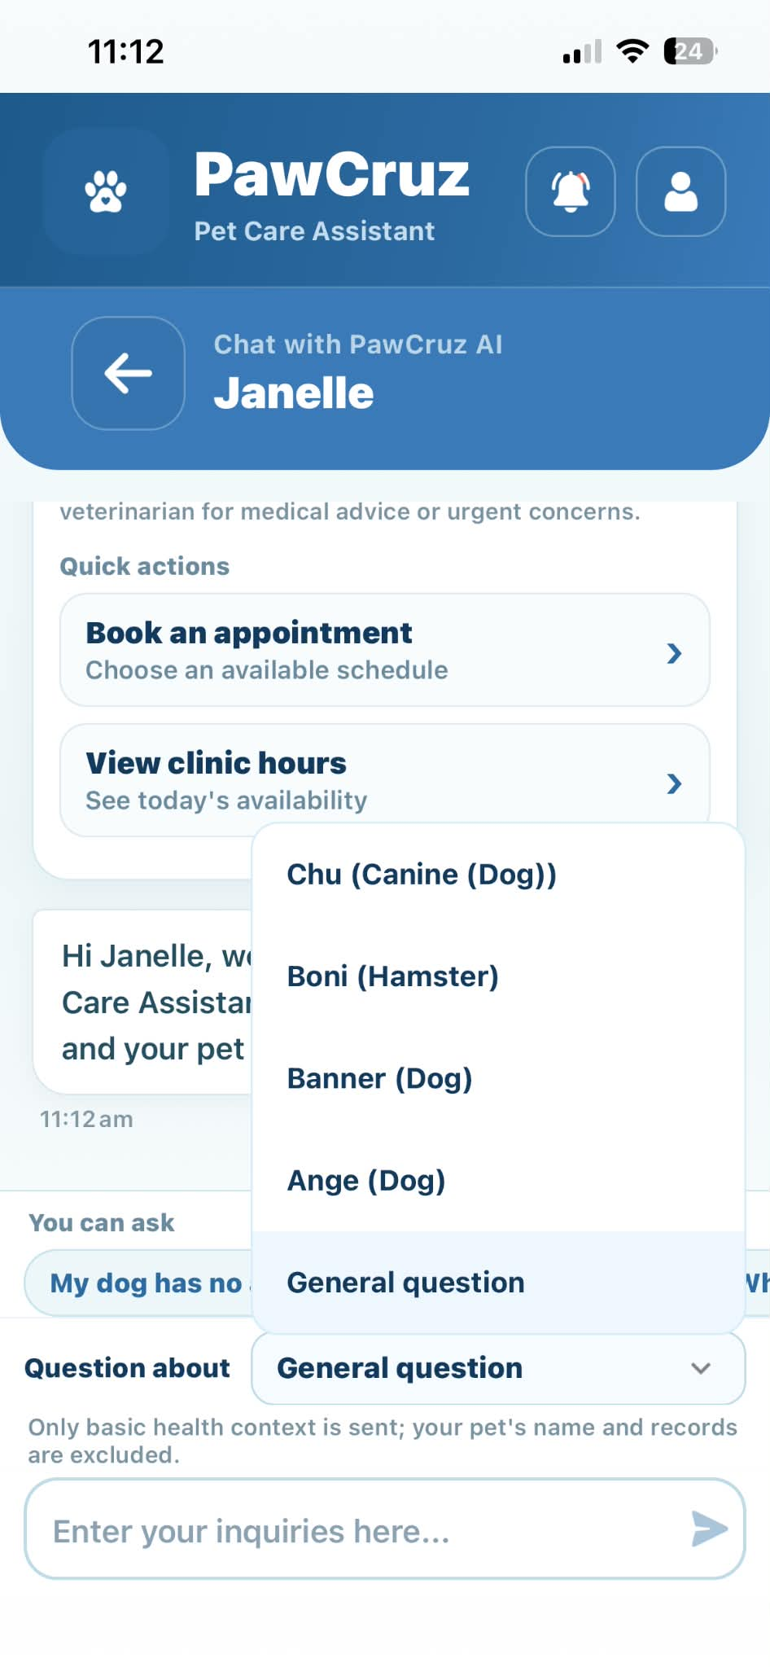 |  | PASSED
PetCare Assistant | Tap "Book an appointment" under quick actions | Redirects user to Book Appointment screen |  | 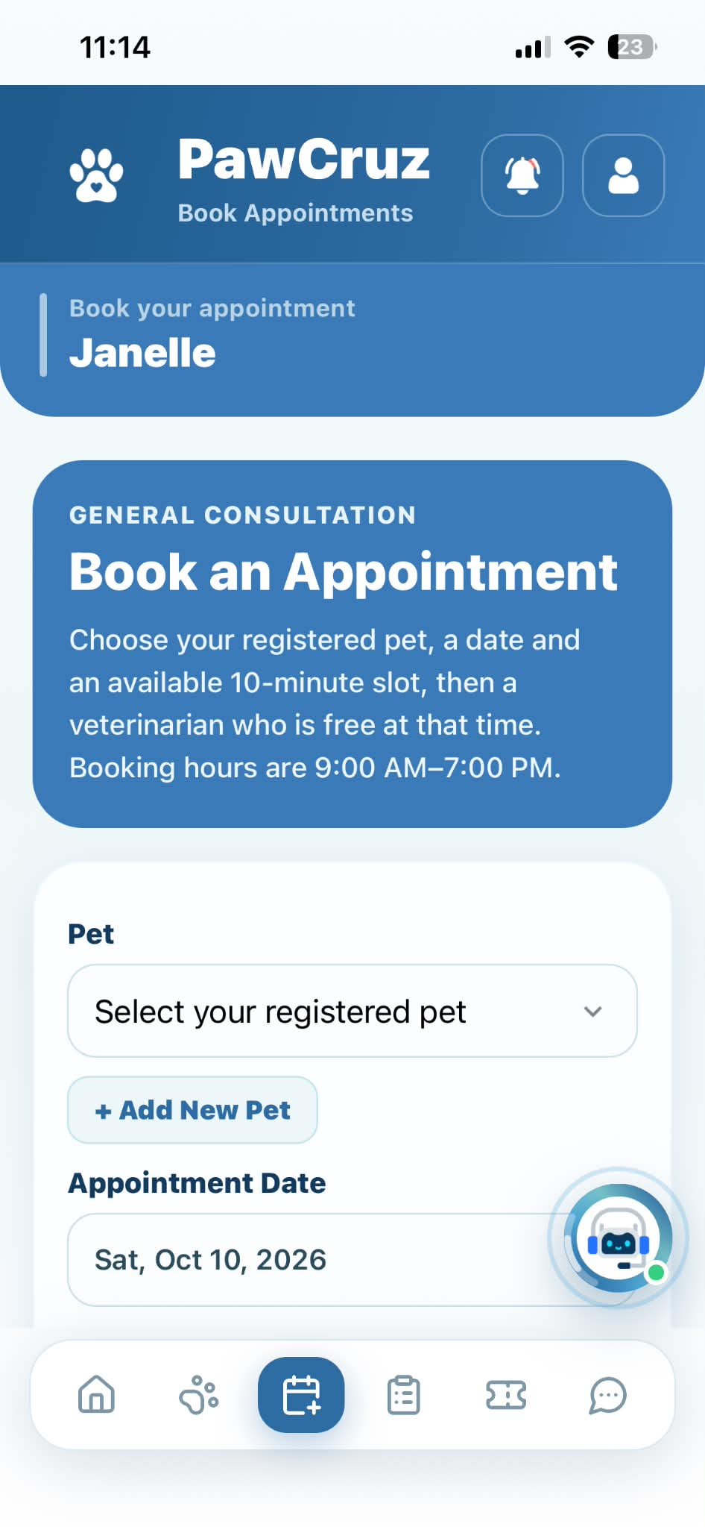 |  | PASSED
PetCare Assistant | Tap "View clinic hours" under quick actions | Displays clinic operational hours in chat |  | 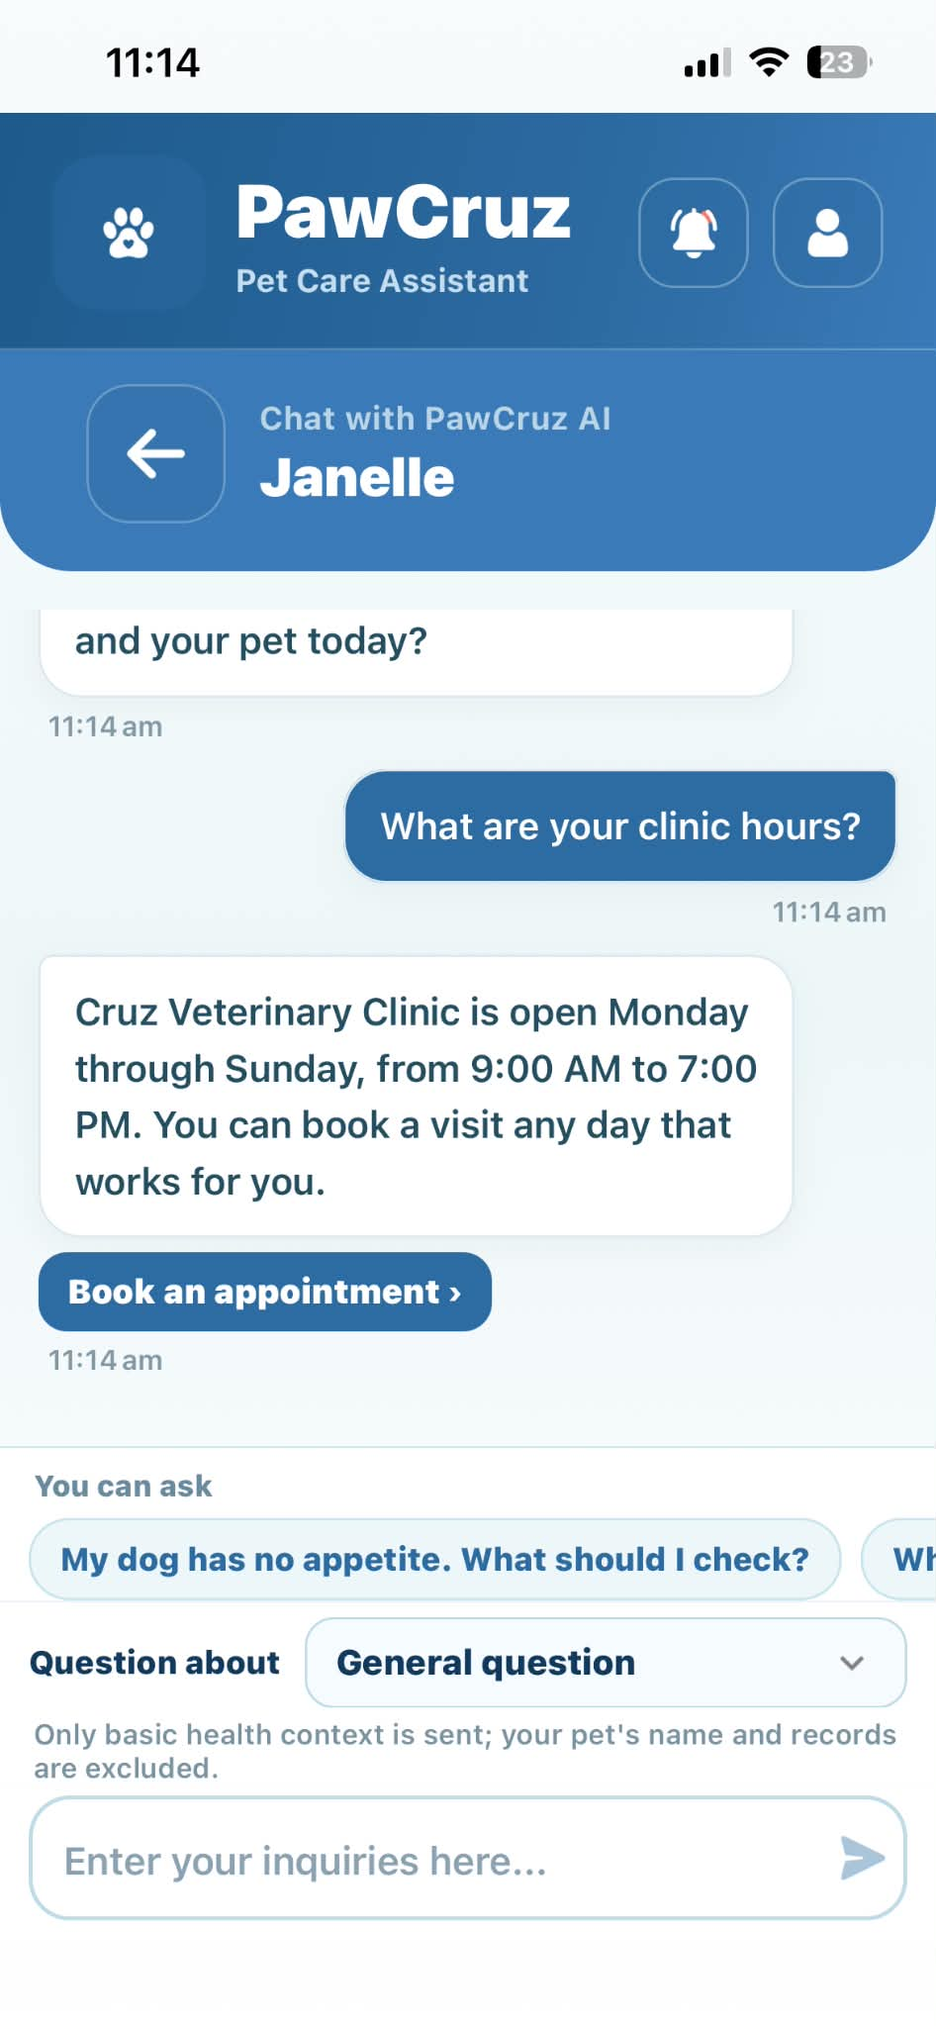 |  | PASSED
PetCare Assistant | Tap "Clear" button | Displays confirmation dialog asking to keep or clear chat |  | 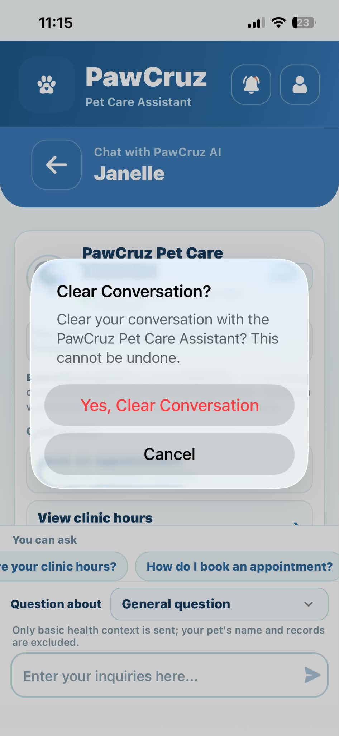 |  | PASSED
PetCare Assistant | Tap "Keep Conversation" in confirmation dialog | Closes dialog and preserves current chat |  | 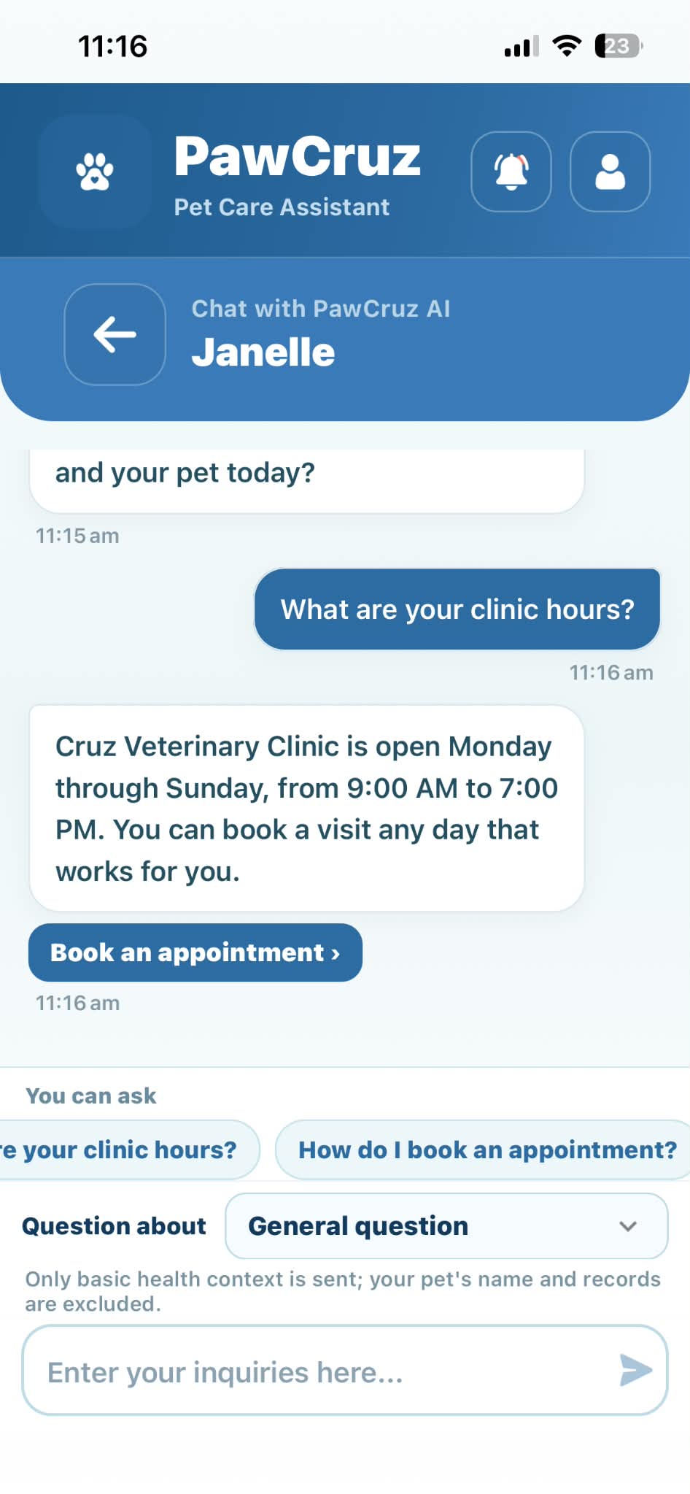 |  | PASSED
PetCare Assistant | Tap "Yes, Clear Conversation" in confirmation dialog | Clears chat window history |  | 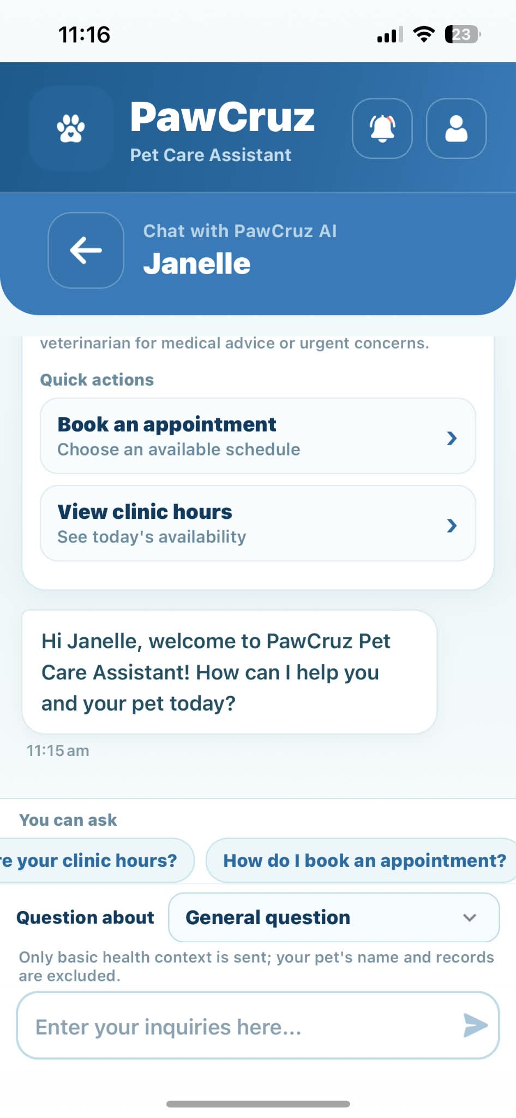 |  | PASSED

INTEGRATION TEST DOCUMENT |  |  | Application/System Name |  | PawCruz
Test Cycle No. | 5 |  | User/Access Type |  | Veterinarian
Date Tested | 10/08/2026 |  | Type of System |  | Mobile Application (IOS)
Pre-conditions | Open the mobile app
Verification Steps | Functions are working with no errors
Modules | Action Descriptions | Expected Results |  | Actual Results |  | Remarks
Login Page | Open the mobile application | Display the login page |  |  |  | PASSED
Login Page | Enter valid credentials and tap the "Login" button | Displays the Pet Owner Mobile Dashboard |  | 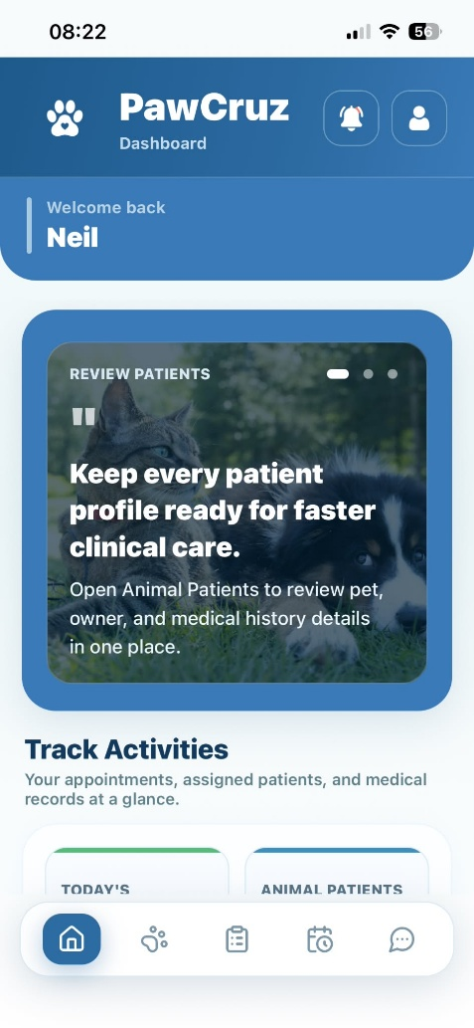 |  | PASSED
Dashboard | Click the “Next” button on the tutorial dialog | Navigates instructions per page |  | 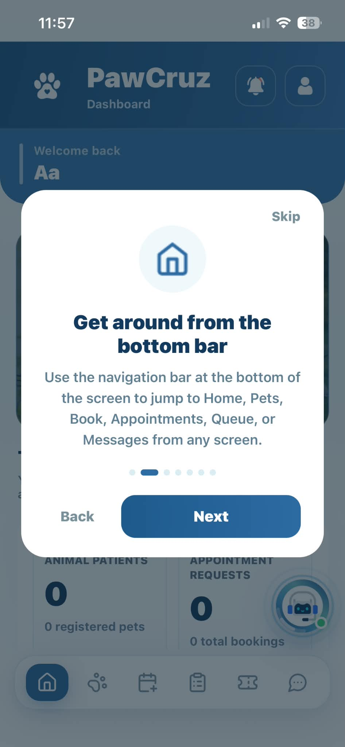 |  | PASSED
Dashboard | Click the “Back” button on the tutorial dialog | Navigates back to the previous page |  | 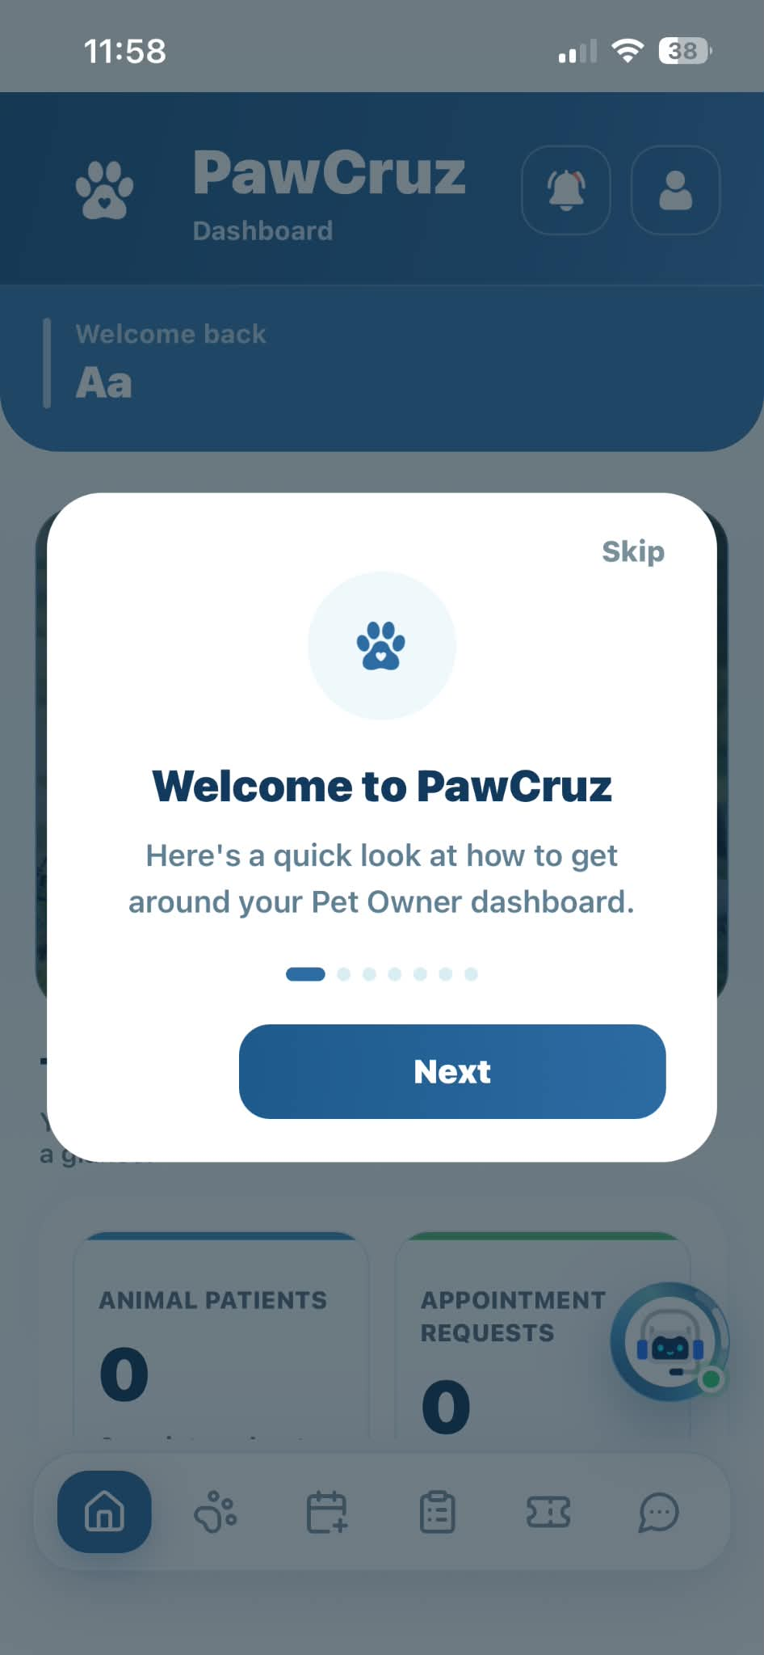 |  | PASSED
Dashboard | Click the “skip” button on the tutorial dialog | Skip the instructions on how to use the mobile application and display the main dashboard of pet owner |  | 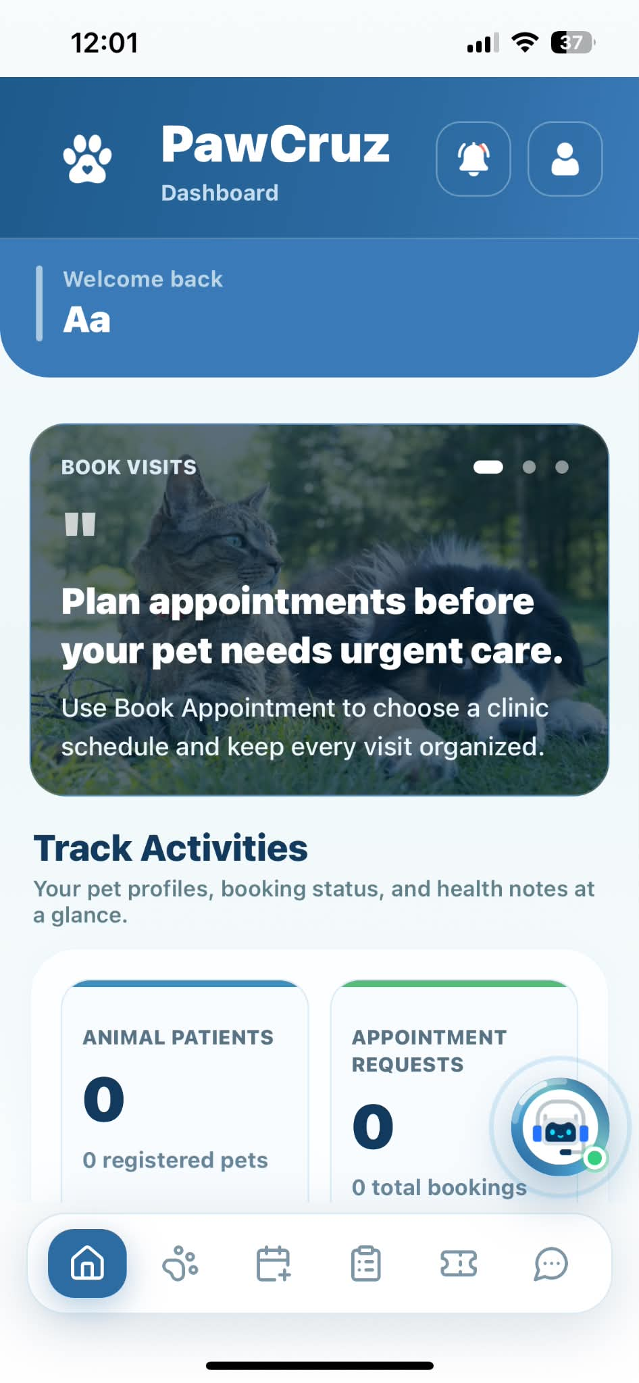 |  | PASSED
OTP Page | Tap "Resend OTP" button | Resends OTP to email address |  | 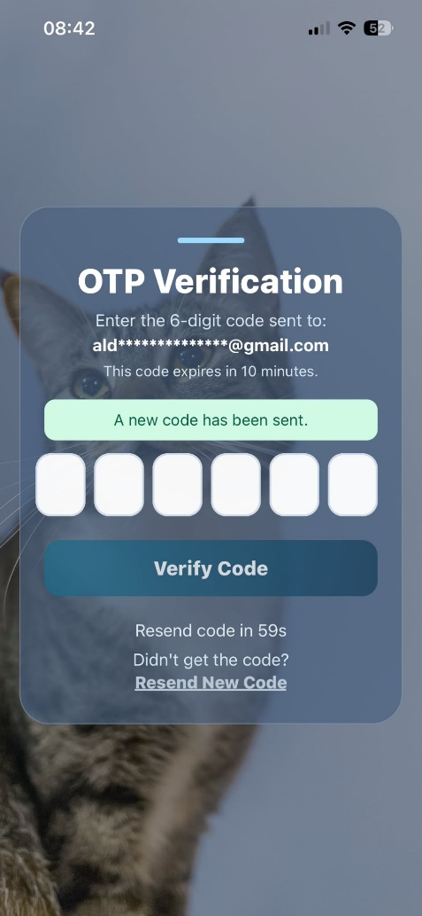 |  | PASSED
Forgot Password Page | Tap "Verify OTP" button after entering code | Displays Set a New Password page |  | 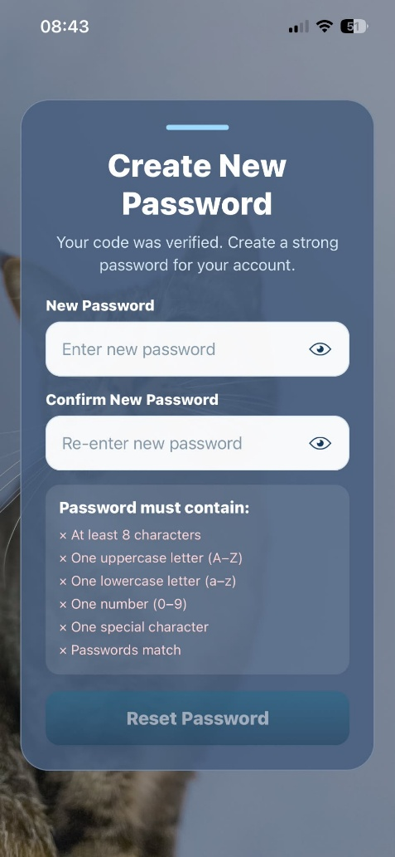 |  | PASSED
Forgot Password Page/ Login Page | Tap "Update Password" button | Displays Login Page if criteria for password are met |  | 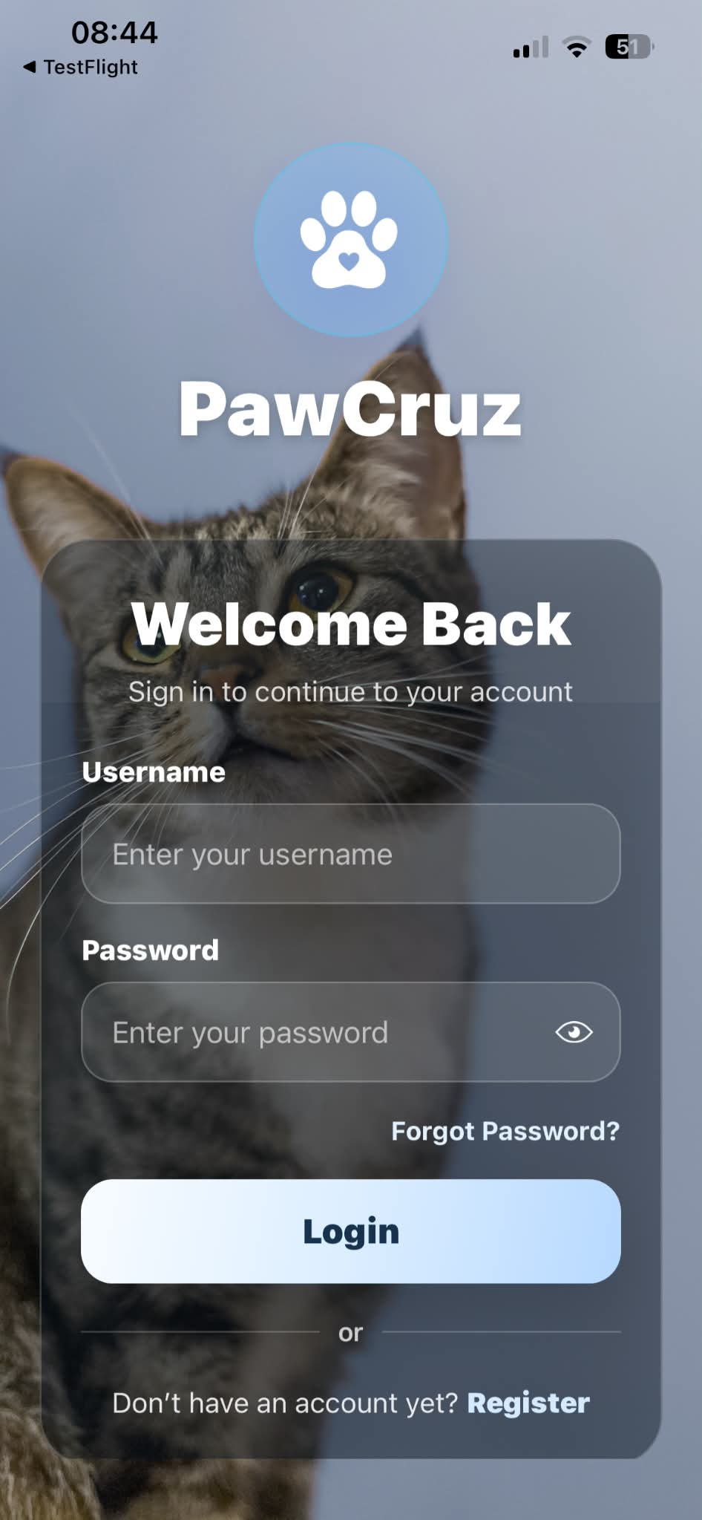 |  | PASSED
Dashboard | Tap the "Notification Bell" icon on header bar | Displays the Notifications screen |  | 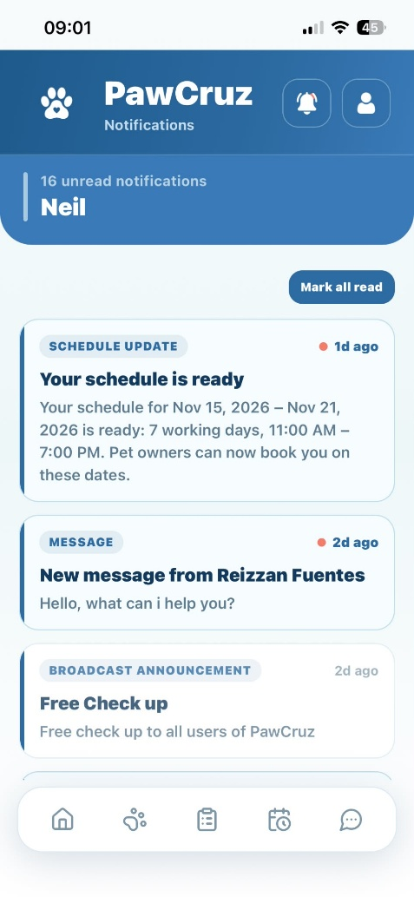 |  | PASSED
Dashboard | Tap the "Profile picture” icon on header bar | Displays the Veterinarian profile options |  | 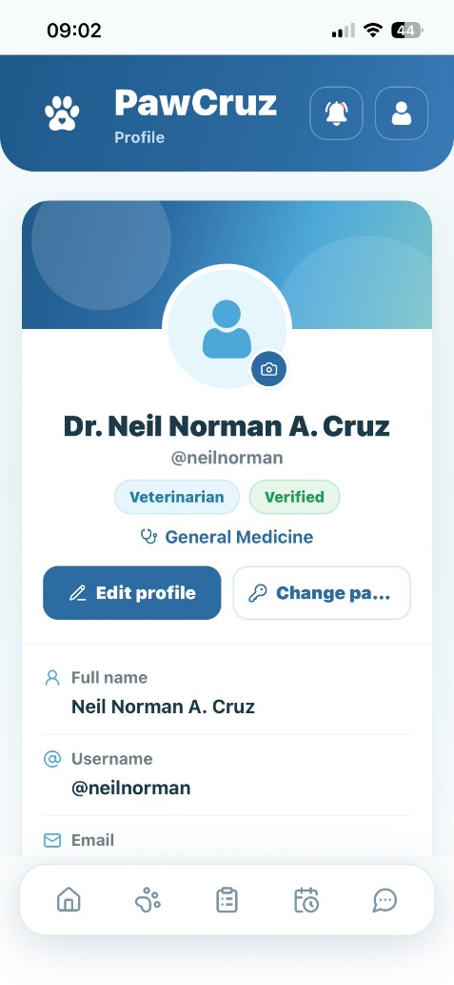 |  | PASSED
Dashboard | Tap "Appointments" tile under Services | Displays the Appointments screen |  | 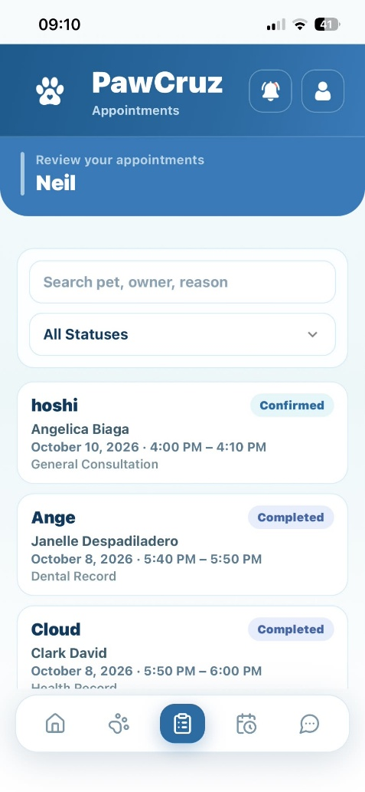 |  | PASSED
Dashboard | Tap "Animal Patients" tile under Services | Displays the Animal Patients screen |  |  |  | PASSED
Dashboard | Tap "Messages" tile under Services | Displays the Messages screen |  | 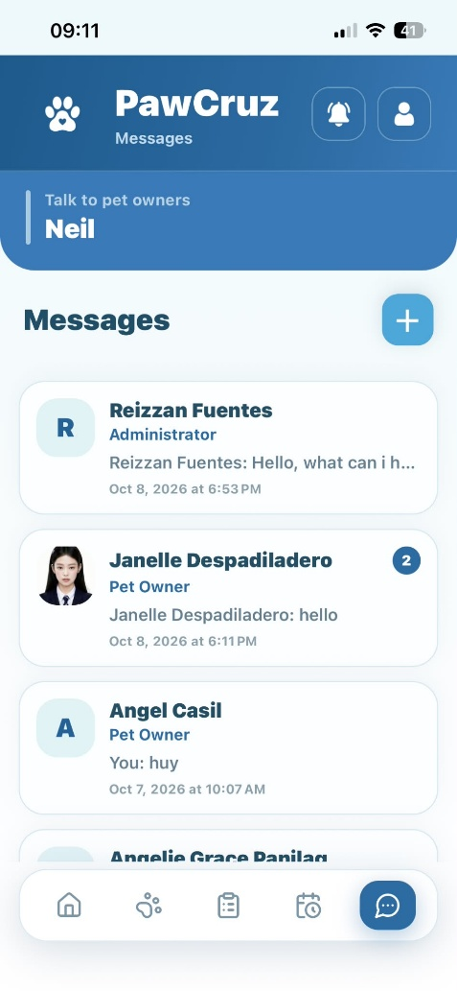 |  | PASSED
Bottom Navigation Bar | Tap "Home" icon tab | Navigates to Veterinarian Mobile Dashboard |  | 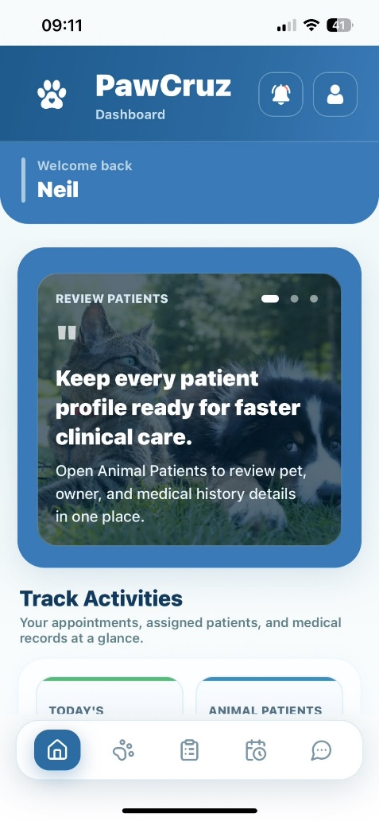 |  | PASSED
Bottom Navigation Bar | Tap "Appointments" icon tab | Navigates to Appointments screen |  |  |  | PASSED
Bottom Navigation Bar | Tap "My Schedule" tab | Navigates to My Schedule screen |  | 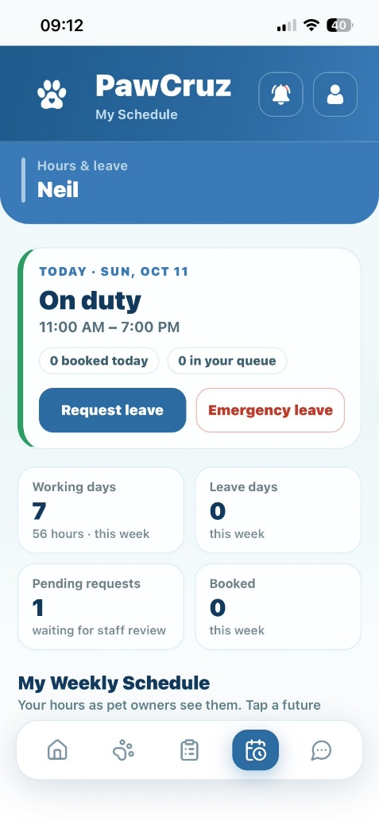 |  | PASSED
Bottom Navigation Bar | Tap "Animal Patients" tab | Navigates to Animal Patients screen |  | 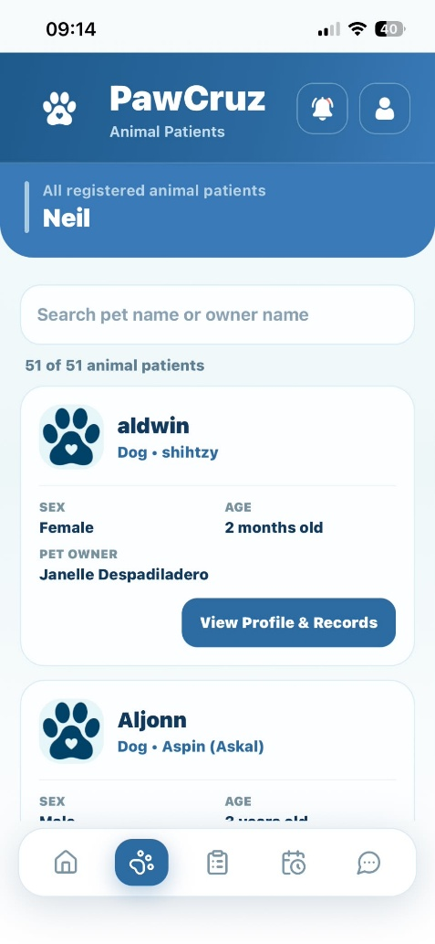 |  | PASSED
Bottom Navigation Bar | Tap "Messages" tab | Navigates to Messages screen |  | 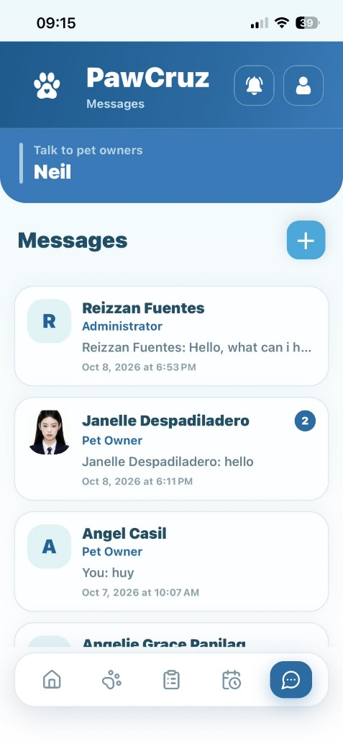 |  | PASSED
Notifications | Tap the “Notification bell” icon | Displays the notifications |  | 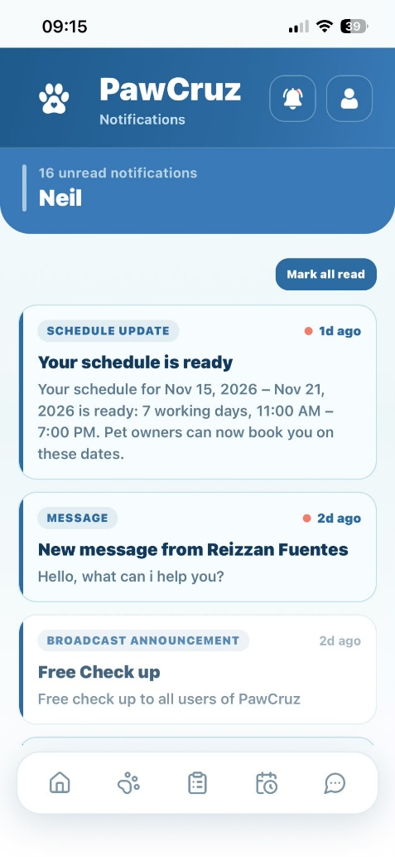 |  | PASSED
Notifications | Tap the "Mark all read" (check icon) | Marks all unread notifications as read and updates badge count |  | 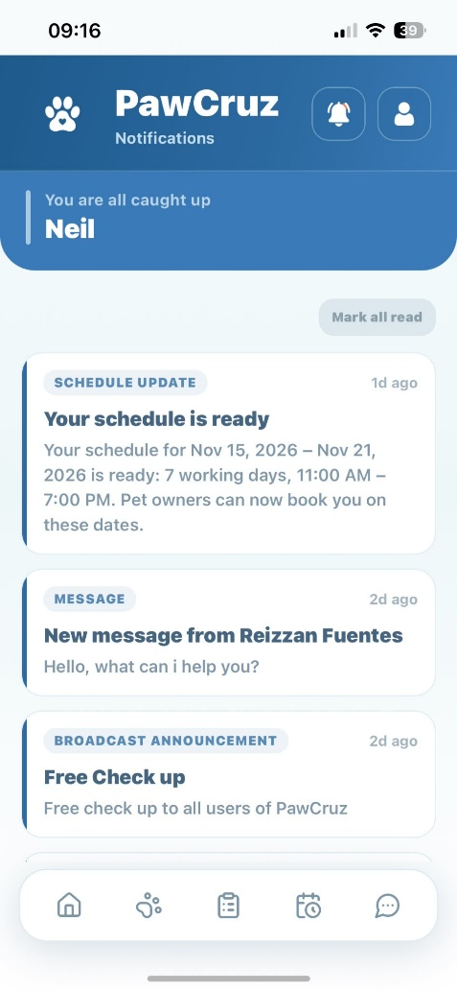 |  | PASSED
Veterinarian Profile | Tap "Edit profile" button | Expands and displays editable personal information fields |  | 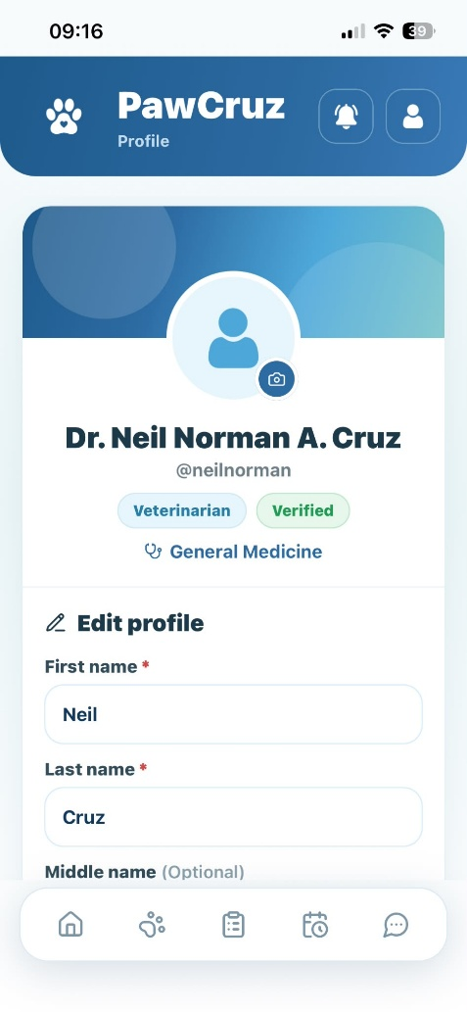 |  | PASSED
Veterinarian Profile | Update personal details and tap "Save changes" button | Saves and updates Pet Owner personal information |  | 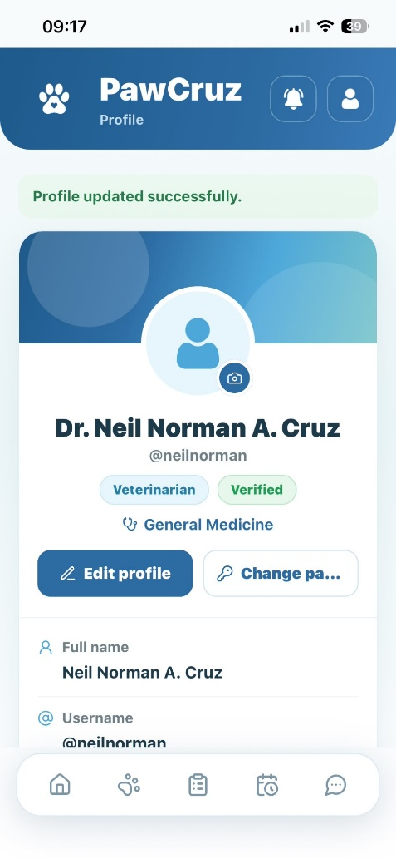 |  | PASSED
Veterinarian Profile | Tap the camera icon on profile picture | Opens file selection window to select profile picture |  | 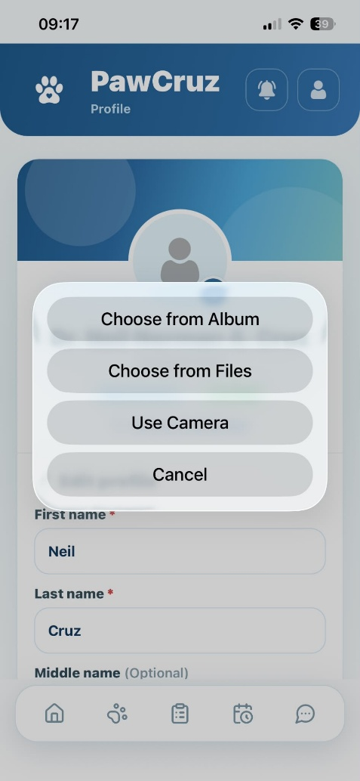 |  | PASSED
Veterinarian Profile | Tap “Change password” button | Displays password update fields with criteria validation |  | 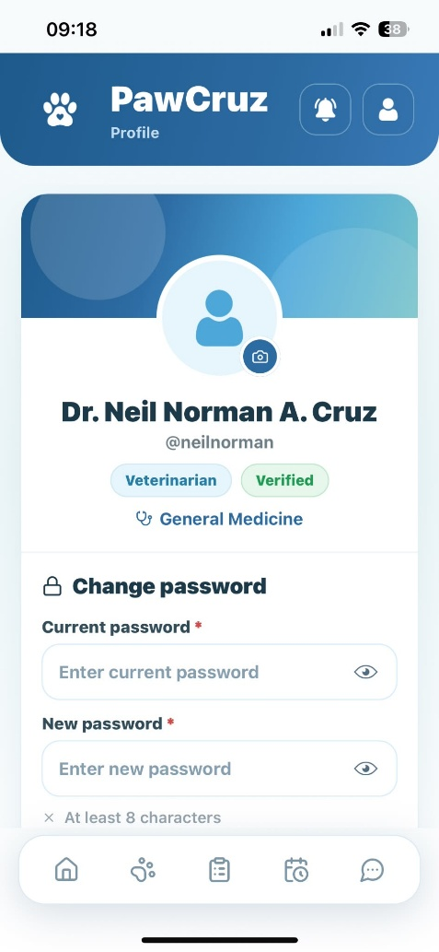 |  | PASSED
Veterinarian Profile | Tap "Show/Hide Password" toggle icon | Displays or hides entered new password text |  | 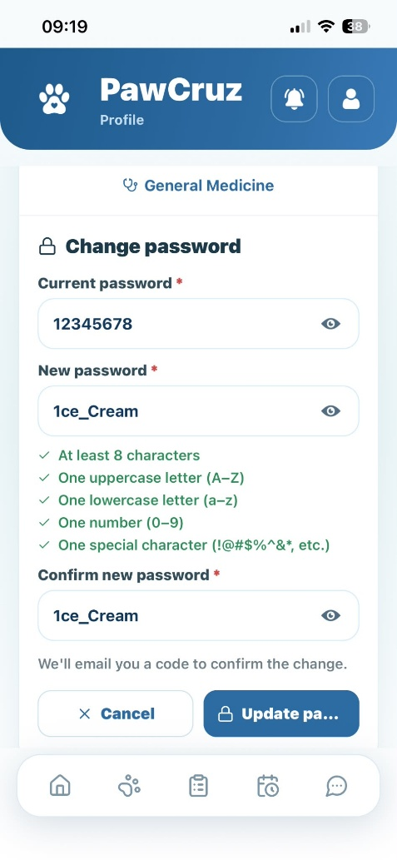 |  | PASSED
Veterinarian Profile | Update password and tap "Update password" button | Sends OTP to pet owner email to verify password change |  | 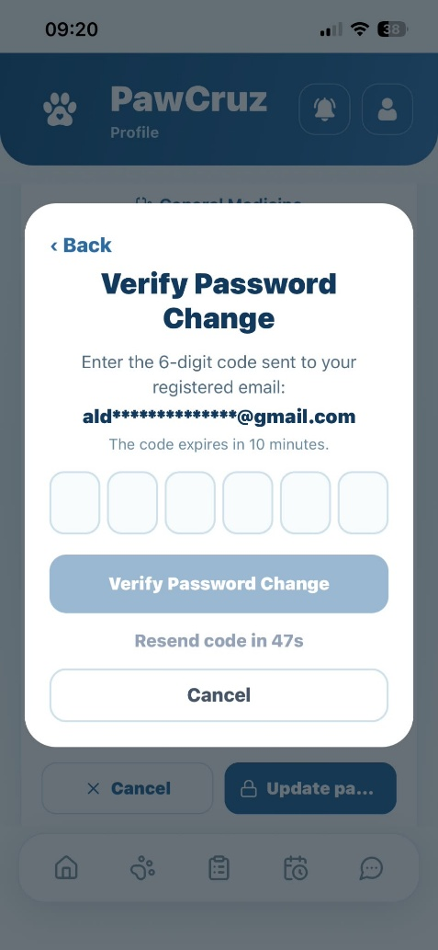 |  | PASSED
Veterinarian Profile | Tap "Cancel" button on verification modal | Cancels action and returns to profile view |  | 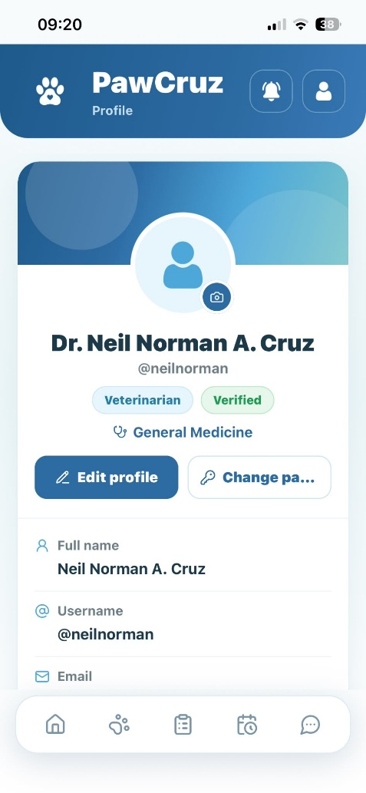 |  | PASSED
Veterinarian Profile | Tap "Verify Code" button after entering code | Updates password and returns to profile view |  | 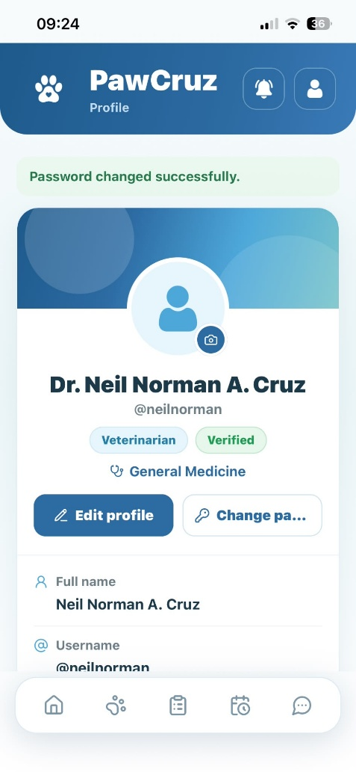 |  | PASSED
Veterinarian Profile/Logout | Tap "Logout" button | Displays logout confirmation modal with "Cancel" and "Logout" |  | 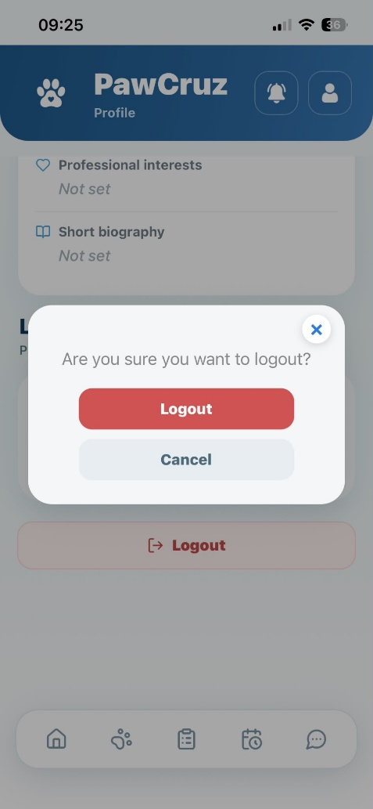 |  | PASSED
Logout | Tap "Cancel" button in confirmation dialog | Closes dialog and keeps Veterinarian logged in |  | 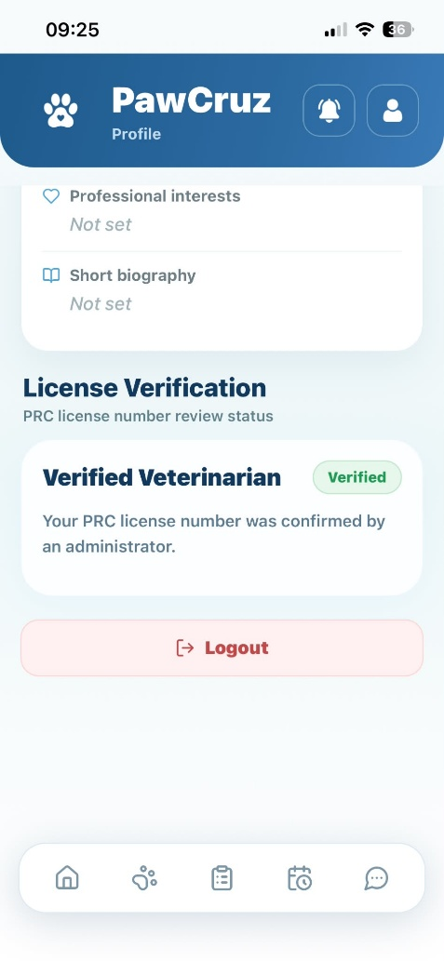 |  | PASSED
Logout | Tap "Yes, log out" button in confirmation dialog | Logs out Veterinarian and redirects to Login page |  | 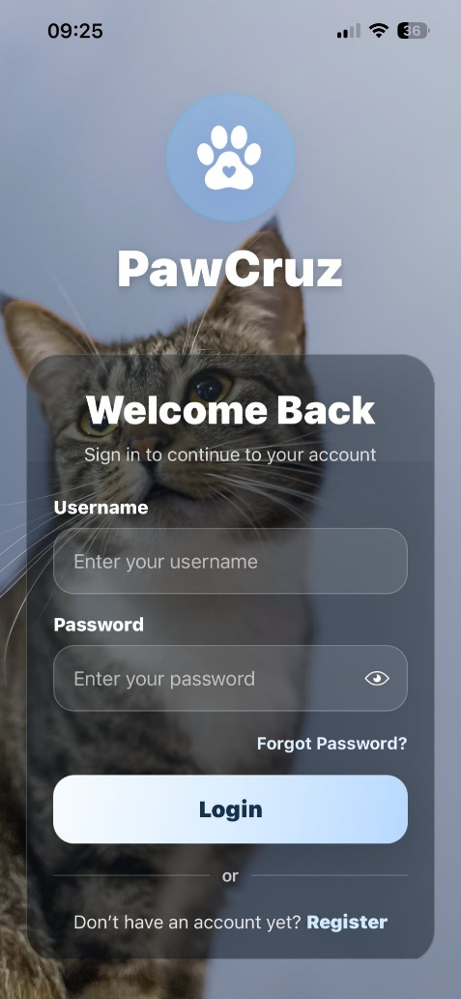 |  | PASSED
Appointments | Tap "Cancel" button | Automatically cancels the selected appointment |  | 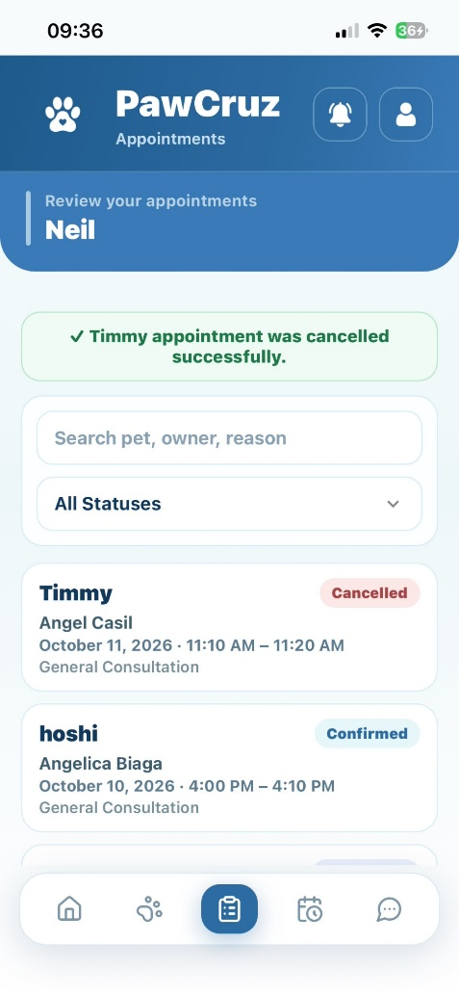 |  | PASSED
Appointments | Tap "Clear" button | Clears appointment list for current day and views full list |  | 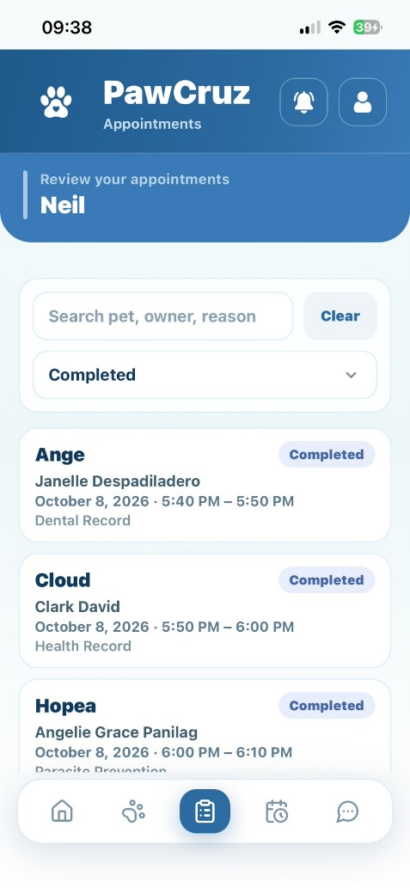 |  | PASSED
Appointments | Tap / Scroll "Next" button | Displays next paginated list of full appointments |  | 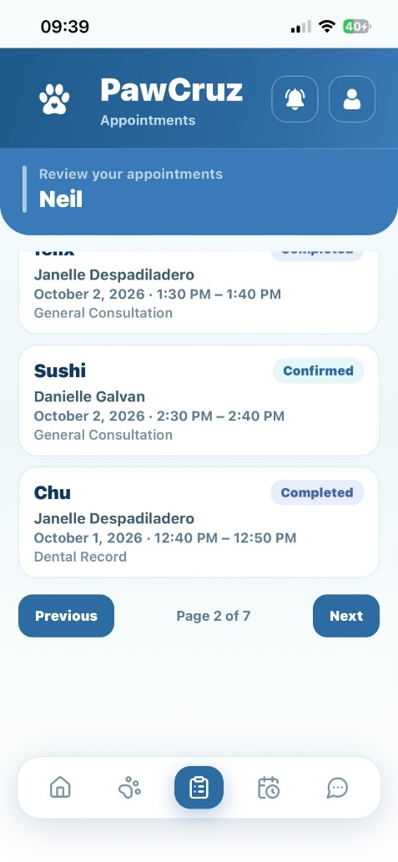 |  | PASSED
Appointments | Tap / Scroll "Previous" button | Tap / Scroll "Previous" button |  | 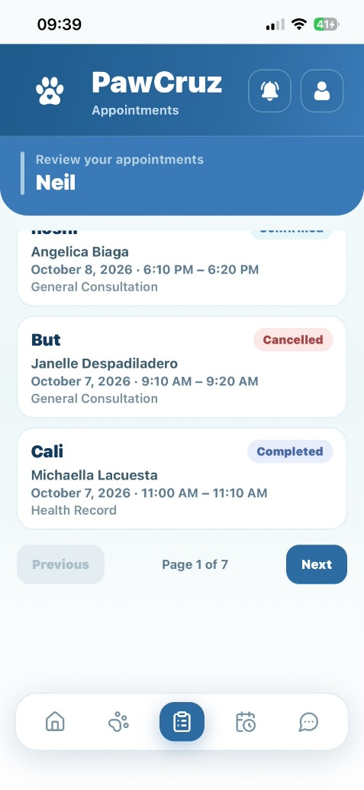 |  | PASSED
My Schedule | Tap "Request leave" button | Opens Request Leave form |  | 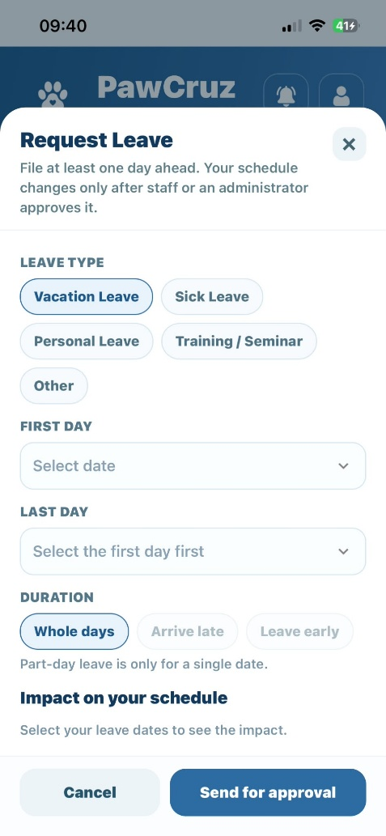 |  | PASSED
My Schedule | Tap "Cancel" button under Request Leave form | Cancels request leave action |  | 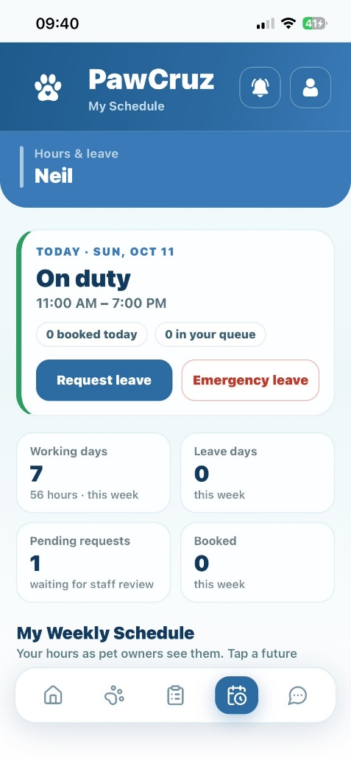 |  | PASSED
My Schedule | Tap "Send for approval" button | Sends request and waits for notification approval by staff |  | 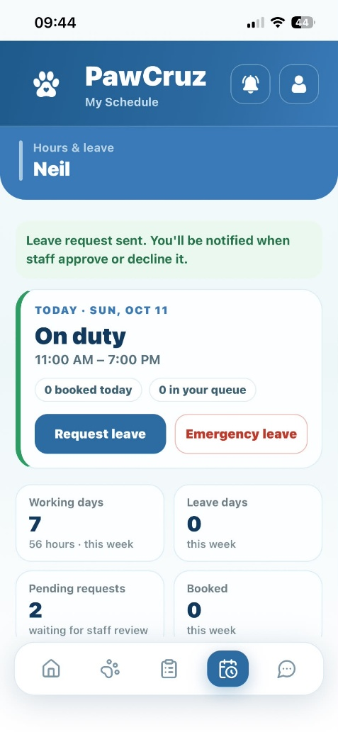 |  | PASSED
My Schedule | Tap "Emergency Leave" button | Opens Emergency Leave form |  | 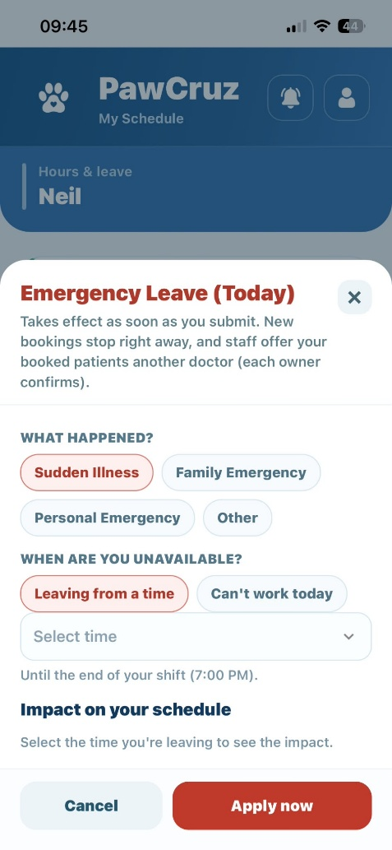 |  | PASSSED
My Schedule | Tap "Cancel" button under Emergency Leave form | Cancels emergency leave action |  | 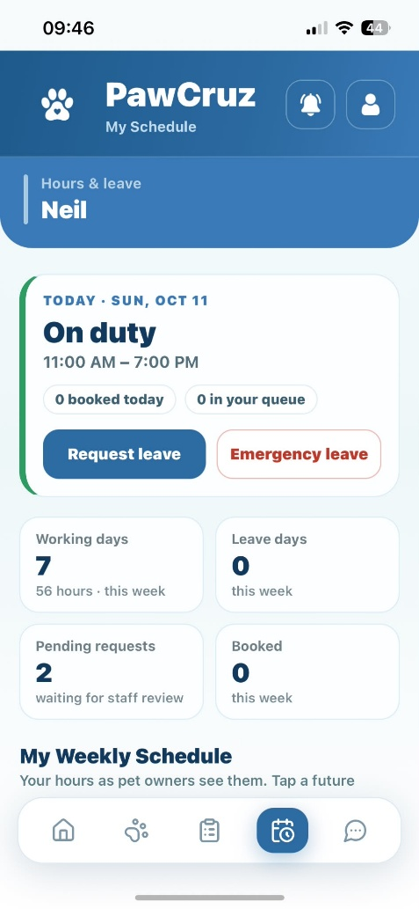 |  | PASSED
My Schedule | Tap "Apply emergency leave now" button | Immediately applies emergency leave and updates schedule |  | 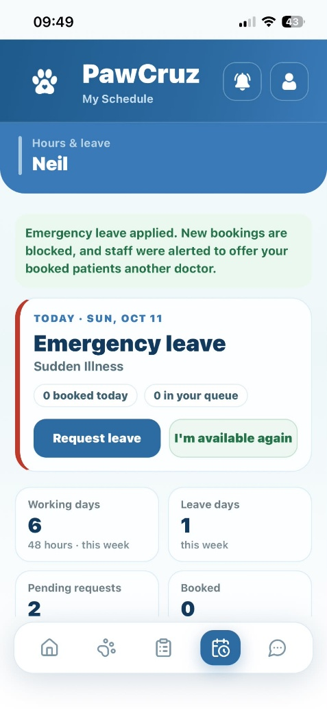 |  | PASSED
My Schedule | Tap "I'm available again" button | Displays confirmation dialog asking if coming back early |  | 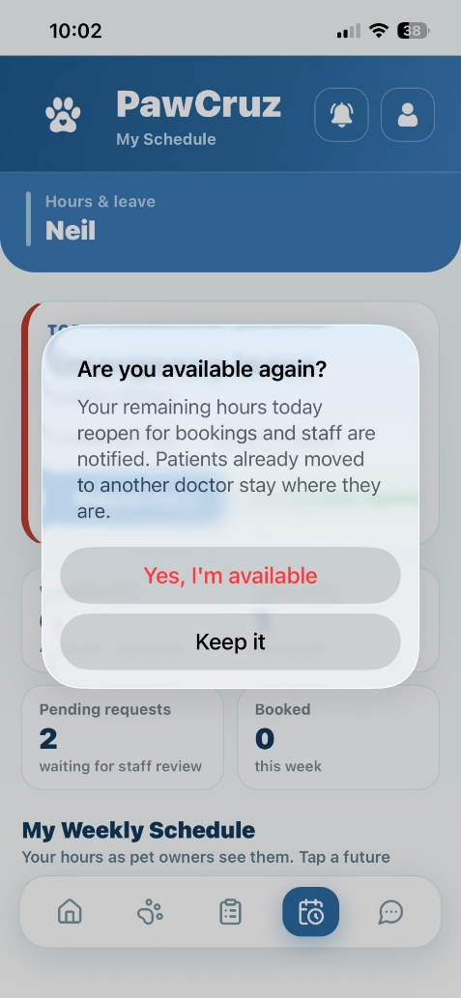 |  | PASSED
My Schedule | Tap "Keep it" button under confirmation dialog | Keeps emergency leave active for logged duration |  | 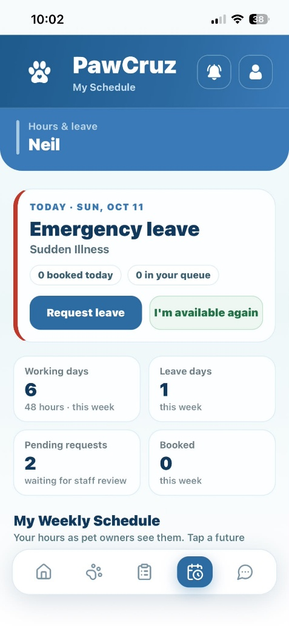 |  | PASSED
My Schedule | Tap "Yes, I'm available" button under confirmation dialog | Cancels remaining emergency leave hours and restores regular schedule |  | 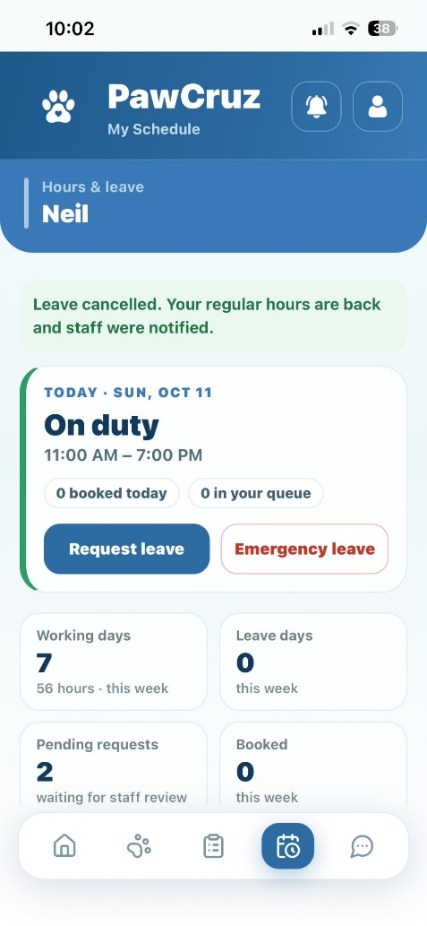 |  | PASSED
My Schedule | Tap "Withdraw" button for pending review | Displays confirmation dialog to withdraw request |  | 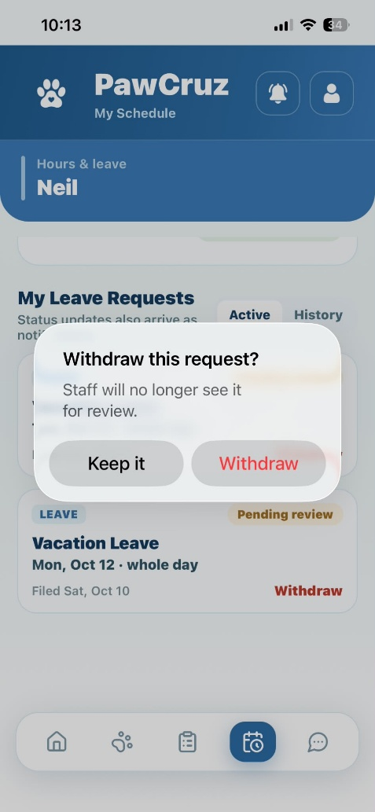 |  | PASSED
My Schedule | Tap "Keep it" button under withdrawal dialog | Retains leave request in pending approval state |  | 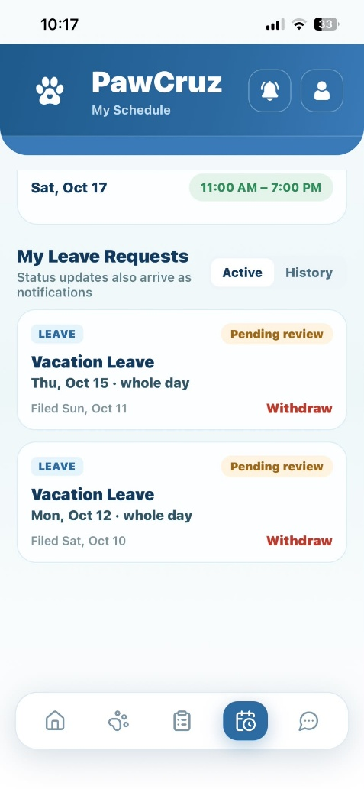 |  | PASSED
My Schedule | Tap "Withdraw" button under withdrawal dialog | Withdraws leave request and removes it from pending list |  | 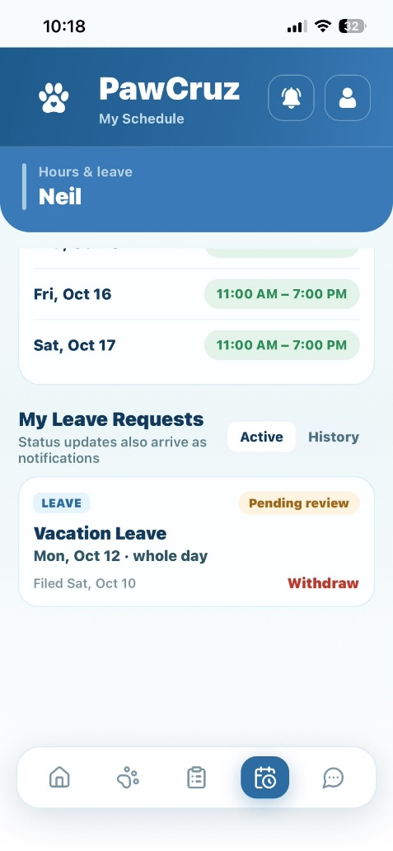 |  | PASSED
Animal Patients | Tap "View Records" button | Displays selected pet's medical records and AI predictive health |  | 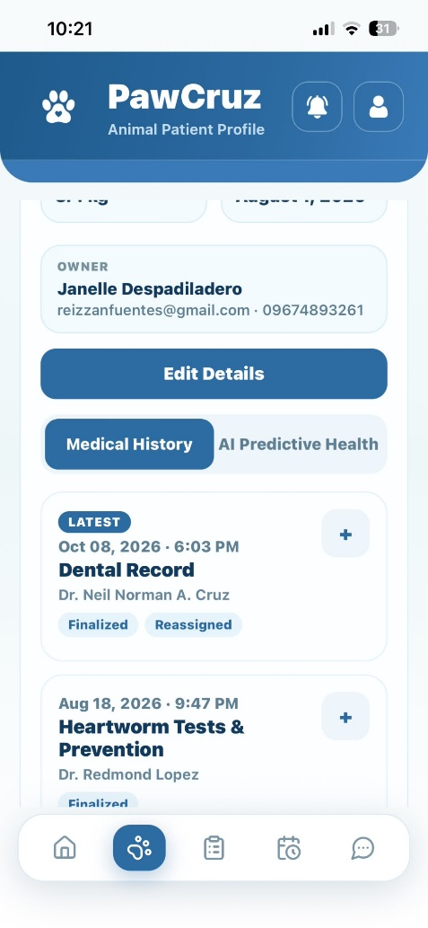 |  | PASSED
Animal Patients | Tap "Download" button in Billing section | Previews file to confirm download |  | 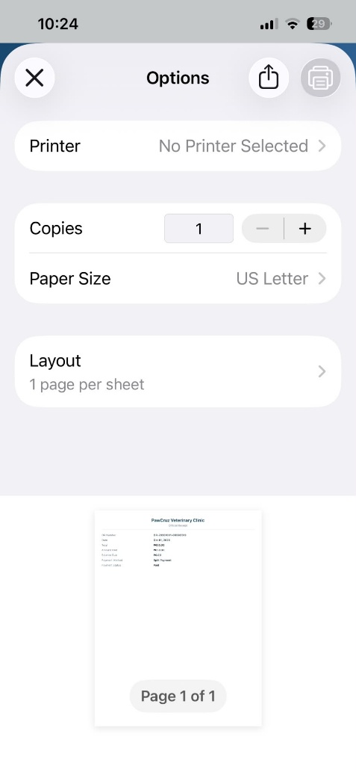 |  | PASSED
Animal Patients | Tap "Download" button on previewed billing file | Downloads file to device and saves as PDF |  | 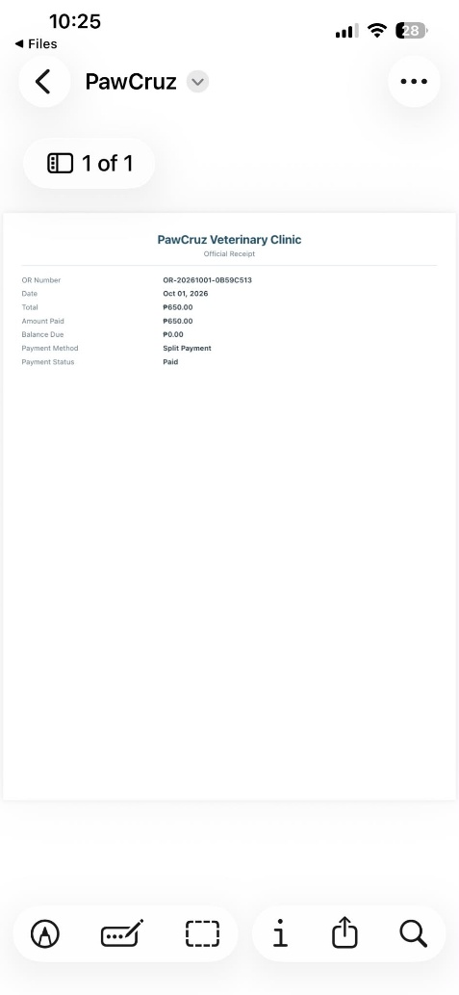 |  | PASSED
Animal Patients | Tap "View" button under prescription record | Previews prescription file prior to printing |  | 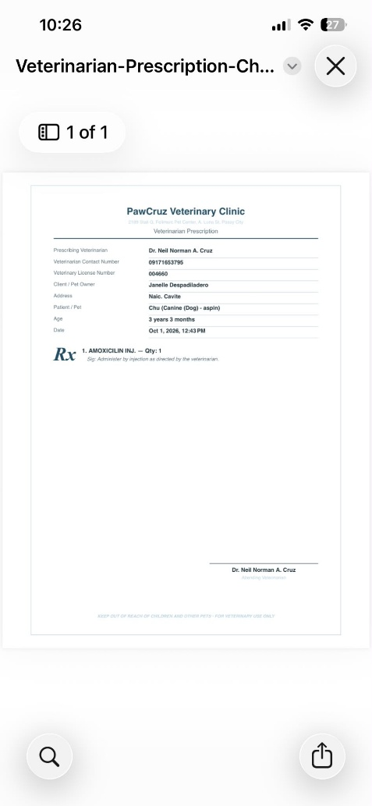 |  | PASSED
Animal Patients | Tap "Print" button on previewed prescription | Redirects to system mobile print menu |  | 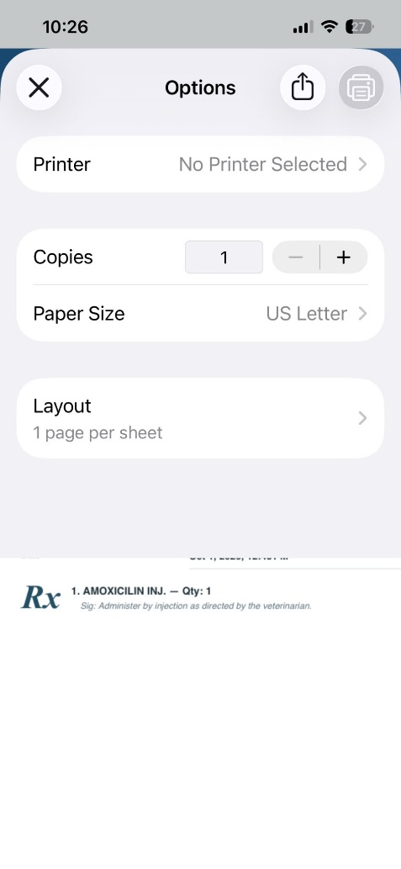 |  | PASSED
Animal Patients | Tap "Edit" button on pet record | Displays Edit Pet Record form |  | 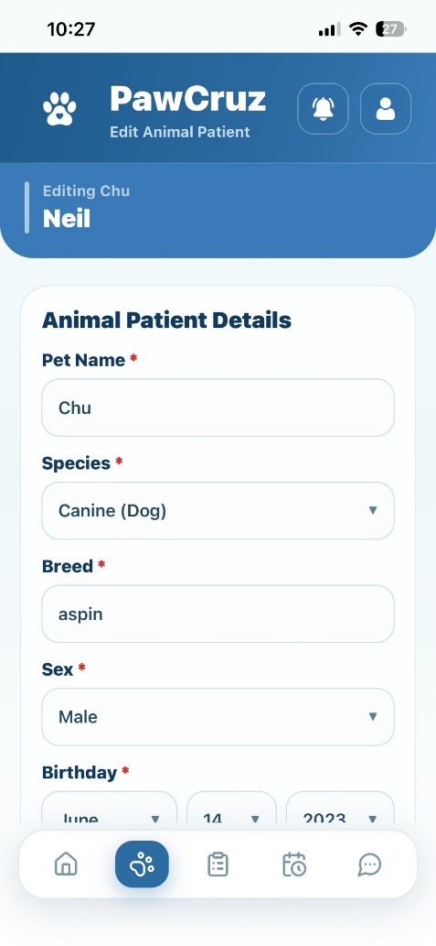 |  | PASSED
Animal Patients | Update pet info and tap "Update Pet" button | Saves changes and updates selected pet record |  | 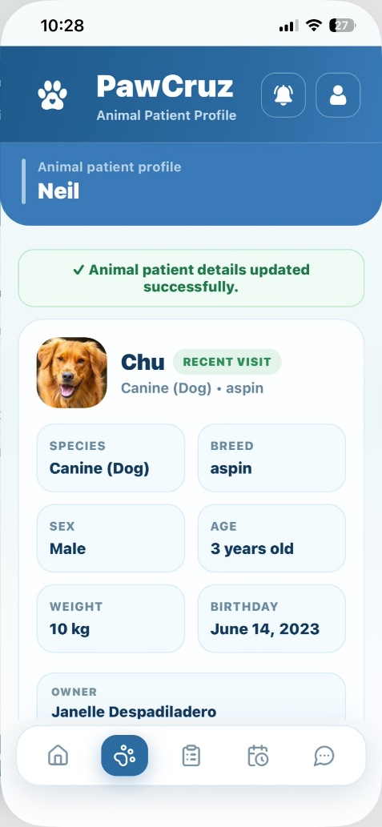 |  | PASSED
Animal Patients | Tap "Archive" button | Displays confirmation modal to archive or cancel pet record |  | 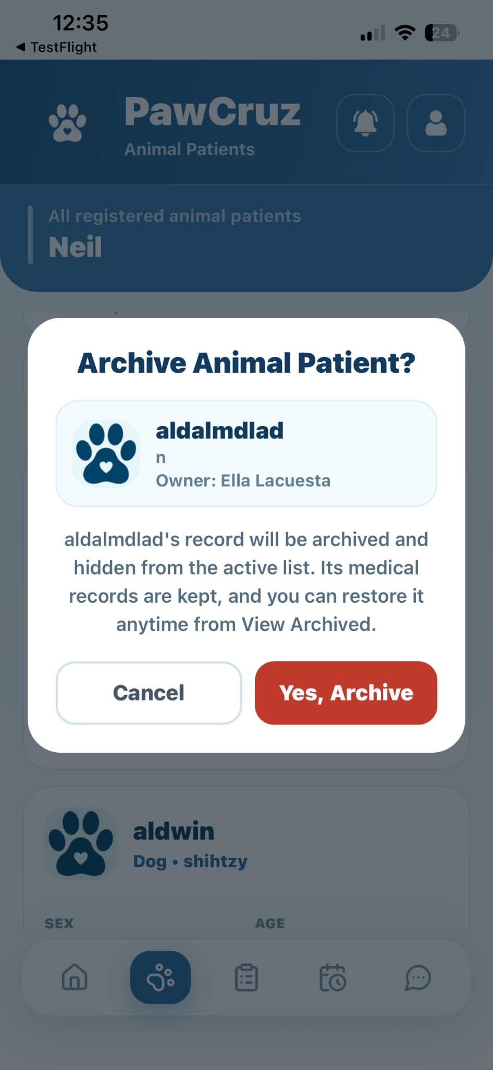 |  | PASSED
Animal Patients | Tap "No" button on archive modal | Cancels action and returns to Animal Patients list |  | 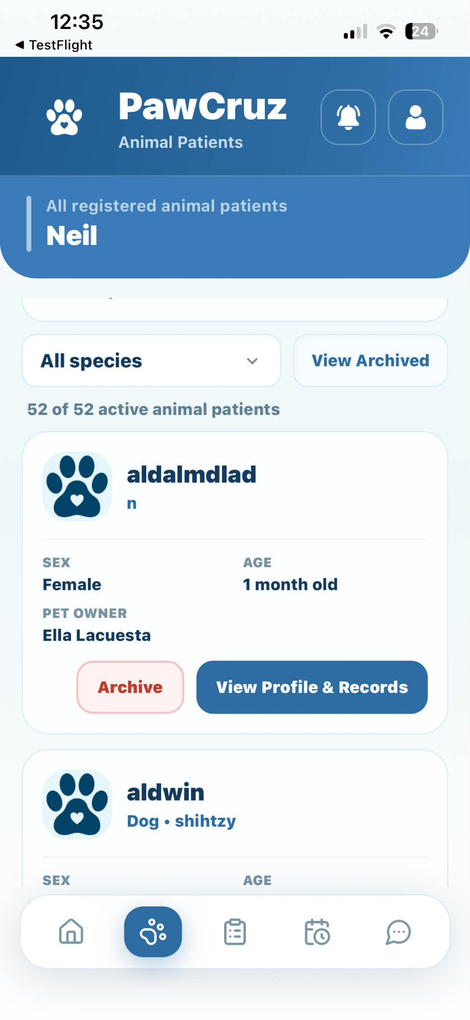 |  | PASSED
Animal Patients | Tap "Yes, Archive" button on archive modal | Archives pet and removes record from active list |  | 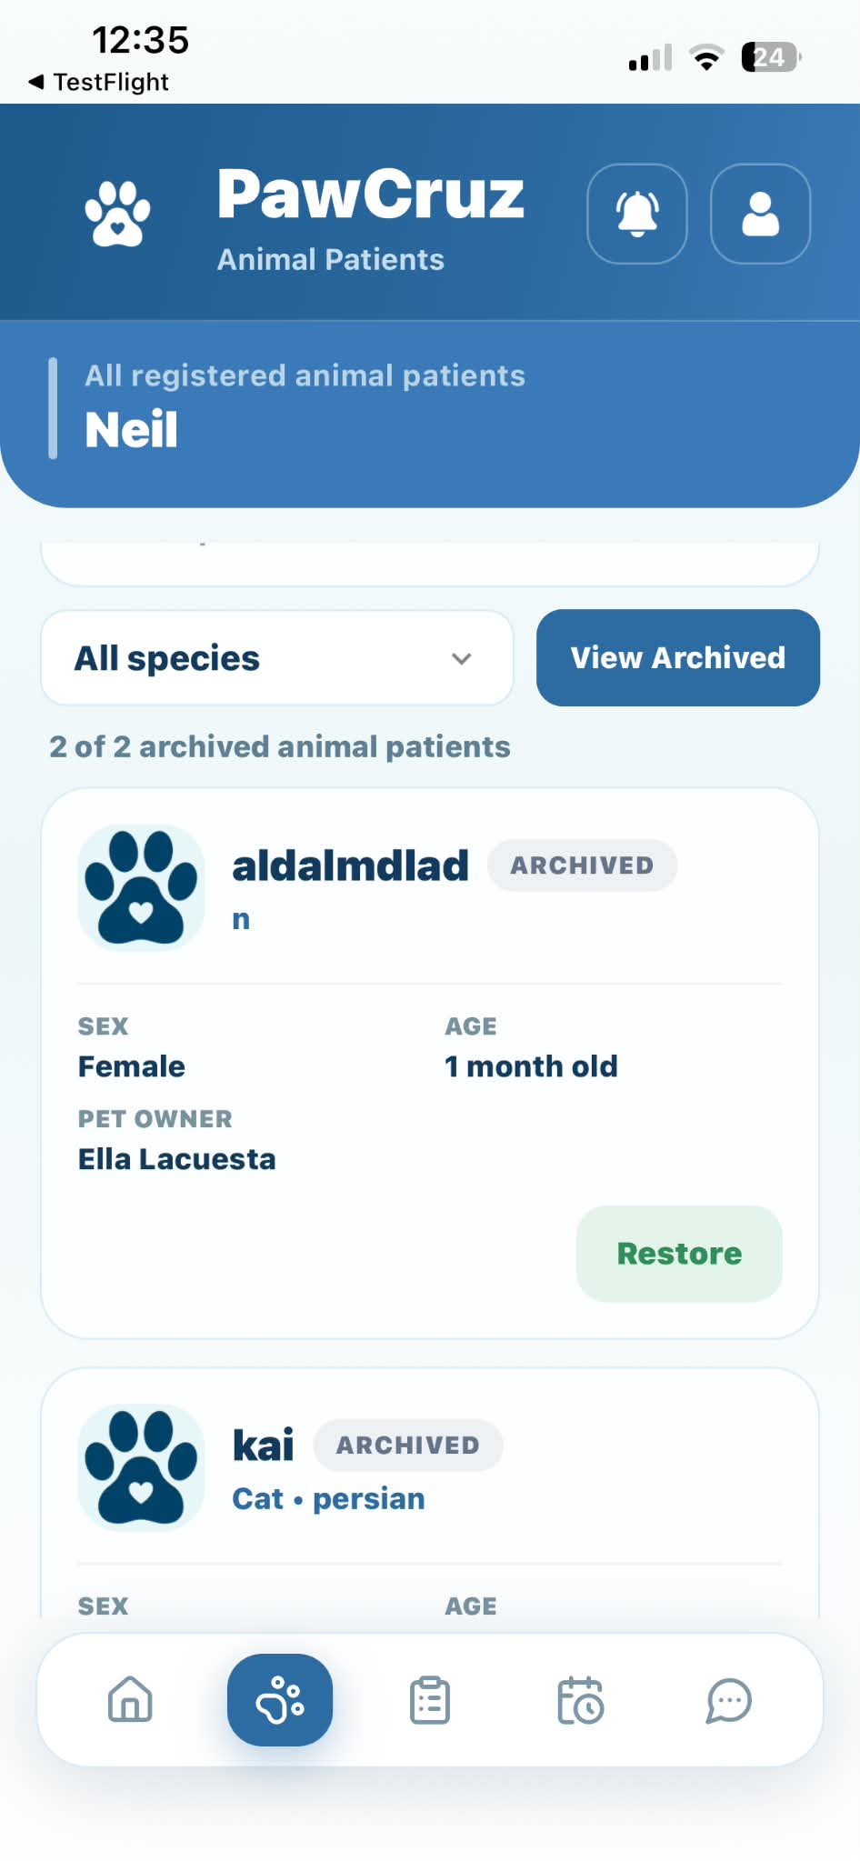 |  | PASSED
Animal Patients | Tap "View Archive" button | Displays list of archived pets |  | 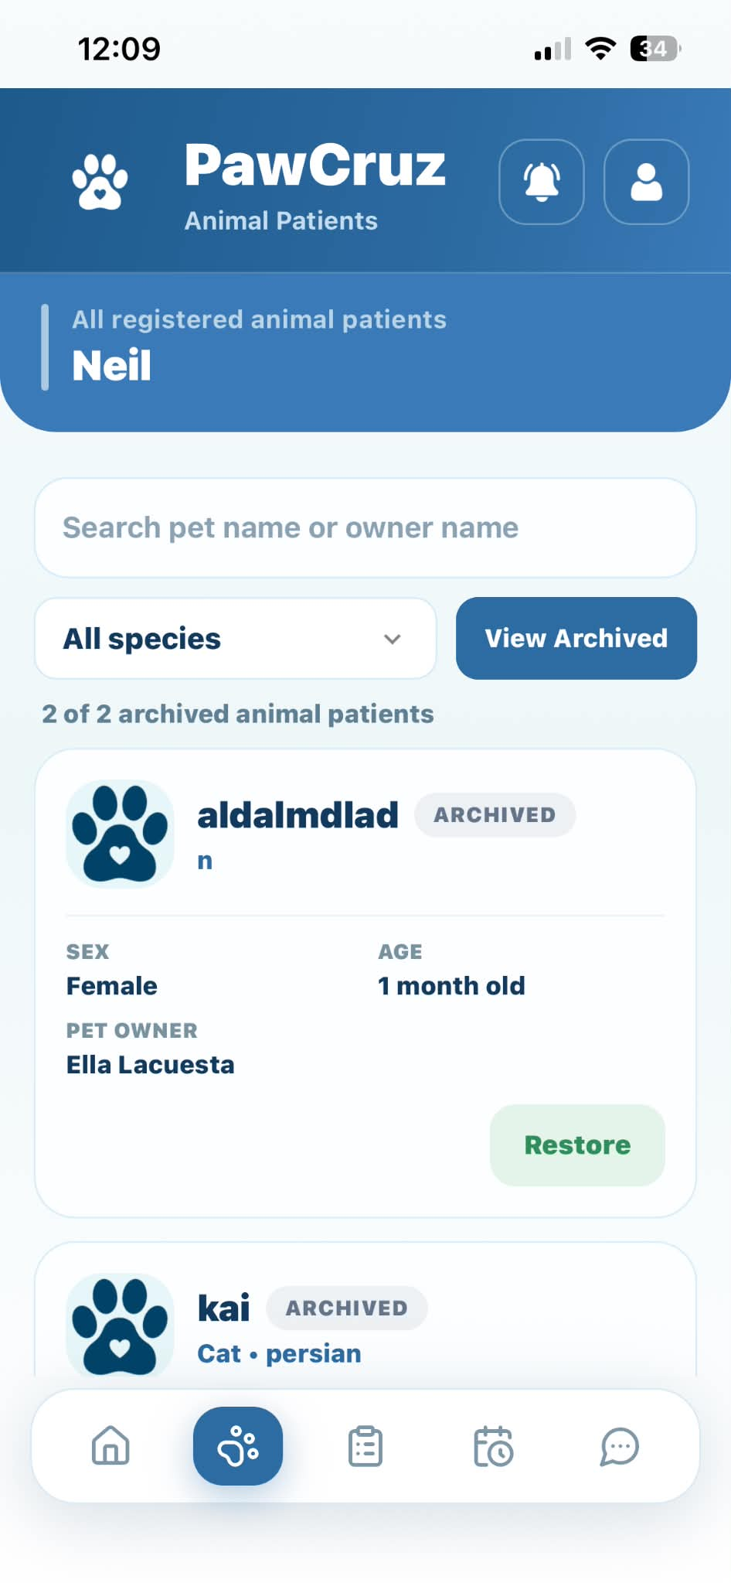 |  | PASSED
Animal Patients | Tap "Restore" icon button on archived pet | Restores pet and returns it to active Animal Patients list |  | 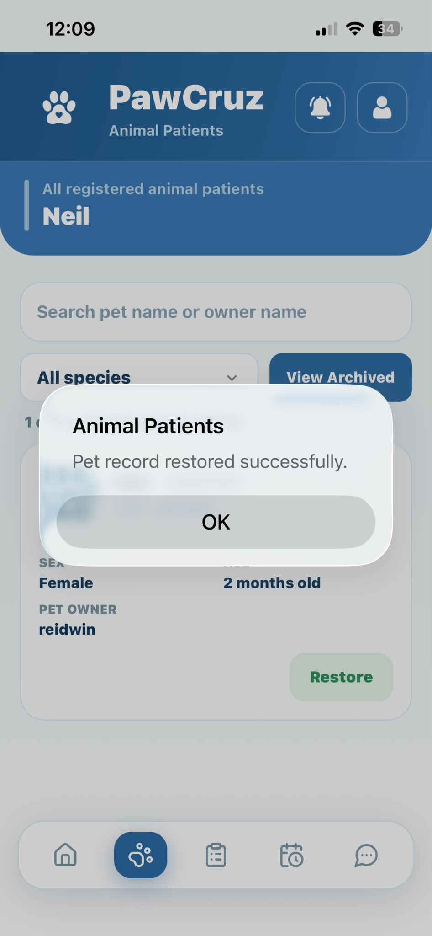 |  | PASSED
Animal Patients | Tap "All species" dropdown | Filters and views available species types |  | 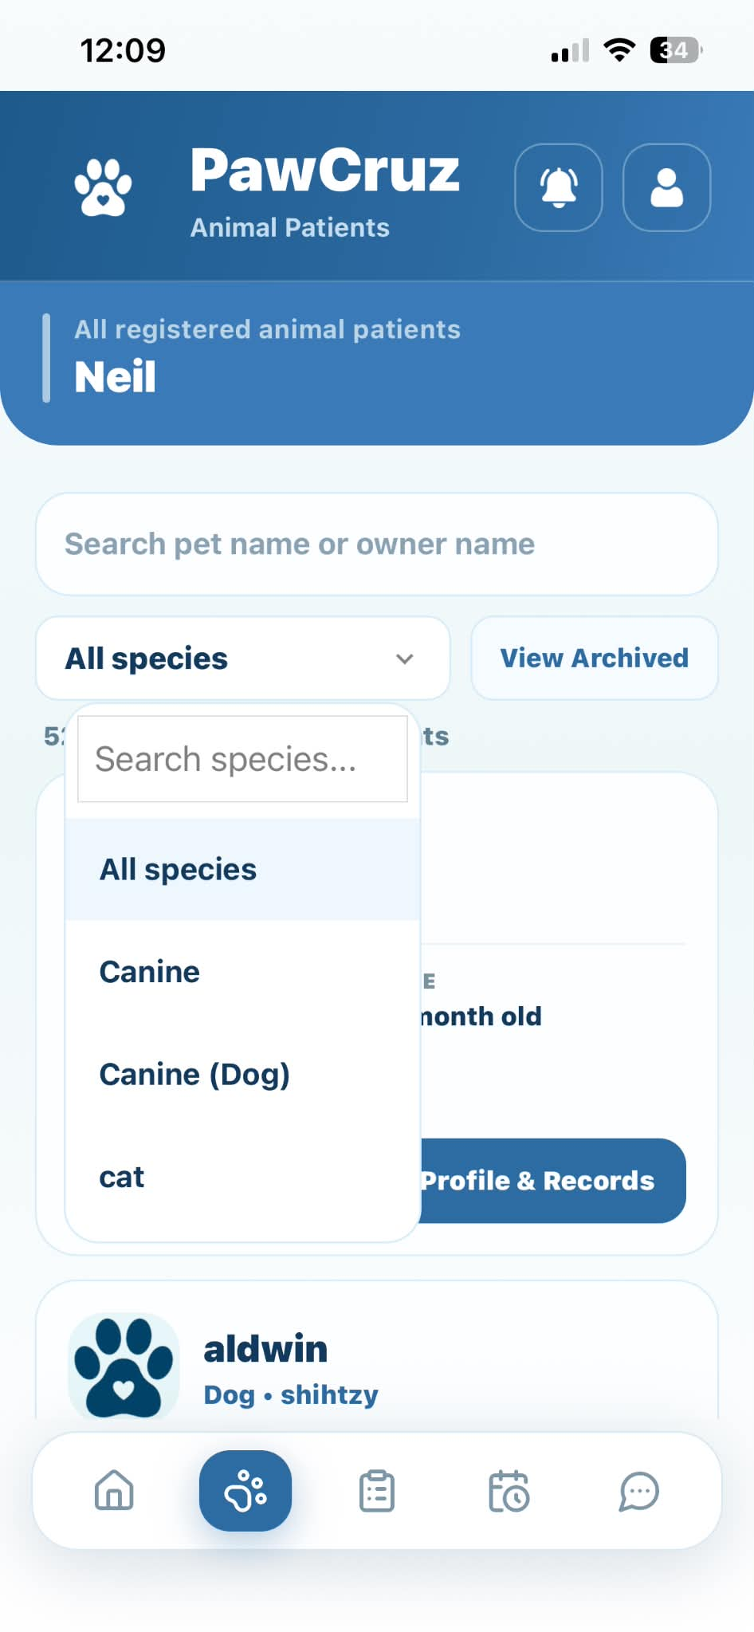 |  | PASSED
Messages | Tap "+" / "Add sign" button | Opens New Conversation dialog modal |  | 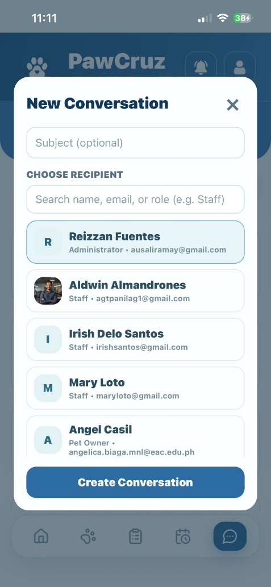 |  | PASSED
Messages | Tap "x" button | Closes conversation dialog modal |  | 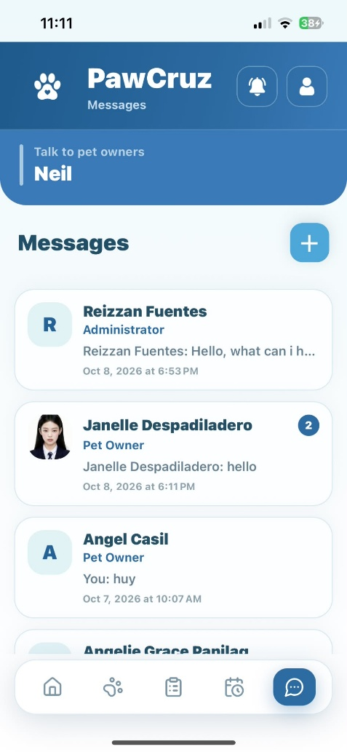 |  | PASSED
Messages | Tap "Create Conversation" button after selecting recipient | Creates new chat thread with selected recipient |  | 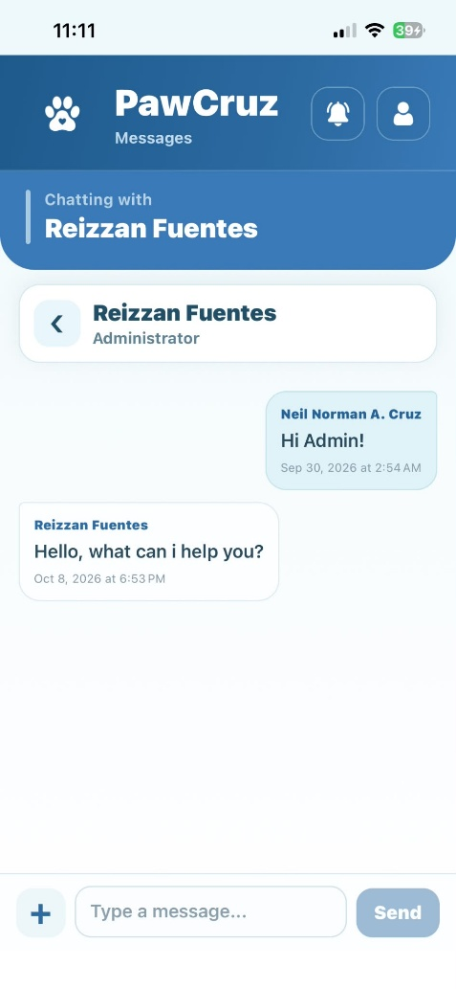 |  | PASSED
Messages | Tap "attachment paperclip" button | Opens file picker option to attach image/file |  | 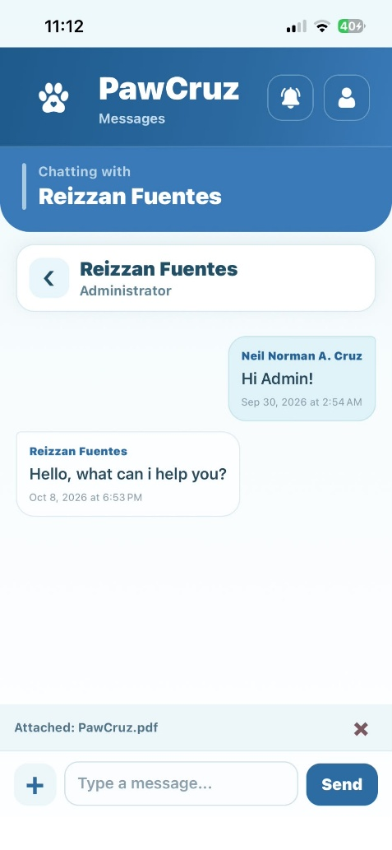 |  | PASSED
Messages | Enter message and tap "Send" icon button | Sends message and displays it in chat conversation |  | 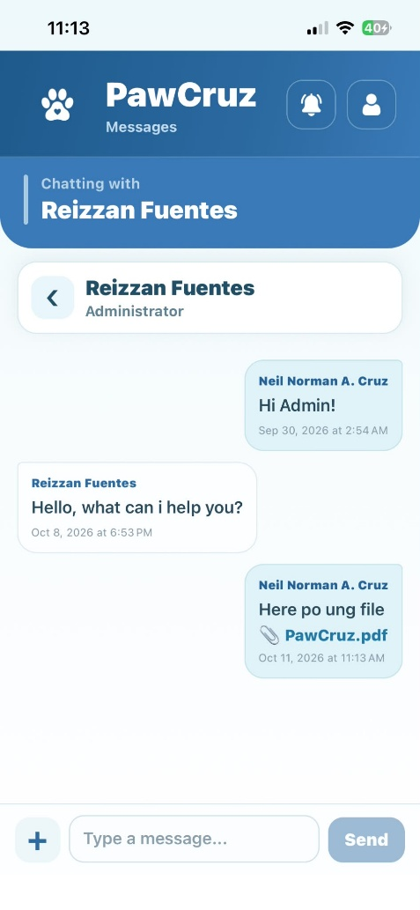 |  | PASSED

Prepared By | Administered/Performed By
Angelie Grace T. Panilag  Signature over Printed Name | Aldwin R. Almadrones  Signature over Printed Name

